Google Cloud Machine Learning Engineer

# ML Pipelines on Google Cloud

## Week 1 - Introduction to TFX Pipelines

### Overview

* TFX is a production -scalable ML platform based on the TensorFlow ecosystem.
* Portable to multiple environment and support orchestration frameworks, such as Apache Beam, Apache AirFlow and KubeFlow.
* Deployment options:
  + TF serving on a high-performance Production ML model server for batch and streaming inference.
  + TF Light for inference on IoT and mobile device.
  + TF JS for web application
  + TF Hub for model sharing and transfer learning

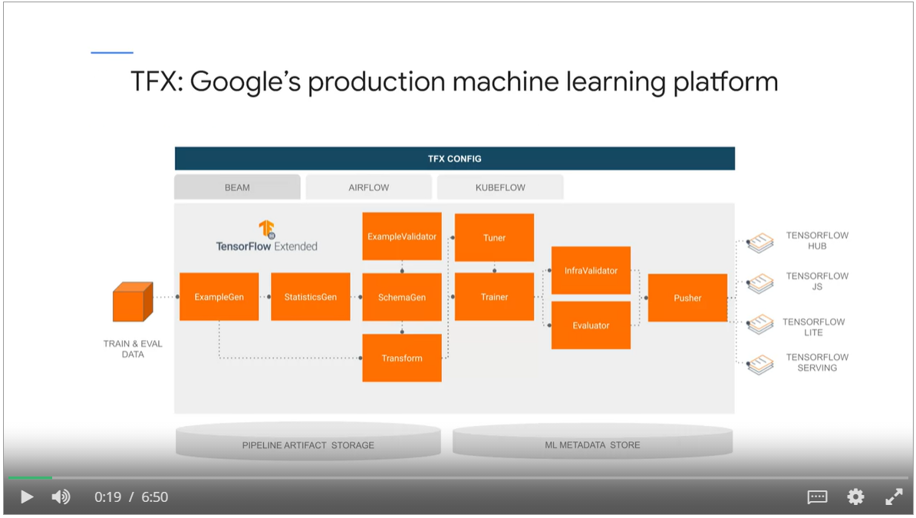

By implementing TFX workflow on Google Cloud, you can

* Scale your ML workflow with your data leveraging DataFlow.
* Increase development and experimentation velocity. Run multiple pipelines in Cloud AI Platform with different data splits, models and hyperparameters.
* Automate ML operations with tools such as Cloud Functions, Container Registry and Cloud Build.

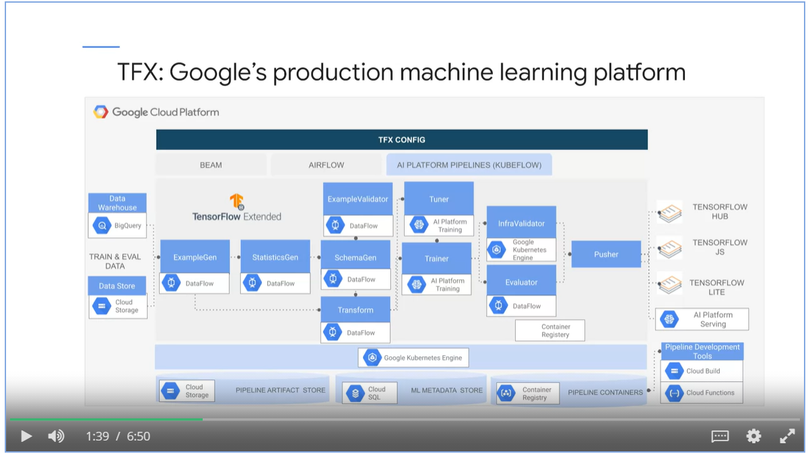

### TFX Concepts

#### TFX Component

* A TFX component is an implementation of a machine learning task.

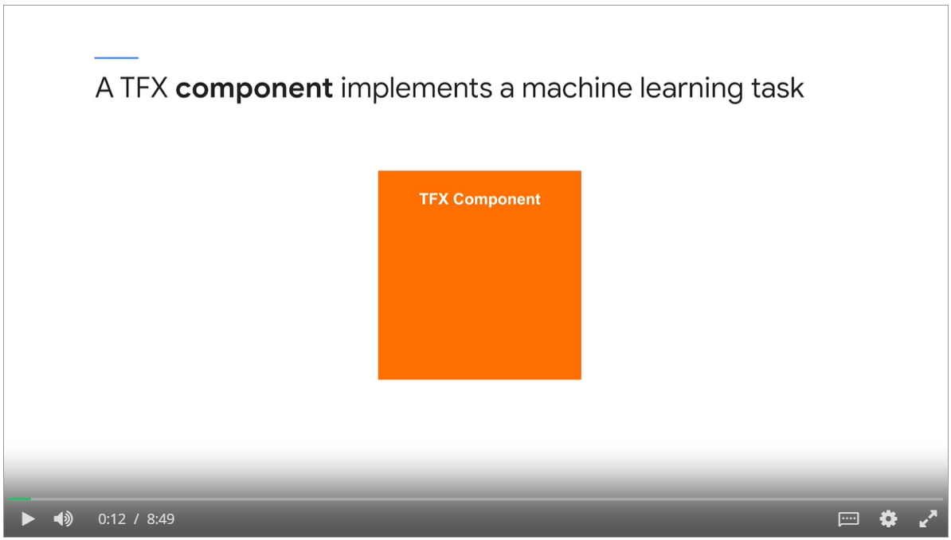

5 parts of TFX components

* Specification: a configuration that defines input and output artifacts and runtime parameters
* Driver: coordinates job execution
* Executor: contains code to perform ML workflow such as data preprocessing or model training
* Publisher: updates ML metadata store
* Interface: packages everything

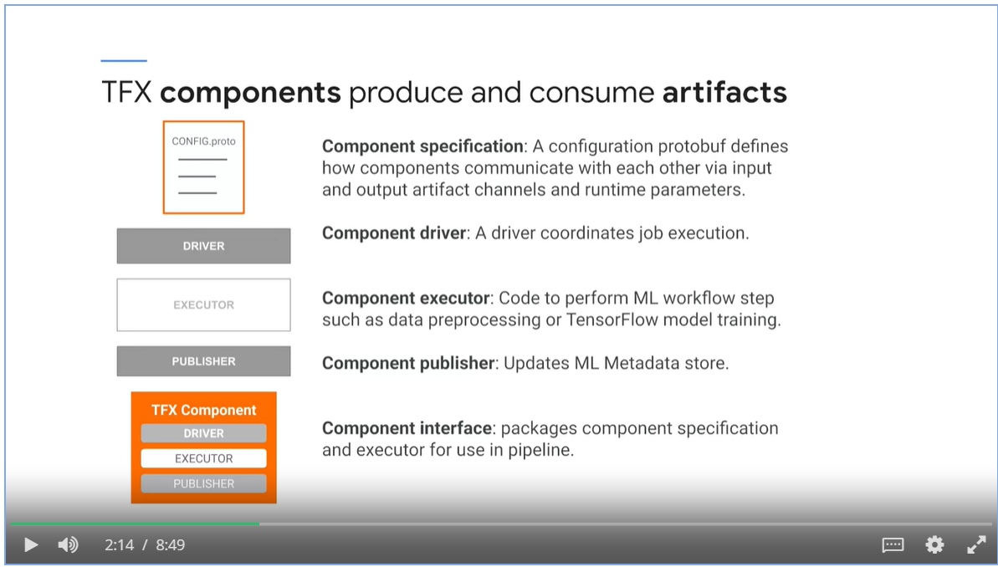

TFX components at Runtime

* Driver reads input artifacts
* Execute performs data preprocessing or computational tasks on artifacts
* Publisher output the result

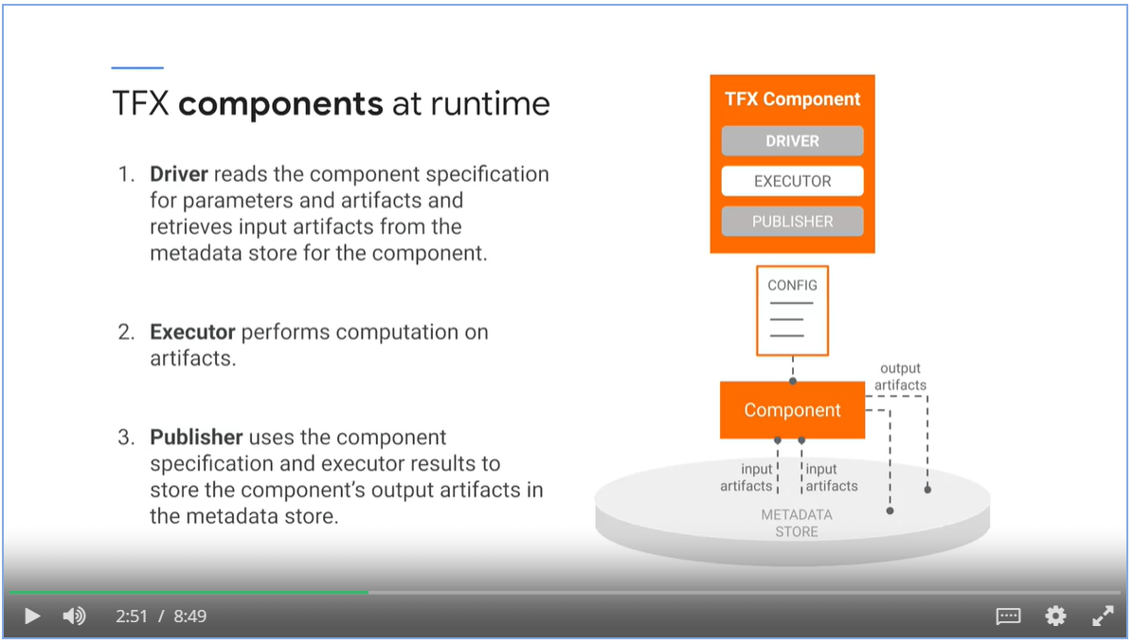

#### TFX Pipeline

* A TFX **pipeline** is a sequence of components
* Input and output artifacts are connected via **channels**
* Change runtime parameters via **configuration** allows you to experiment with different models and parameters.

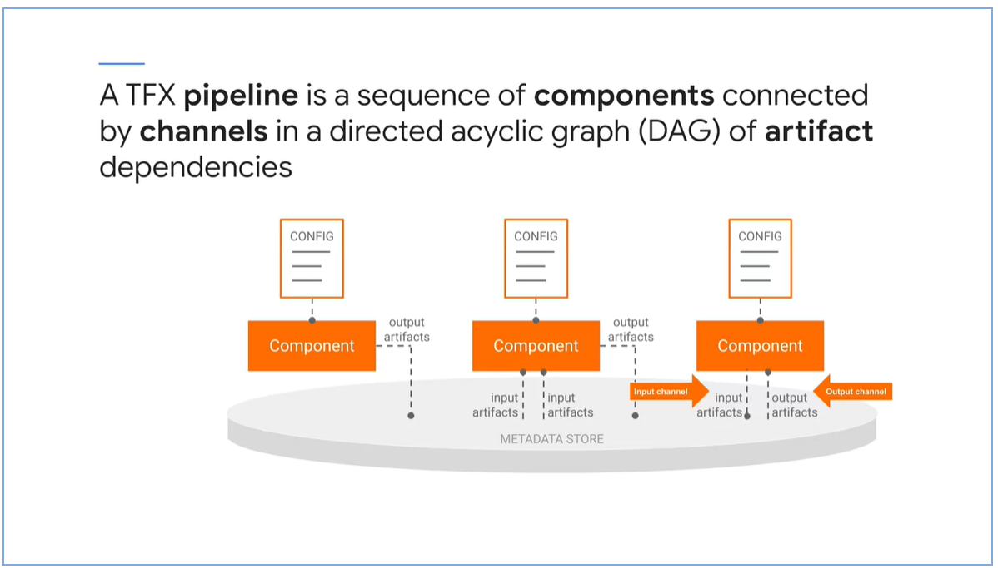

* TFX pipelines use **ML Metadata** for artifact management and an **orchestrator** for sequential component execution.
* **Orchestrator** coordinate pipeline runs. Component executors are executed sequentially from a DAG.
* Orchestrator ensures consistency with **execution order**, **component logging**, **retries and failure recovery**, and intelligent **parallelization** of component data processing.

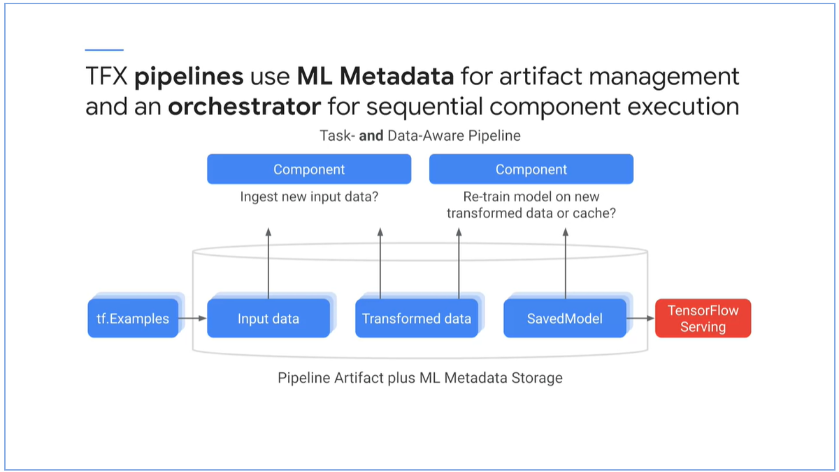

Task and Data-aware pipeline

* A **task-aware pipeline** is capable of running one or several tasks defined in a pipeline. A task can be an **entire** **pipeline run** or a **partial pipeline run** of an individual component and its downstream component.
* Data-aware pipeline stores all artifacts from every component over many executions.
  + Checks whether artifacts have changed from previous runs
  + Avoid re-computation of large dataset. Speed up performance and save resource.



#### Horizontal Layer

* TF horizontal layer coordinate pipeline components.
* Libraries and utilities that simplify development of TFX pipelines across different computing and orchestration environments.

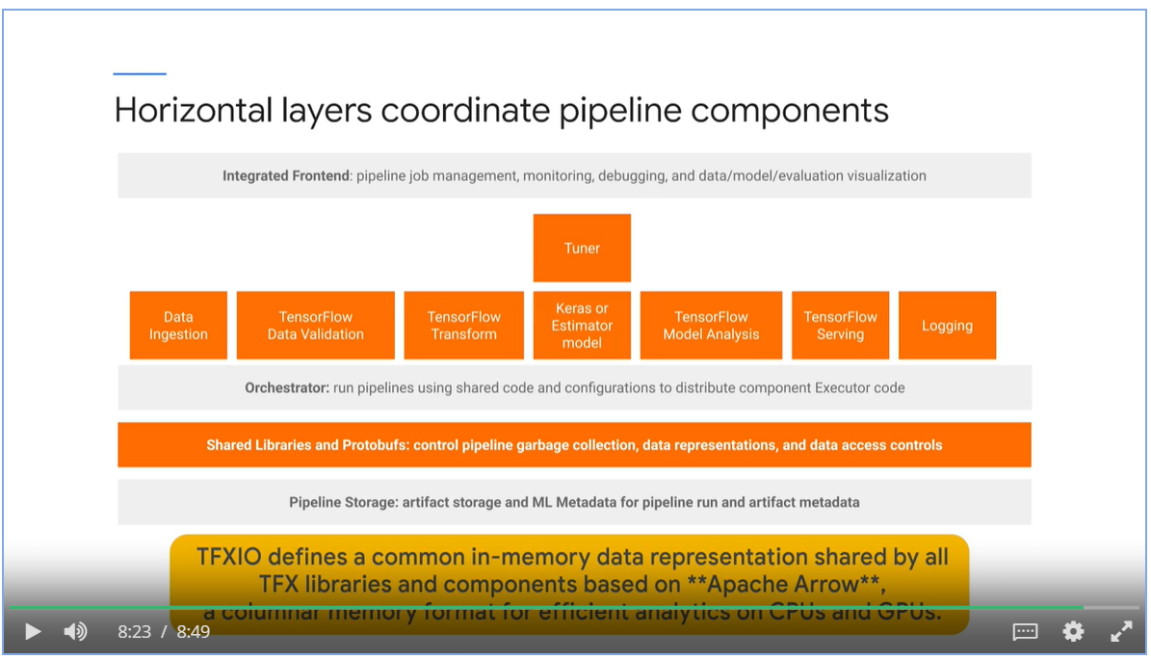

* Integrated front-end
* Orchestrator
* Shared libraries and Protobufs
* Pipeline Storage

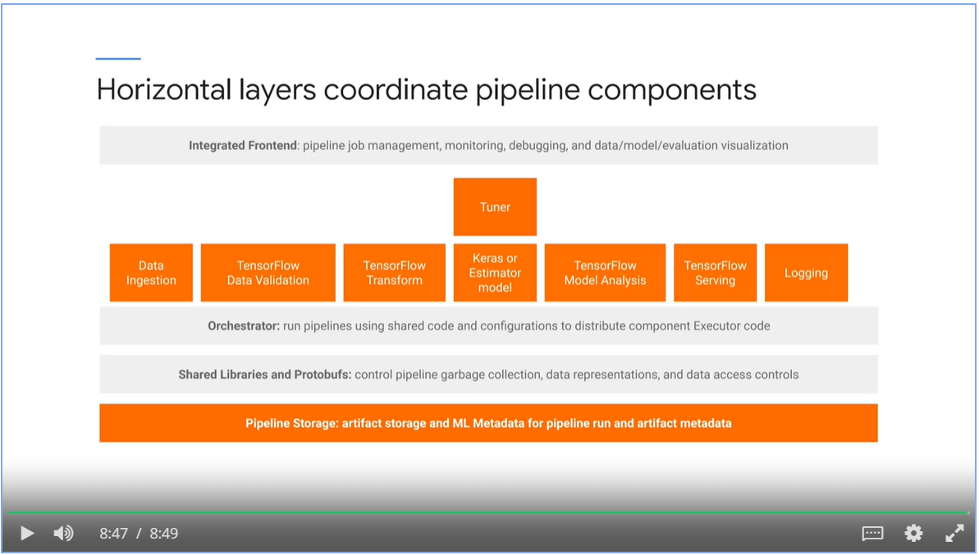

### TFX Standard data components

#### ExampleGen

* Ingest data such as CSV, TF Records, Avro and Parquet.
* Outputs TF examples or TF sequence examples.

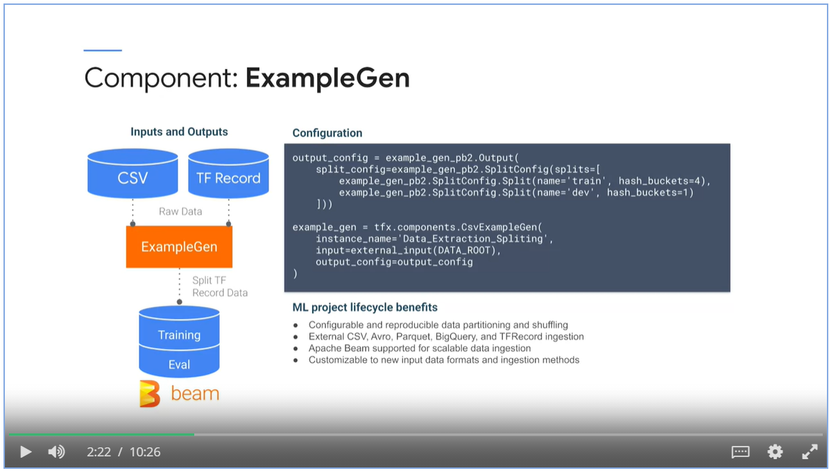

* Supports **data partitioning**, **versioning** and custom **splitting** **on features or time**.
* Organize data using **spans, versions and splits**.
  + Span is a grouping of data, i.e. each file directory represents a span, or each day of data represented as a span.
  + Each span holds multiple versions. i.e. removing outliers creates a new version.
  + One version of span can be divided into splits. i.e. train and test splits.

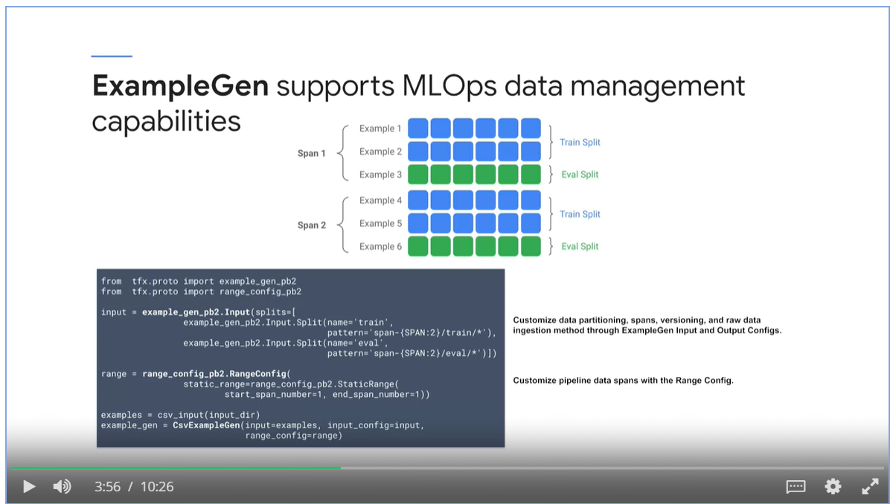

#### StatisticsGen

* StatisticsGen performs a complete pass over your data, using Apache Beam and the TensorFlow Validation library, to calculate summary statistics.
* StatisticsGen takes input using TF examples from ExampleGen.
* StatisticsGen outputs a dataset of statistic artifact.

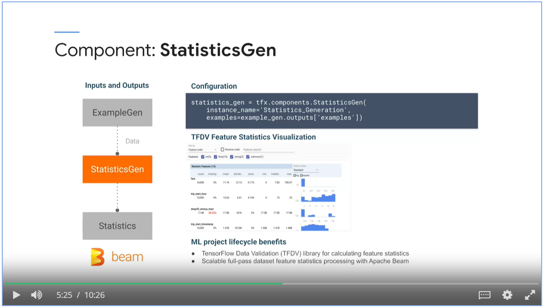

#### SchemaGen

* SchemaGen reads the StatisticsGen artifact to infer characteristics of your input data.
* Produces schema artifact, a schema.proto description of your data.
* TensorFlow Data Validation (TFDV) creates common description of your data using SchemaGen.

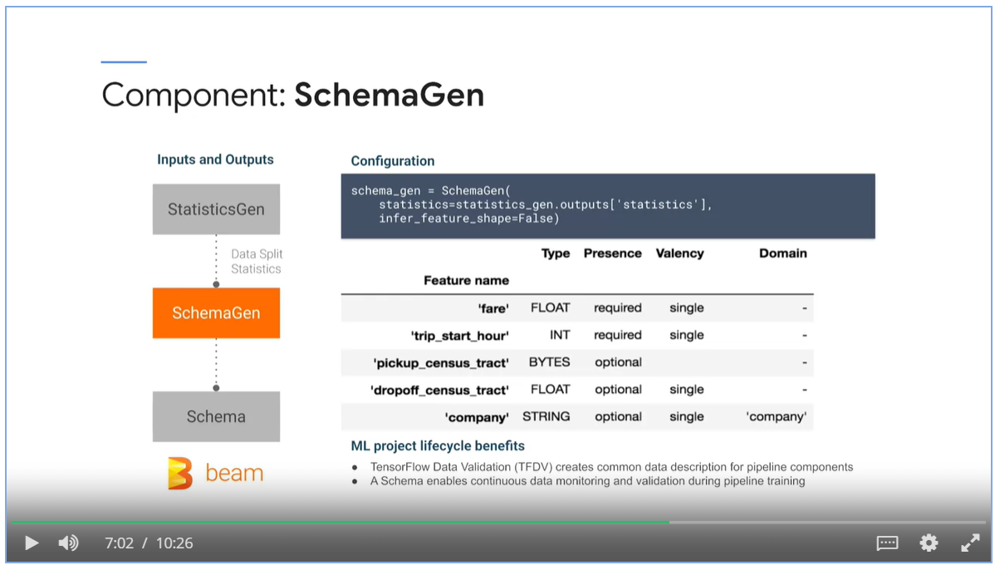

#### ExampleValidator

* Takes StatisticsGen and SchemaGen as input
* Outputs an anomalies report
* Used in data monitoring for detection of anomalies, train-serving skew and data drift.

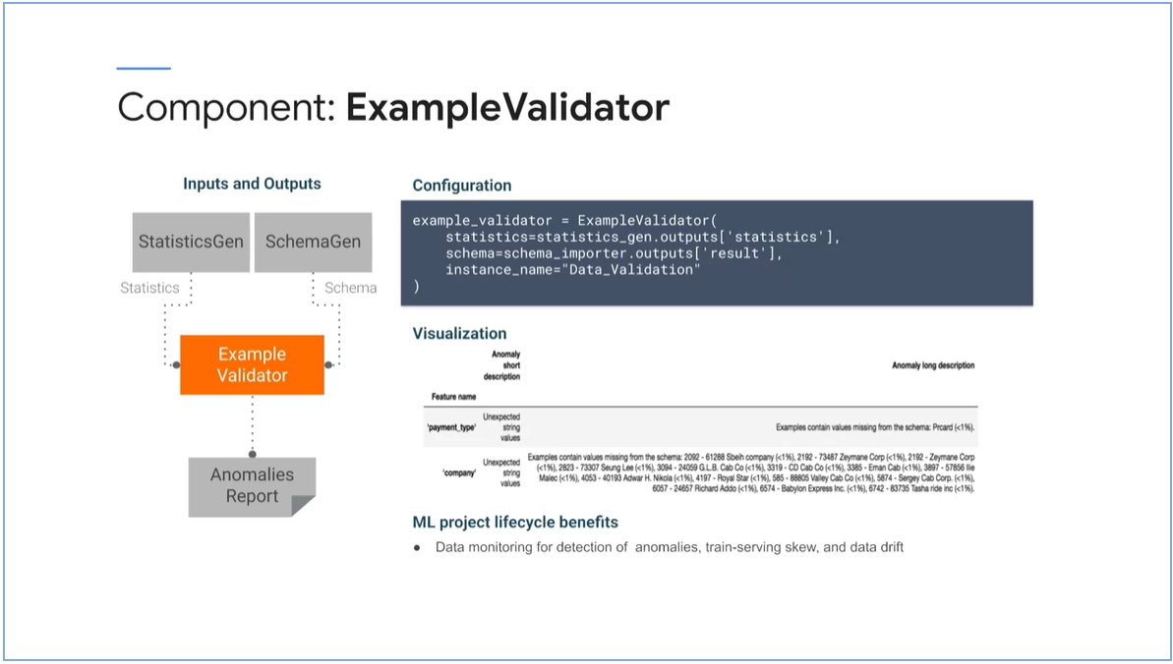

#### Transform

* Performs feature engineering using TF examples from ExampleGen component, using data schema artifact from the SchemaGen.
* Emits a SavedModel and it encapsulates feature engineering logic.

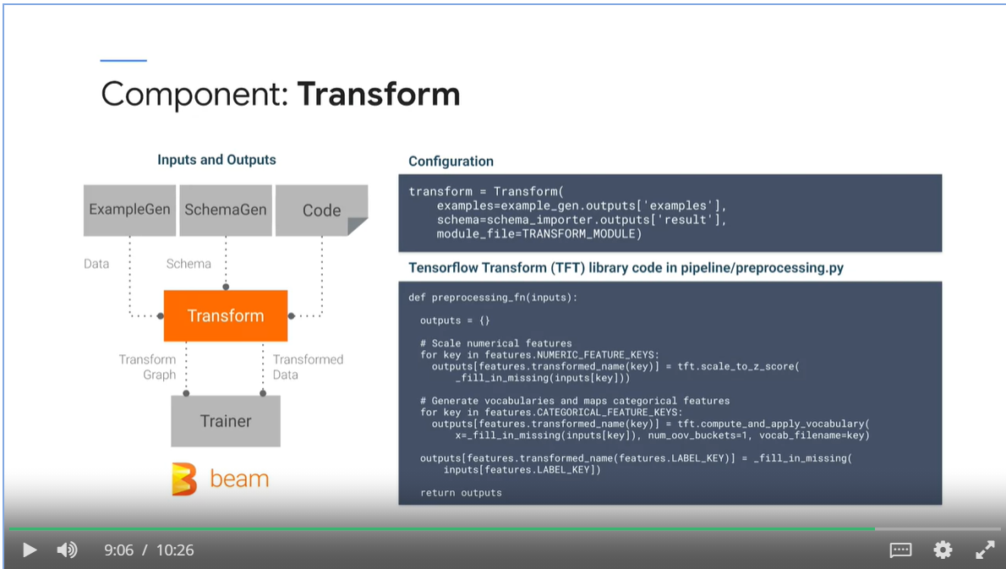

* Generates SavedModel for consistent training and serving feature engineering.
* Backed by Apache Beam for scalable distributed data processing to large datasets.

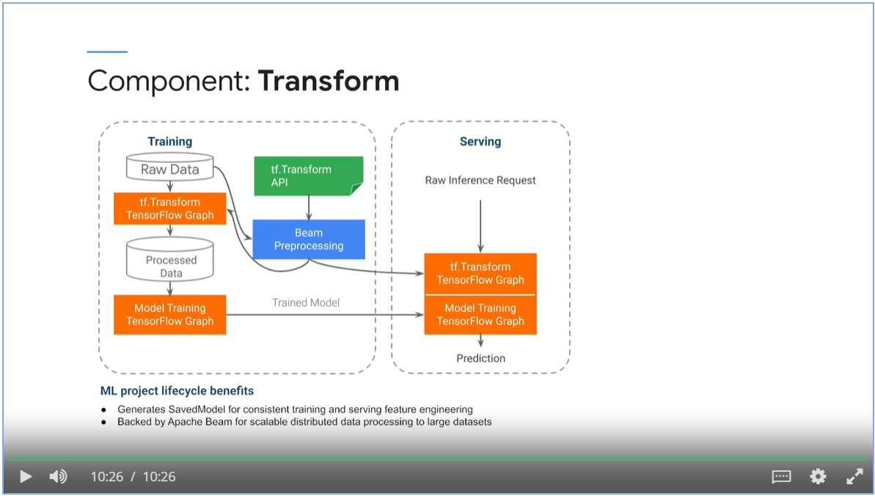

### TFX Standard Model Components

#### Trainer

* A trainer component trains a tensor flow model
* Supports TF1 estimators and native TF2 Keras model via the generic executor.

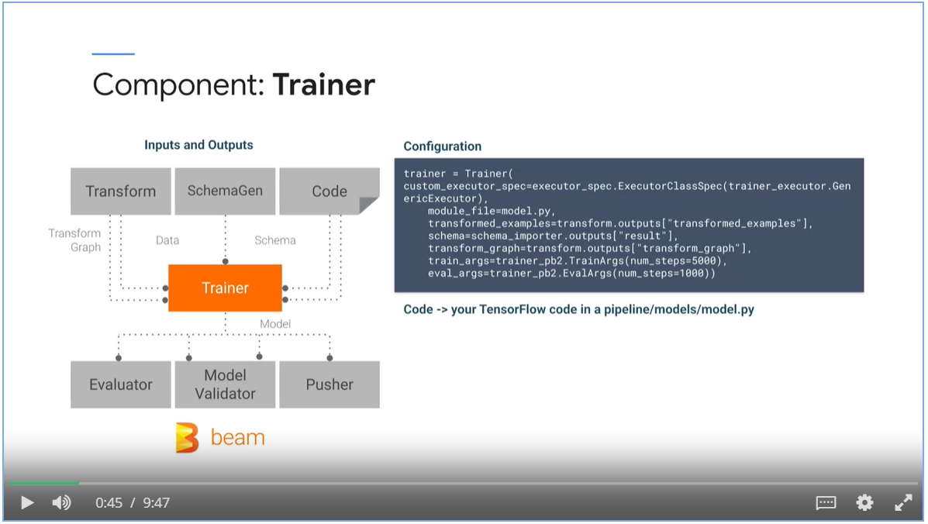

* The Trainer model produces at least one SavedModel for inference and serving.
* An EvalSavedModel is produced optionally. It contains additional information for model analysis.

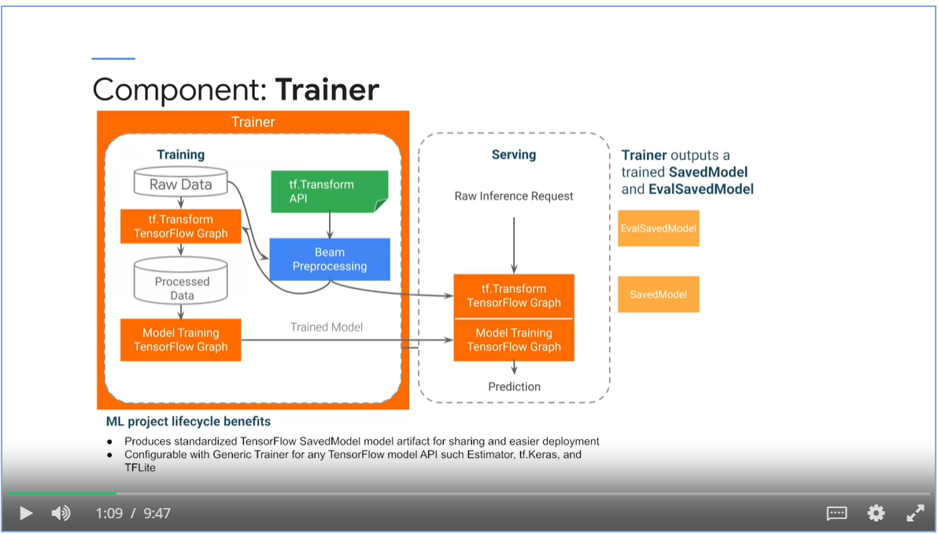

Trainer brings standardization to your ML project

* The SavedModel does not require the original model building code to run, which makes it portable and easy to deploy.
* SavedModel can utilize TensorFlow Distributed APIs, for distributed training.

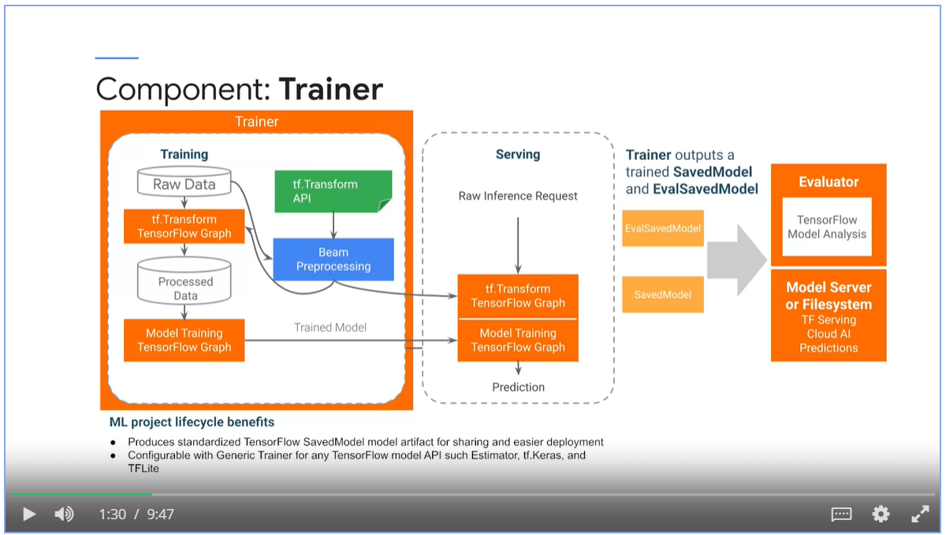

#### Tuner

* Takes in transformed data in transform graph artifacts.
* Outputs a hyperparameter artifacts
* Due to computational cost, we run tuner component as a one-off execution.
* Tuner component can take advantage of two services: AI Platform Optimizer and AI Platform training.

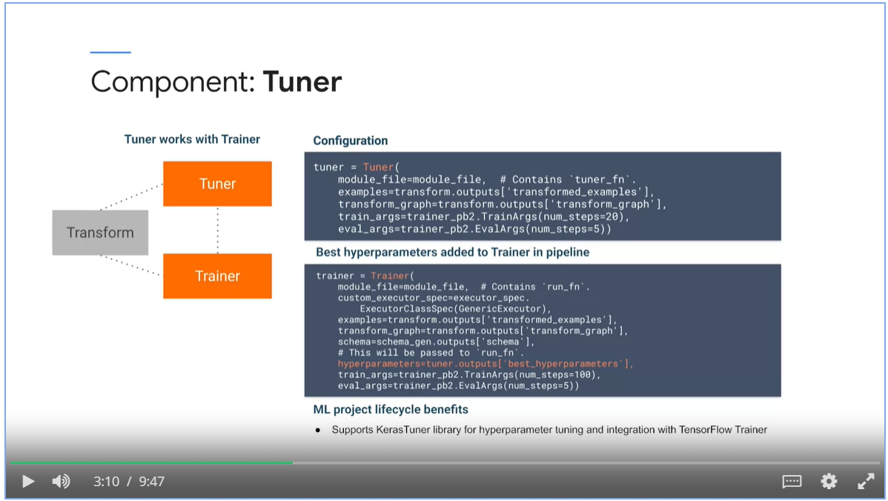

#### Evaluator

* Input: Data from ExampleGen and SavedModel from Trainer
* Evaluator performs thorough analysis using the TensorFlow model analysis library.
* It is **not enough** to look at model performance at a **high level**, you need to look at the **individual slices** of your dataset.
* Output
  + evaluation artifact that contains configurable model performance metrics slices.
  + Model blessing artifact that indicates whether the model performance is above a threshold and ready for production.

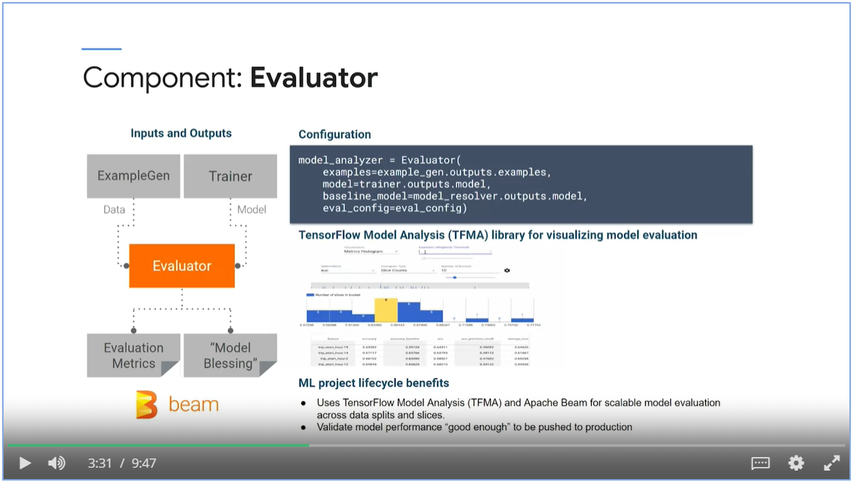

#### InfraValidator

* An Evaluator guarantees the performance of the model. An InfraValidator guarantees that the model is mechanically fine.
* It validates the model in the actual model serving infrastructure.
* Mirror model serving environments such as Kubernetes clusters and TF serving.

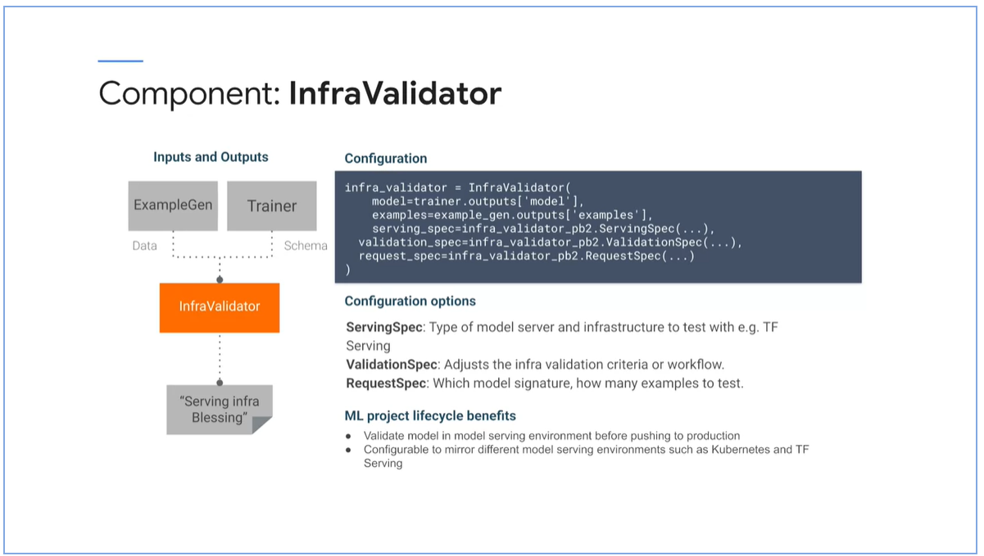

#### Pusher

* Inputs: Blessing from Evaluator and Blessing from InfraValidator
* Pushes the model to production.

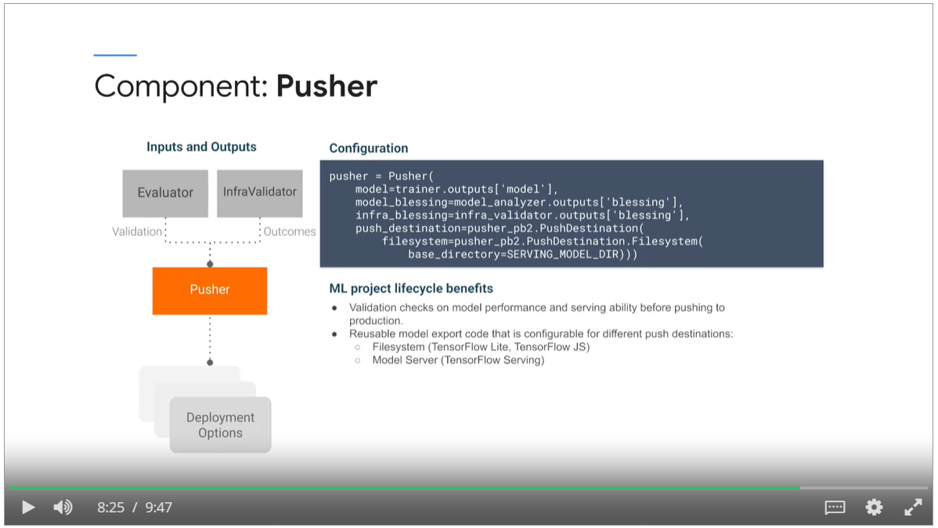

#### BulkInferer

* Perform batch inference
* Deployed after an evaluator to performance inference with a validated model.
* Or Deployed after an trainer component to directly perform inference on an exported model.
* Performs in-memory or remote inference. Remote inference requires the model to be hosted on Cloud AI Platform.

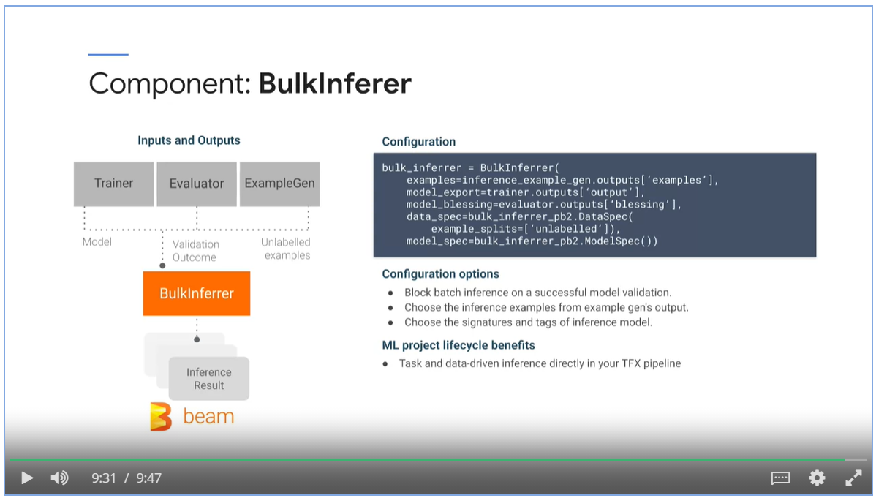

### TFX Pipelines Nodes

* Pipeline nodes are special purpose classes for performing advanced metadata operations
* Importing external artifacts into ML metadata, performing queries of current ML metadata

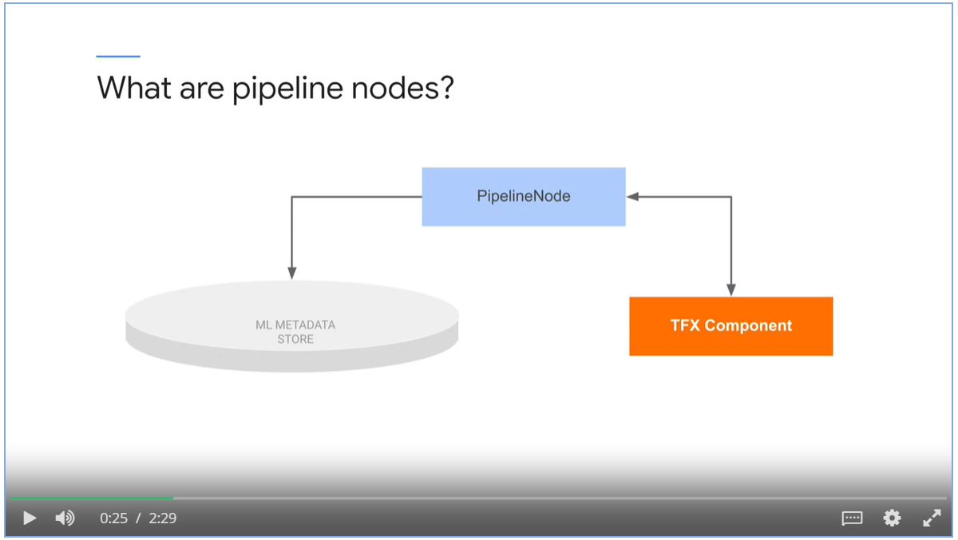

ImporterNode imports an external data object into ML Metadata.

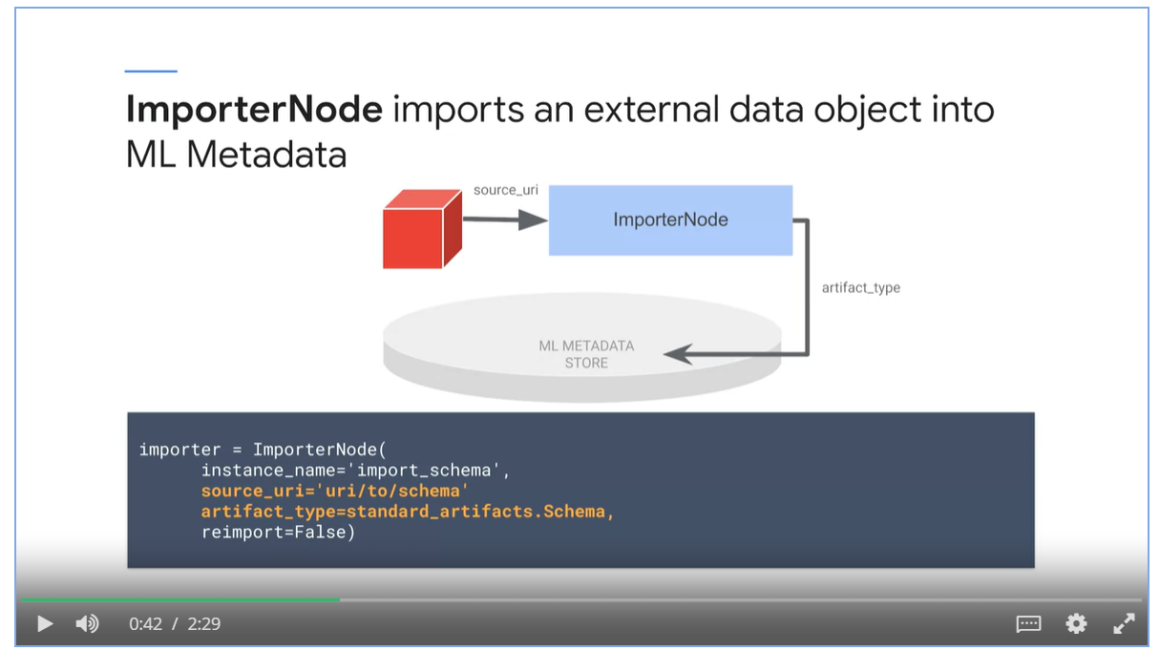

* Resolver nodes handles artifact resolution logistics that will be used as inputs for downstream nodes.

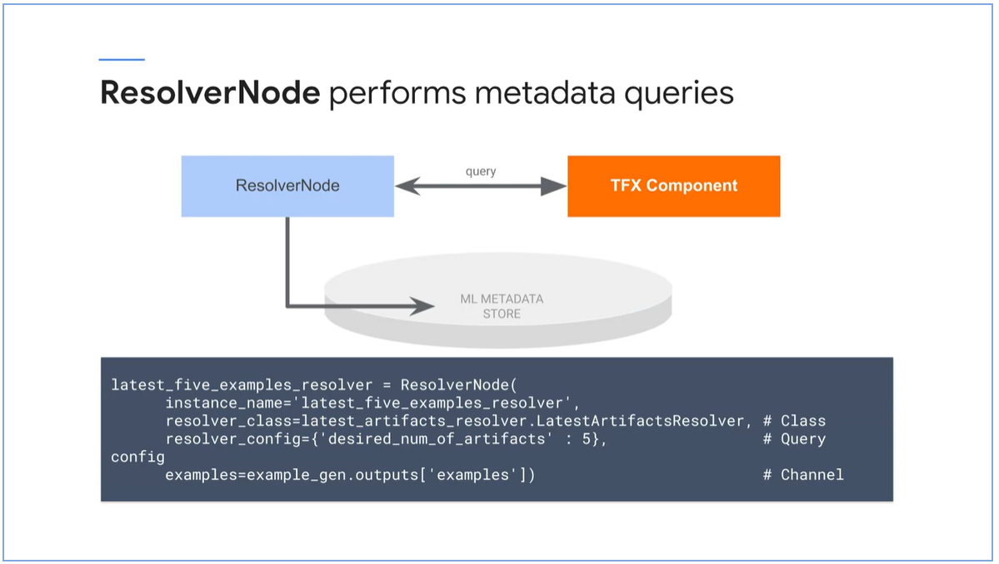

### TFX Libraries

* TFX components are underpinned by TFX libraries

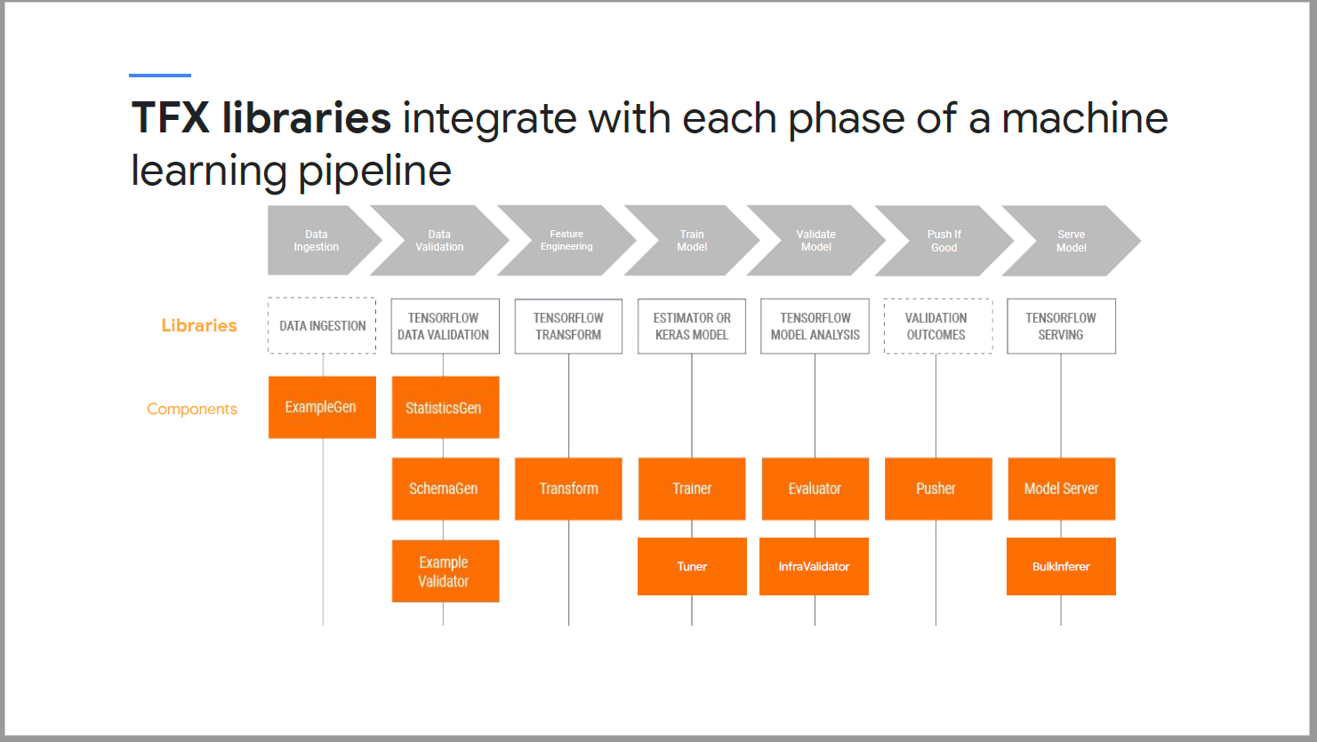

#### TensorFlow Data Validation (TFDV)

* TensorFlow Data Validation (TFDV) for analyzing and validating data.

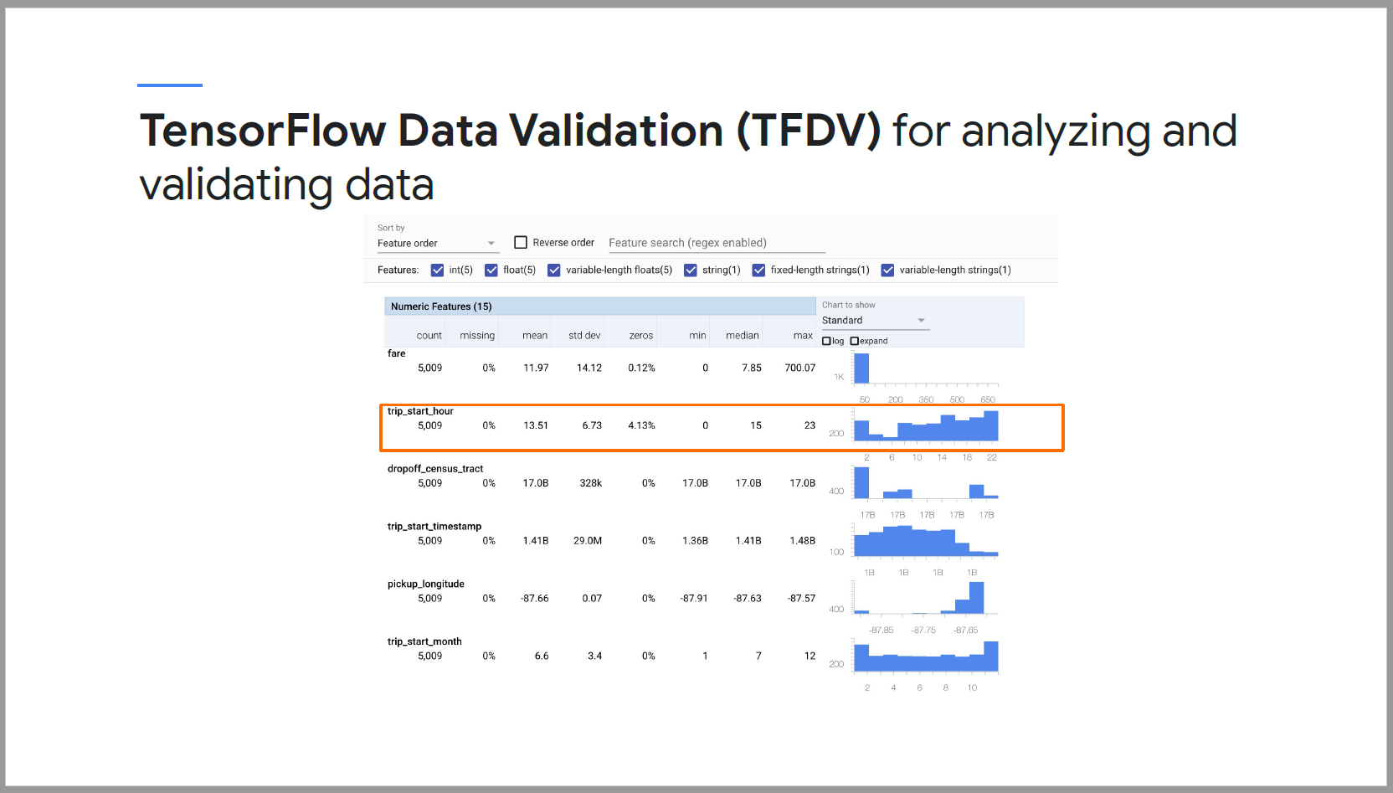

#### TensorFlow Transform (TFT)

* TensorFlow Transform (TFT) for preprocessing data and feature engineering with TensorFlow
* Scalable full-pass dataset transformation

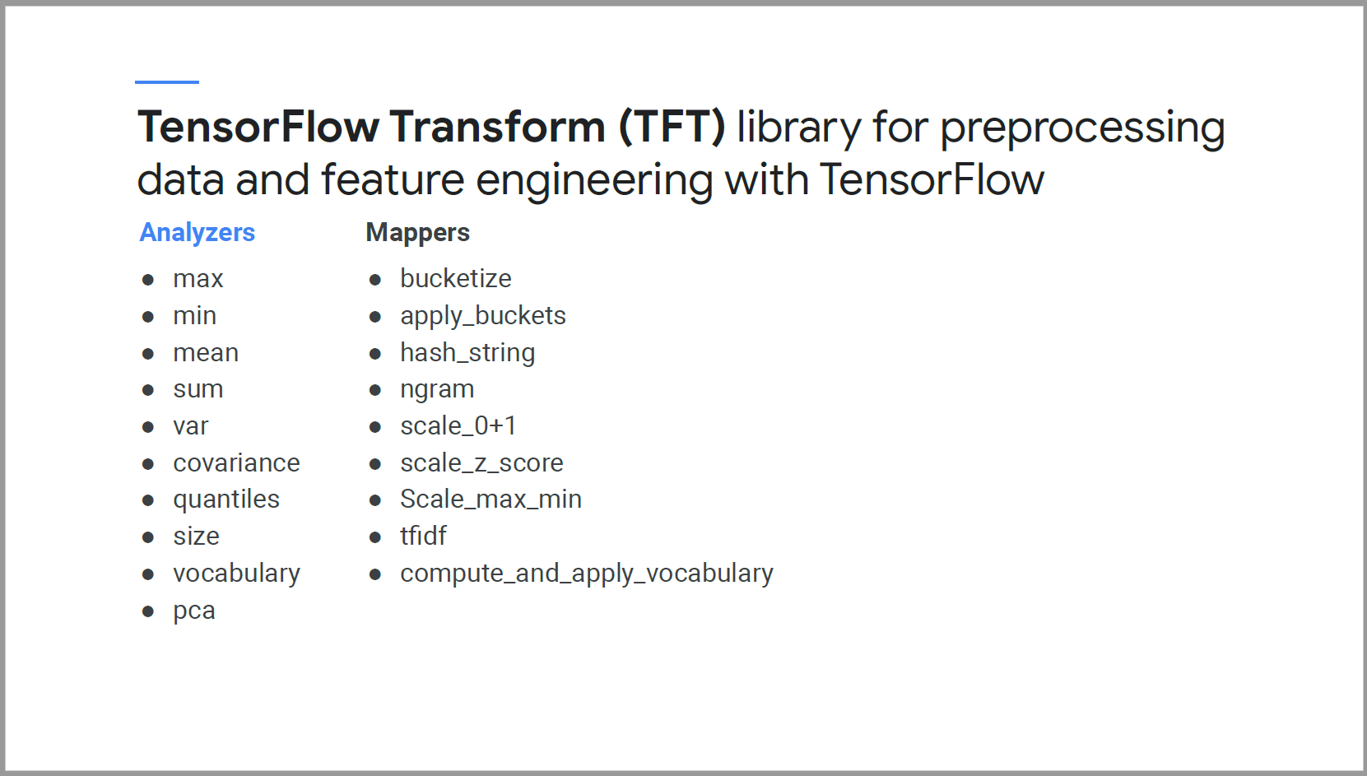

* Encodes ML best practices on feature engineering directly into your TensorFlow graph for preprocessing input data consistently for model training and serving. Reduce training serving skew.

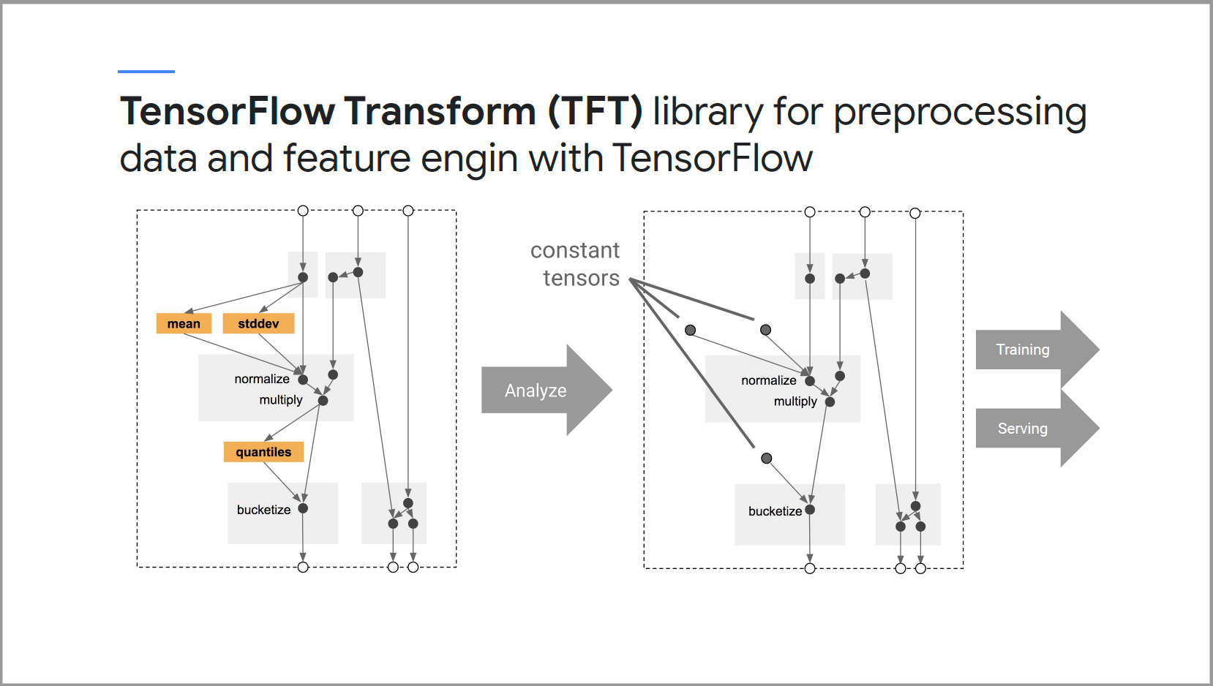

#### TensorBoard

* Trackinng and visualization metrics, such as loss in accuracy
* Visualizing the model graph, including operations and layers, viewing histograms of weight biases
* Projecting embeddings to a lower-dimension space
* Display images, text and audio data
* Profiling TensorFlow programs.

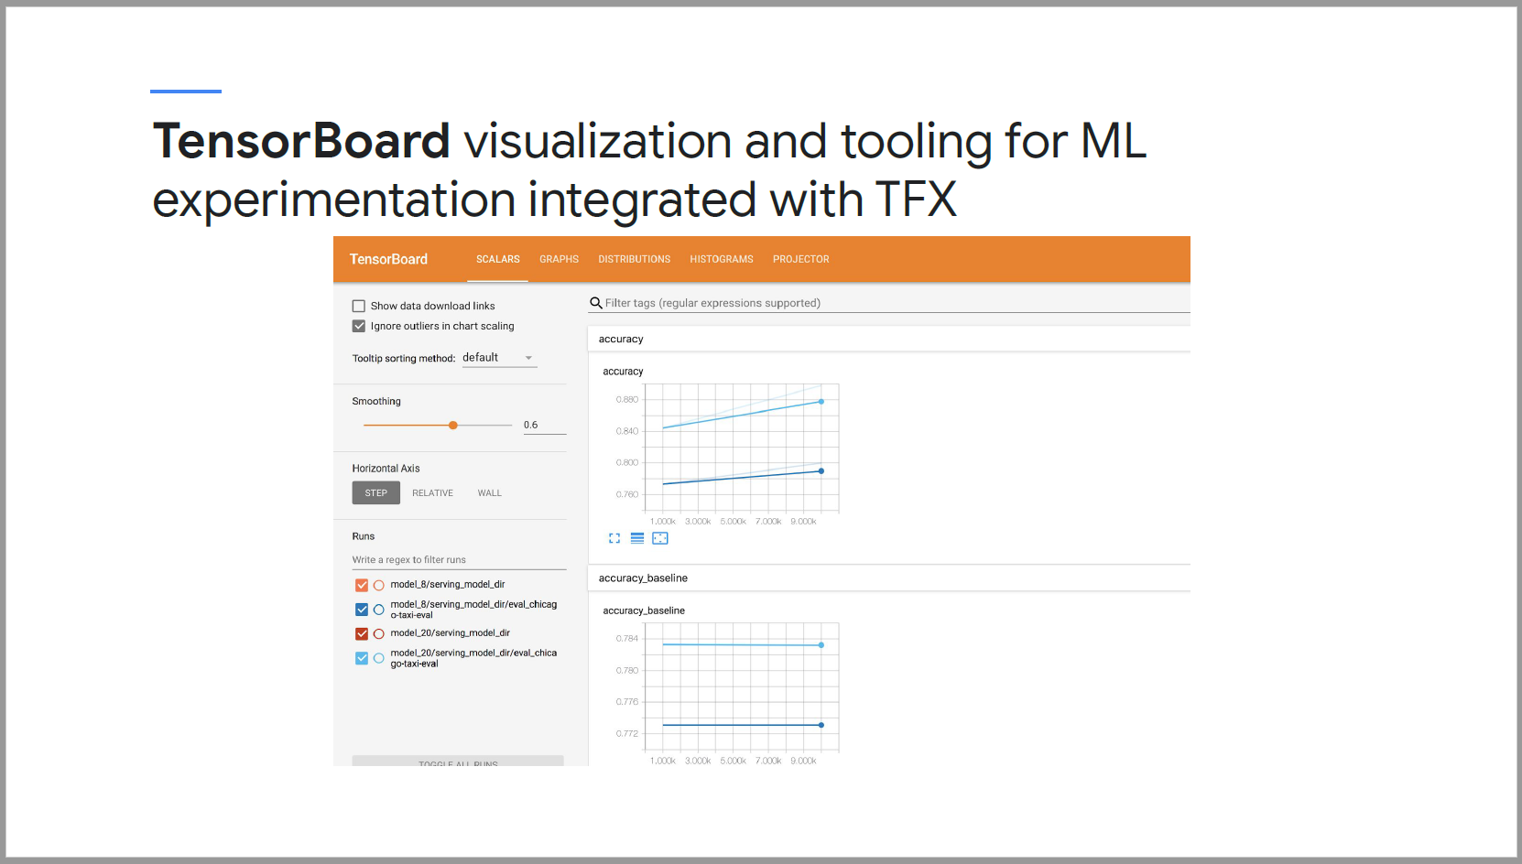

#### TensorFlow Model Analysis (TFMA)

* Compute and visualize model performance for slices of the data.
* Uses Apache Beam to scale model evaluation with your data, adjust TF examples with a series of instructors and evaluators.

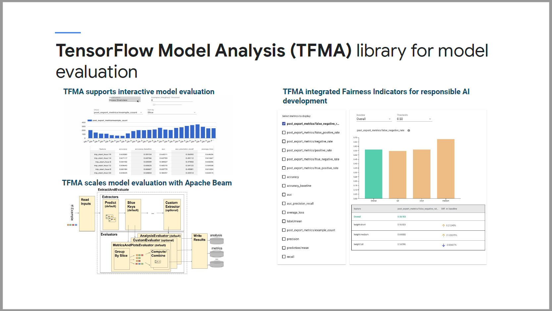

* TensorBoard evaluates the whole model via checkpoints during training
* TFMA computes and visualizes metrics using an exported eval/saved model format in batch to give you much deeper granularity on your model performance across slices.

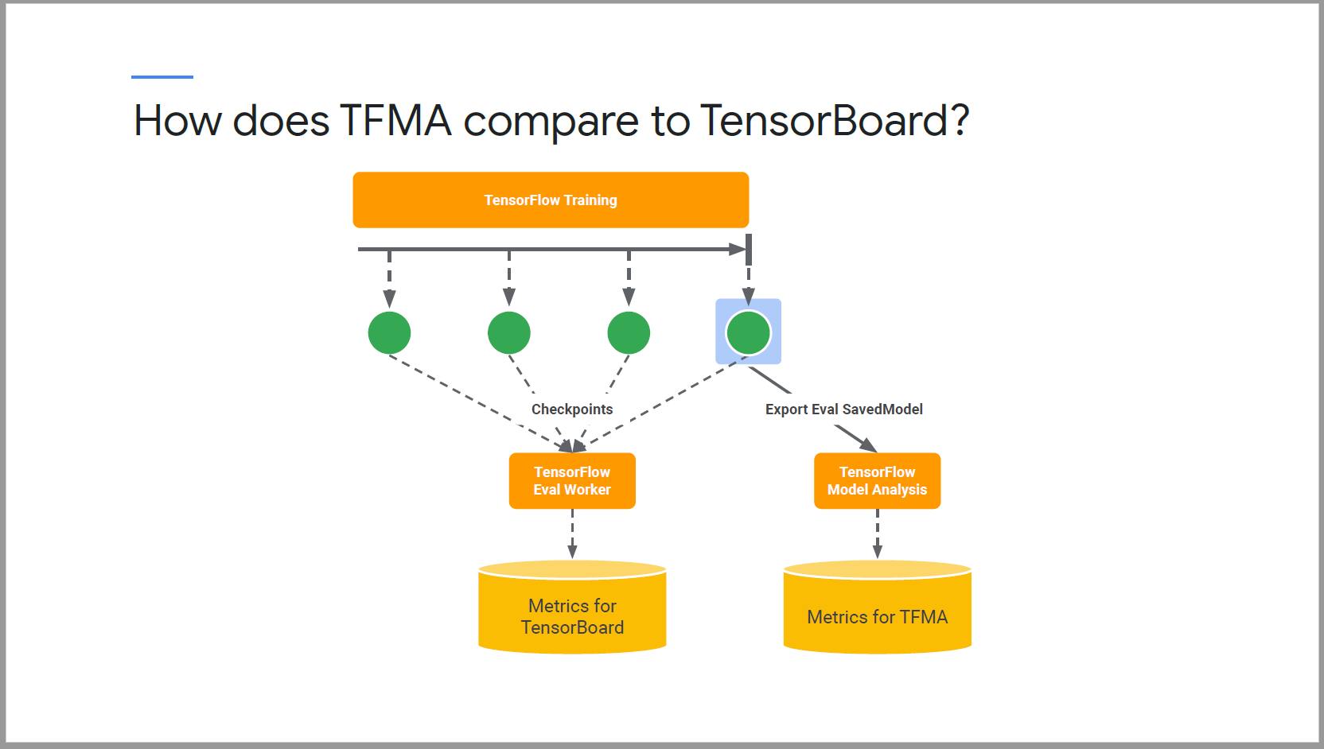

## Week 2 – Pipeline orchestration with TFX

### TFX Orchestrators

* Standardization software engineering best practices to machine learning workflows.
* Without orchestration, teams will face unique project setups, arbitrary log file locations, unique debugging steps and quickly accumulate costly technical debt.

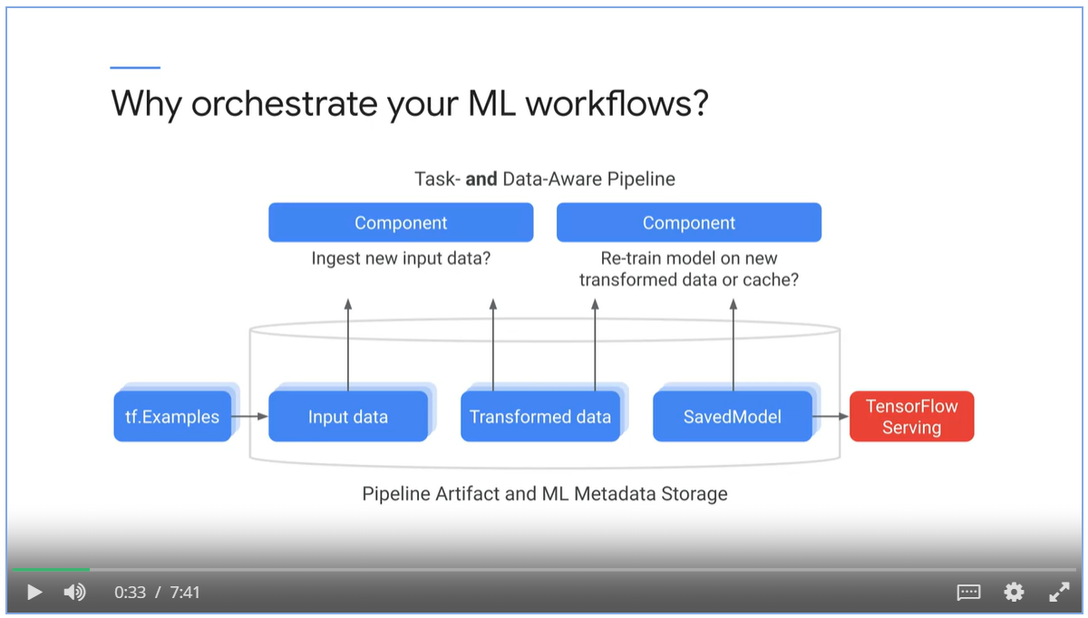

* TFX orchestration begins with in a Juypter notebook.
* Build the pipeline interactively using InteractiveContext.

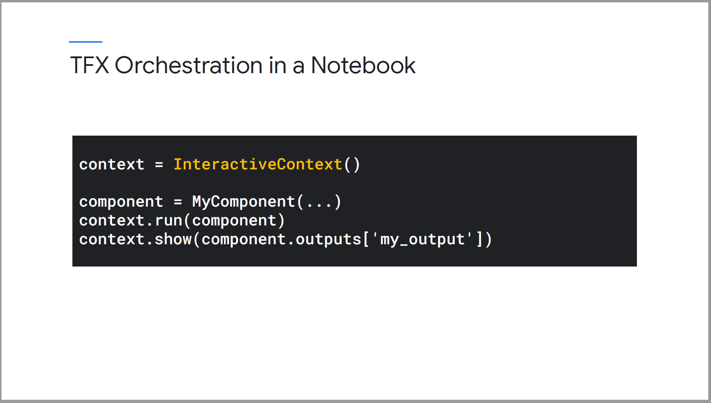

* Notebook does not have level of automation for continuous training and computation for production ML.
* Orchestrators serve as a level of abstraction that sits over the computing environment that supports scaling.
* TFX pipelines are portable across orchestrators.

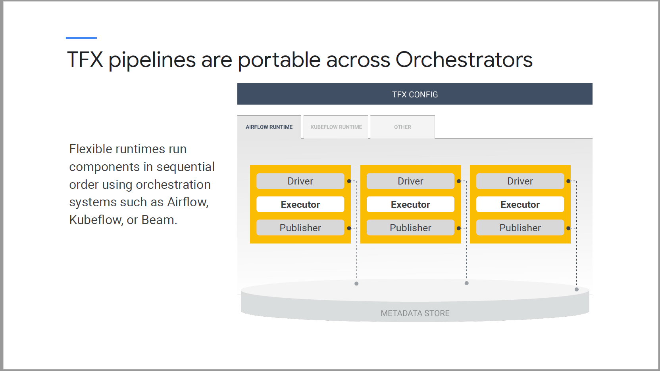

TFX pipelines support 3 orchestrators

* Apache Airflow, Apache Beam and Kubeflow Pipelines.

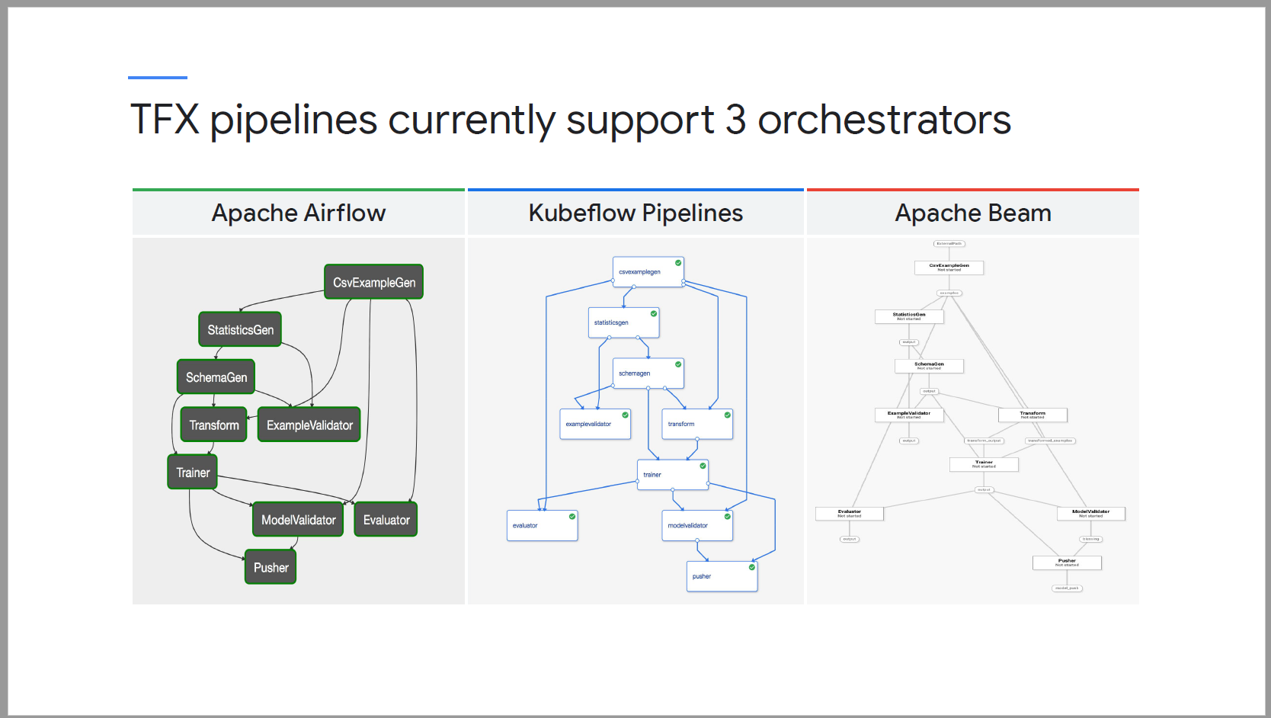

#### Apache Beam

* Use Apache Beam direct runner to orchestrate and execute the pipeline DAG.
* Package your pipeline define in a notebook into pipeline.py using interactive context
* Execute your file locally using the direct running to debug and validate.
* After validation, run pipeline using the beam runner on distributed compute environment, such as GCP.

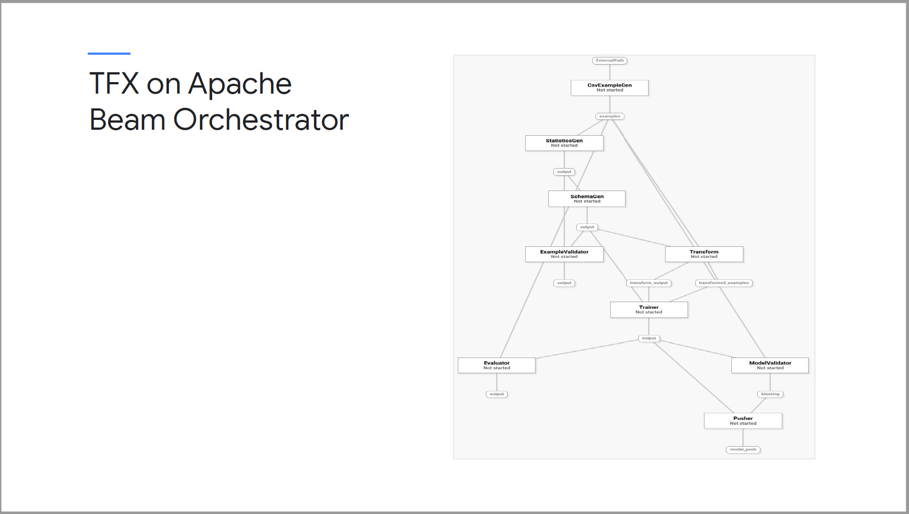

#### Kubeflow

* TFX pipelines runs on top of the Kubeflow flow pipelines orchestrator on GCP for hosted and managed pipelines.
* Kubeflow pipelines includes hosted ML metadata store container and a UI to develop, run and manage ML tasks.
* KFP allows you to set up service account for secure access to GCP services such as Cloud Storage.

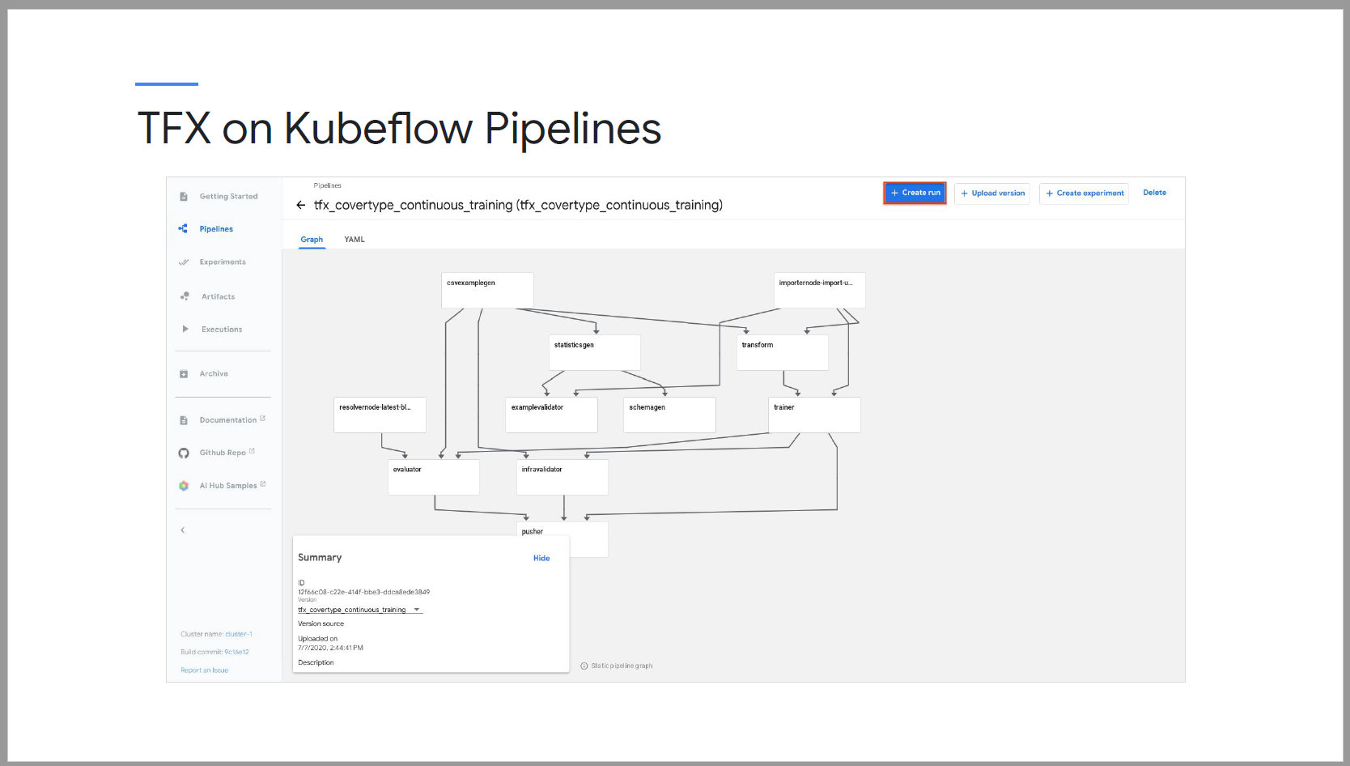

#### Airflow

* Airflow is a mature platform to programmatically author, schedule and monitor your workflows.
* GCP has a fully managed version of airflow called composer that tightly integrates with services such as BigQuery and Dataflow.

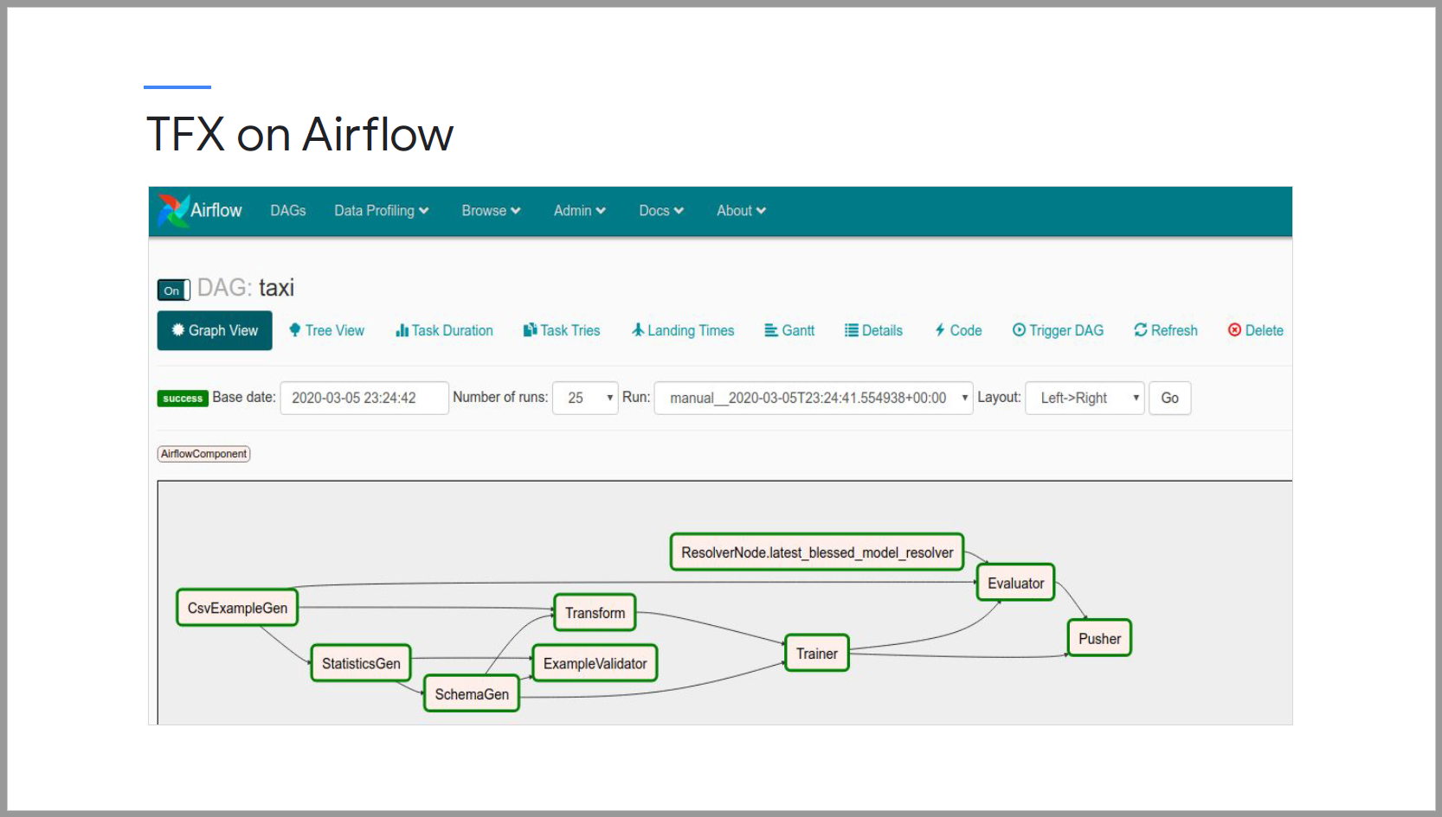

Command line interface

* Supports a full range of pipeline actions using pipeline orchestrators such as airflow, beam and Kubeflow pipelines

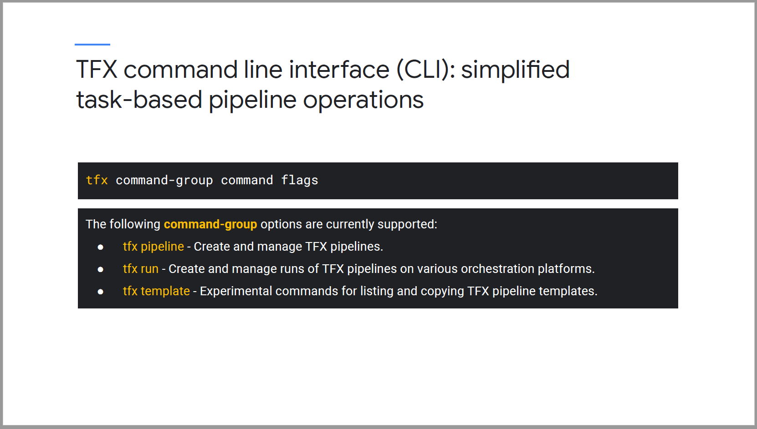

### Apache Beam

* Beam is an abstraction with incredible flexibility and unification of batch and stream data processing capabilities that underpins TFX pipelines.
* Several TFX libraries use Beam for running task with high degree of scalability across compute clusters.
* Beam includes support for a variety of execution engines, such as a direct runner that runs on a single compute node.

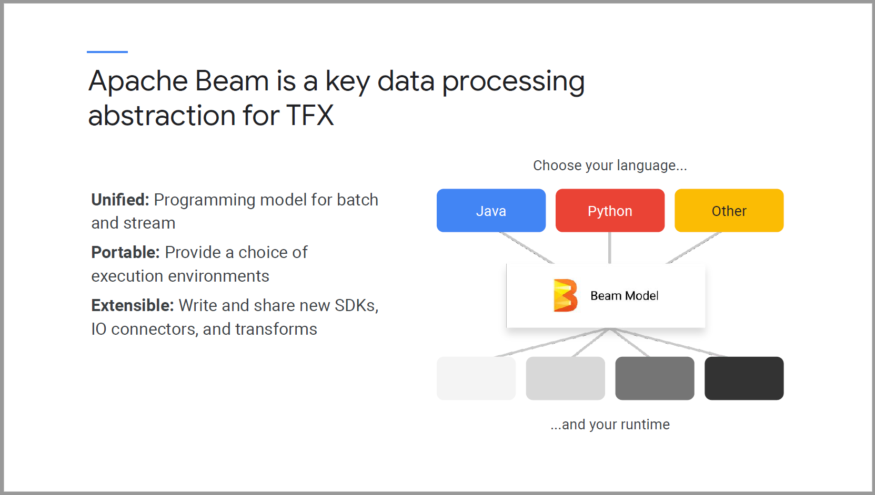

Apache Beam scales TFS component libraries

* Data ingestion, TF Data Validation, TF Transform, TF Model Analysis and TF Serving are all underpinned by Beam.

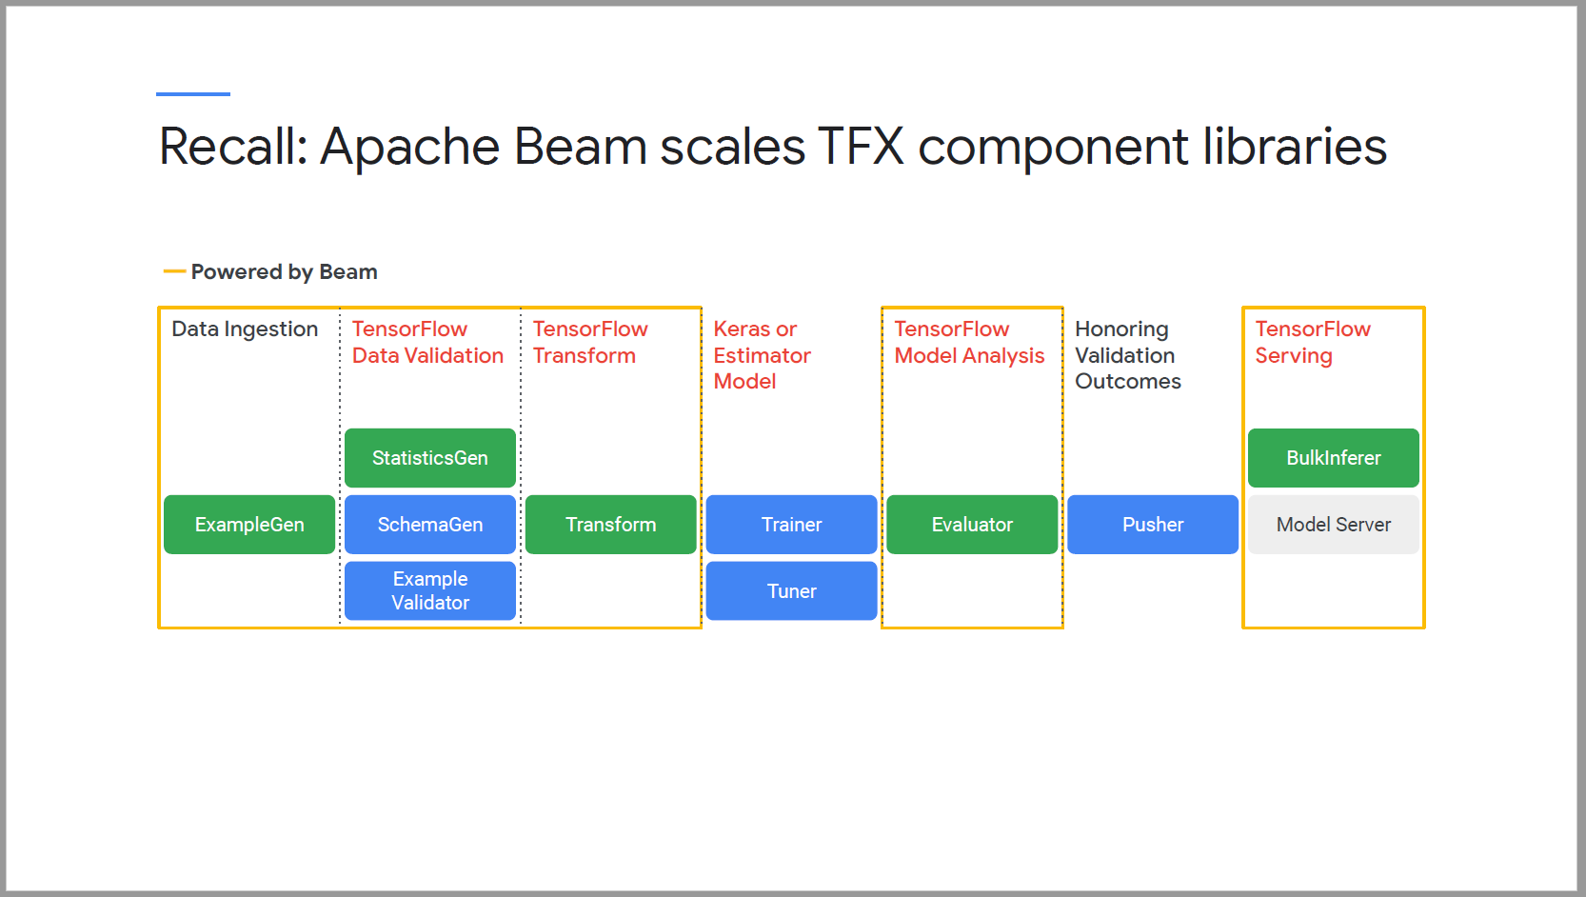

How TFX components use Beam

* Beam SDK can work with numerous runtimes, including full operating systems, python or docker container.
* It translates tasks on runtimes to distributed compute cluster via runner.
* Components wrap-up component executor code in Beam pipelines, send them off and get the results back across multiple different runners such as Spark, Flink and Google Cloud Dataflow.

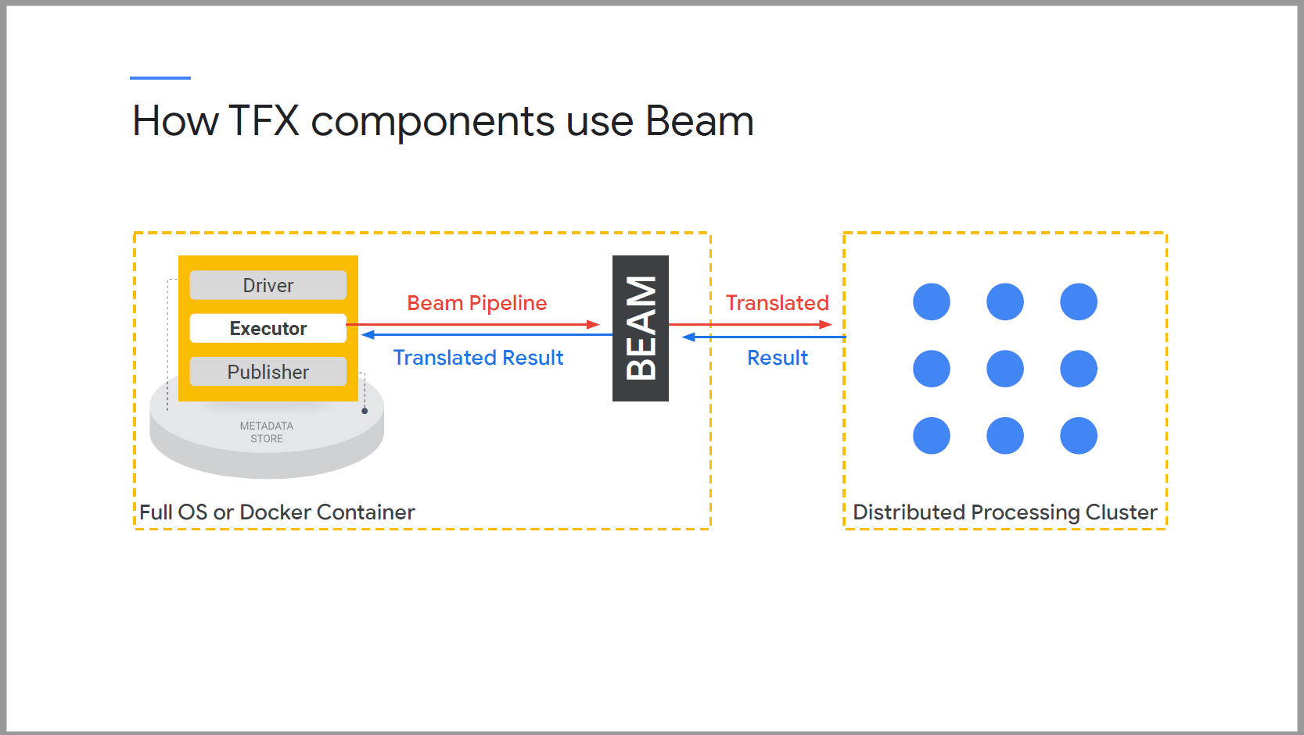

#### Beam primitives:

* Pipeline: Entire set of operations to be performed.
* PCollection: An unordered set of data, for input and output for PTransform.
* PTransform: Transfomrs a PCollection. It creates a new PCollection without modifying the old one. ParDo executes user custom processing logics, possibly in a parallel fashion.
* IOTransform writes to data sources.

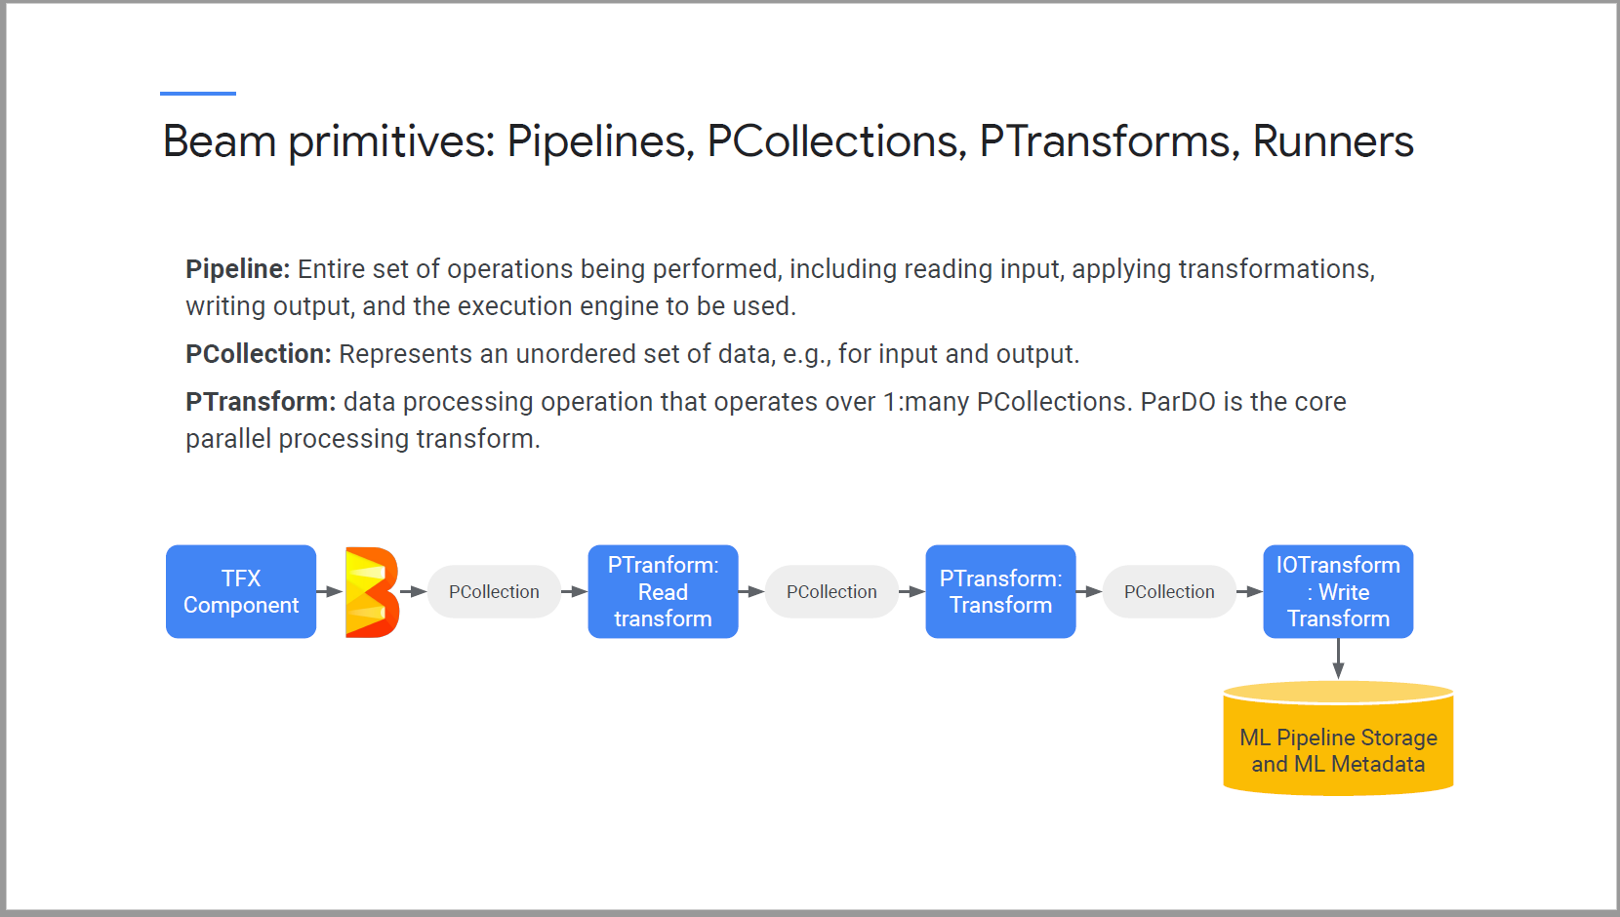

* Runner translate pipelines to parallel big-data processing system.
* TFX runner supports for local testing and debugging
* TFX runner supports Kubeflow DAG runner for Google Cloud.
* Dataflow is the Apache Beam runner for Google Cloud
  + Event times, watermarks, triggering and full management of resources at low-level detail.

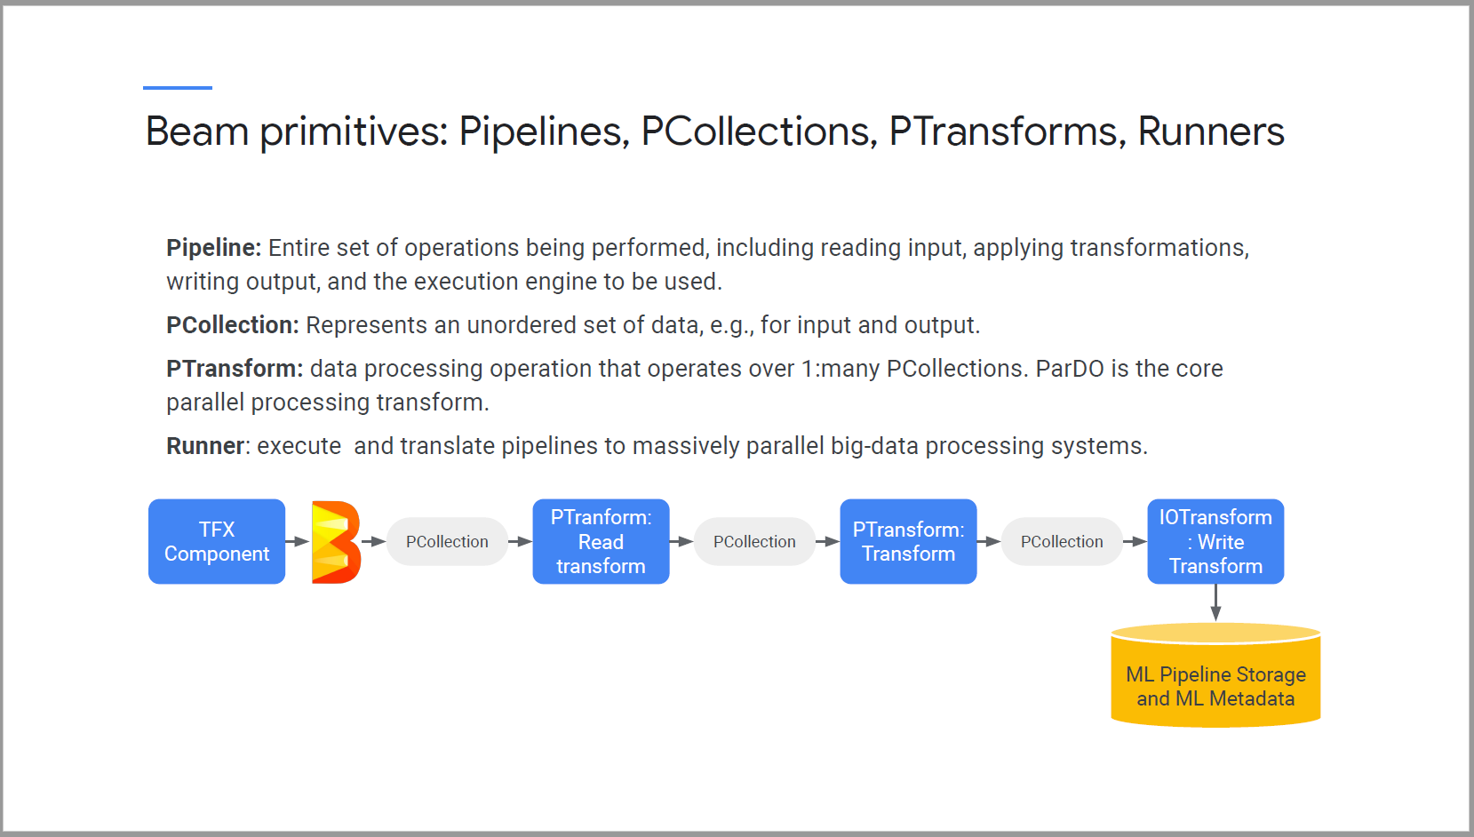

Example of TFD data processing with Apache Beam

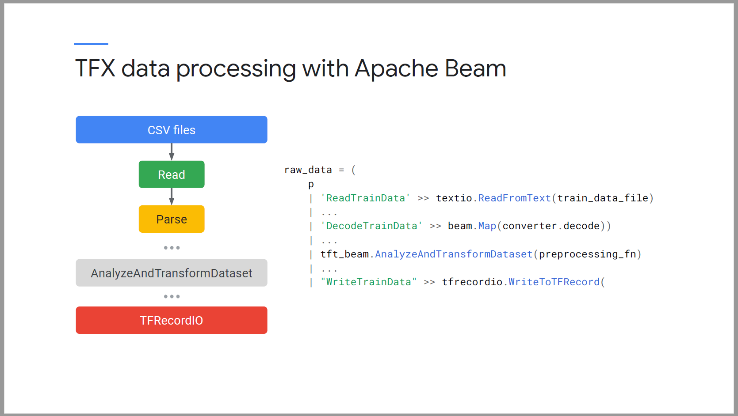

* Each Beam supported component is translated into a Beam graph.

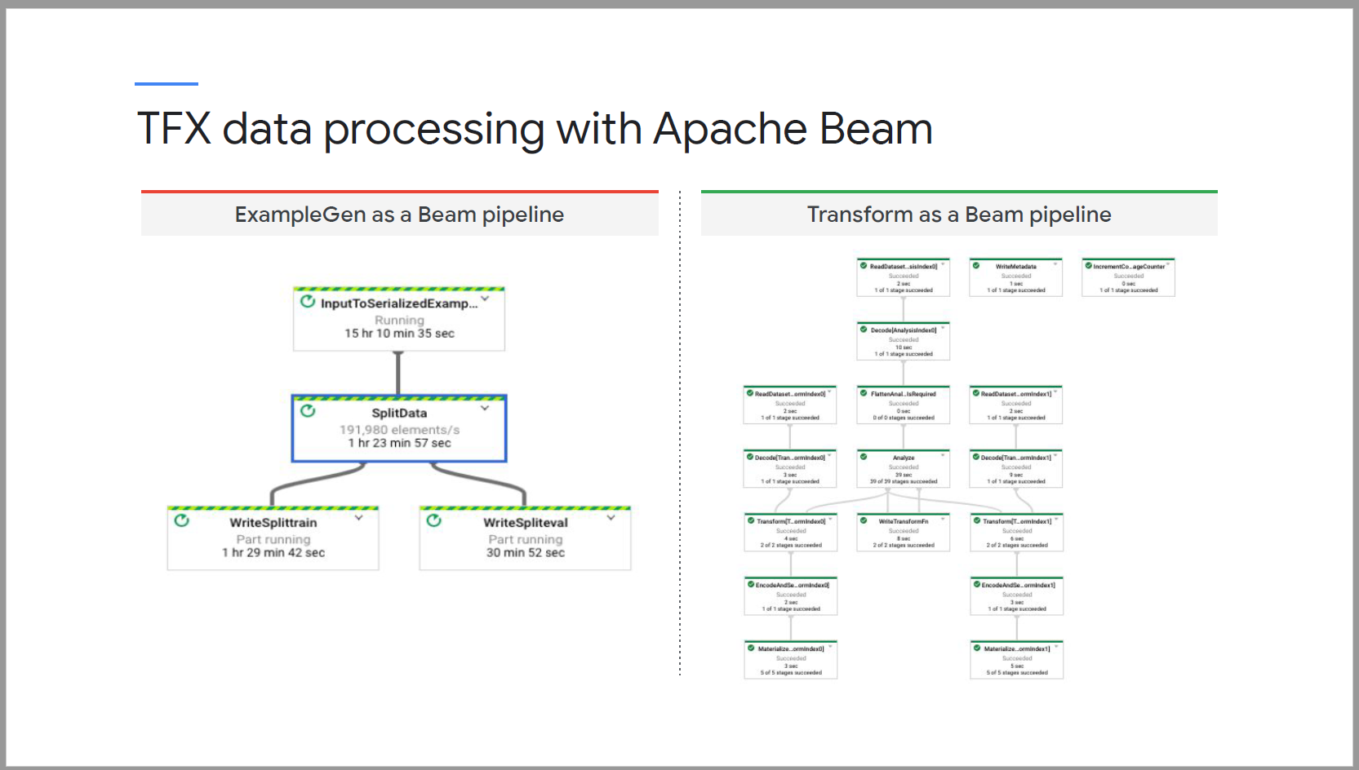

TFX BSL library is the horizontal layer of abstraction to extend or create new TFX Beam pipeline operations.

It interacts with ML metadata and Cloud storage for metadata operations.

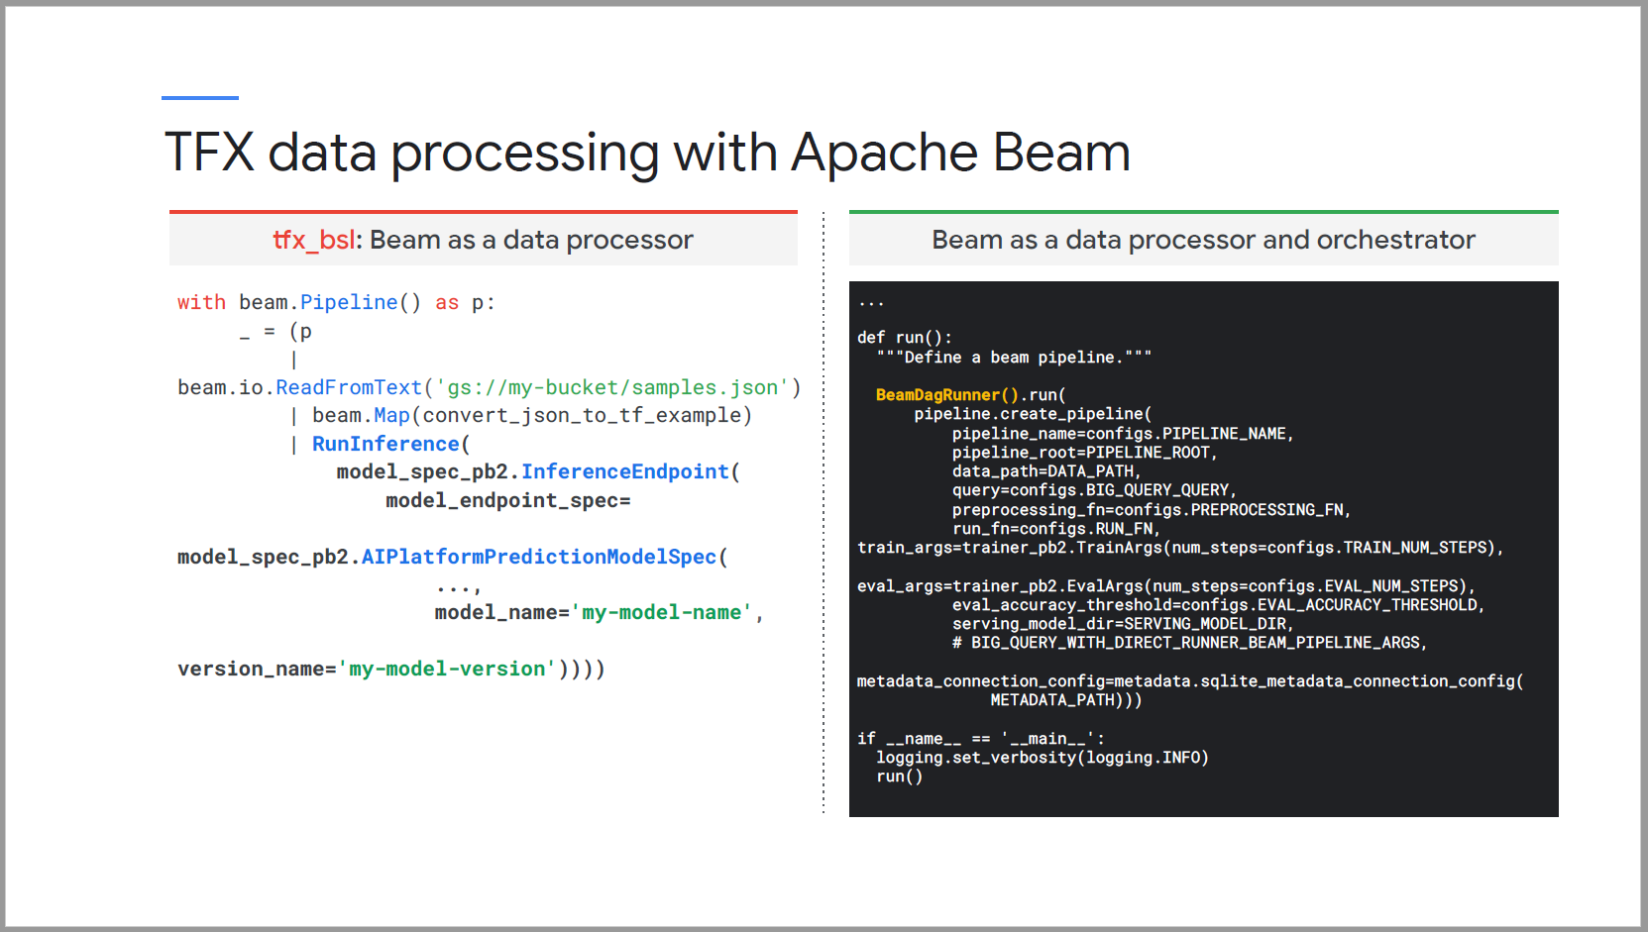

### TFX on Cloud AI Platform

#### High-level Architecture of TFX on Google Cloud

* On GCP, TFX runs on top of an AI platform Kubeflow pipelines instance
* Kubeflow Pipeliens runs on top of a Google Kubernetes Engine cluster. GKE coordinates the execution of the actual pipeline jobs. As well as host ML metadata.

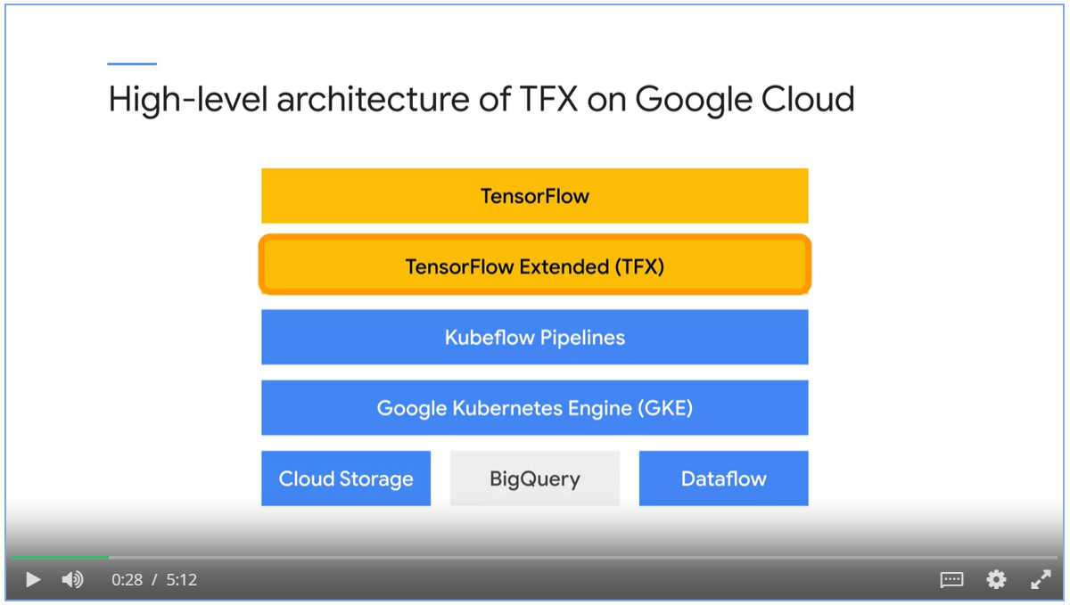

* TFX simplifies standardized pipeline directory management for artifacts and metadata on local file system.
* It can also be extended to Cloud storage.

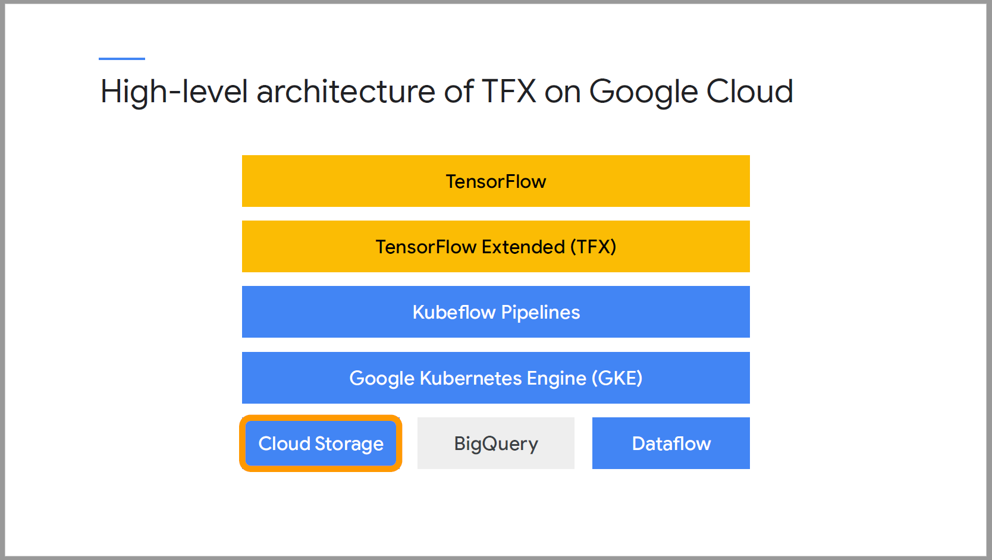

#### Detailed view

1. TFX domain specific language for pipeline authoring takes a user defined “pipeline.py” file, which includes a mix of standard and custom component.
2. TFX SDK translate pipeline description into Kubeflow pipeline YAML file that can be executed with a Kubeflow DAG runner.
3. Your TFX pipeline is now a Kubeflow pipeline, runs on a GKE cluster. The Argo workflow engine coordinates your pipeline componetns, ML metadata is stored on a persistent disk on your GKE instance.

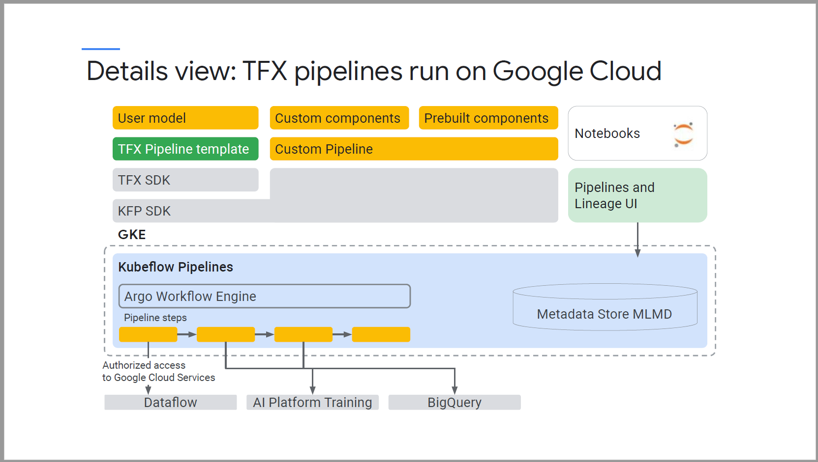

##### Components powered by DataFlow

* For standard data and model components that use Apache Beam to implement data parallel pipelines, Google Cloud Dataflow manages the execution of the data processing workflows.

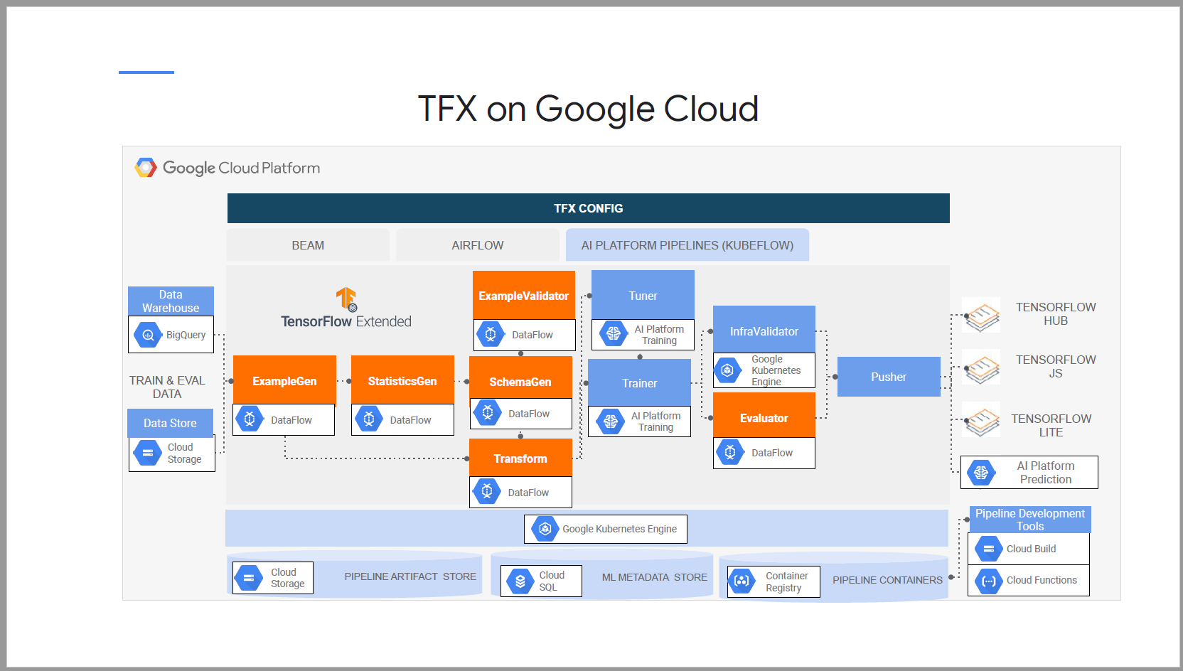

##### Support for BigQuery and Google Data Store.

* BigQuery ExampleGen takes SQL queries and generate TF records to feed into the pipeline
* ExampleGen supports data ingestion from Data Store, google storage file system, distributed using glob file pattern.

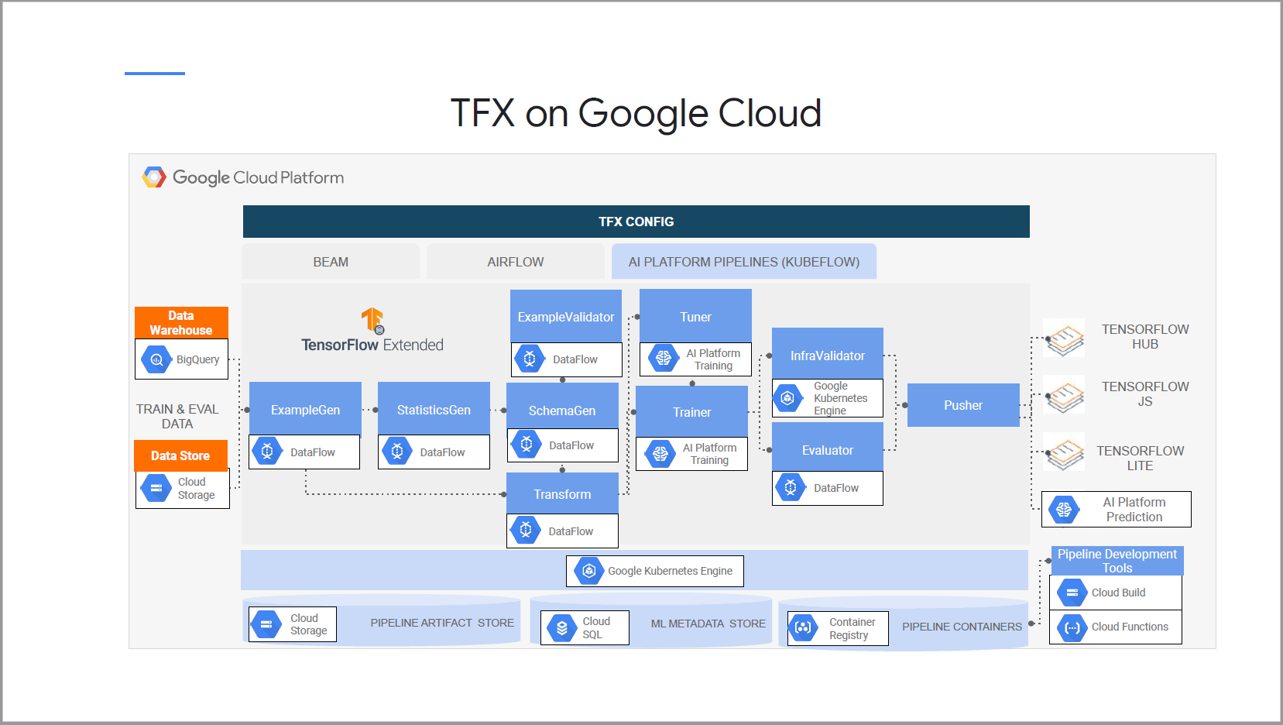

##### Components powered by Cloud AI Platform

* A custom trainer component runs TensorFlow jobs on Cloud AI Platform training.
* A custom tuner component runs on Cloud AI Platform using Keras tuning API.
* A custom pusher component pushes TFX model to Cloud AI Platform for model serving.

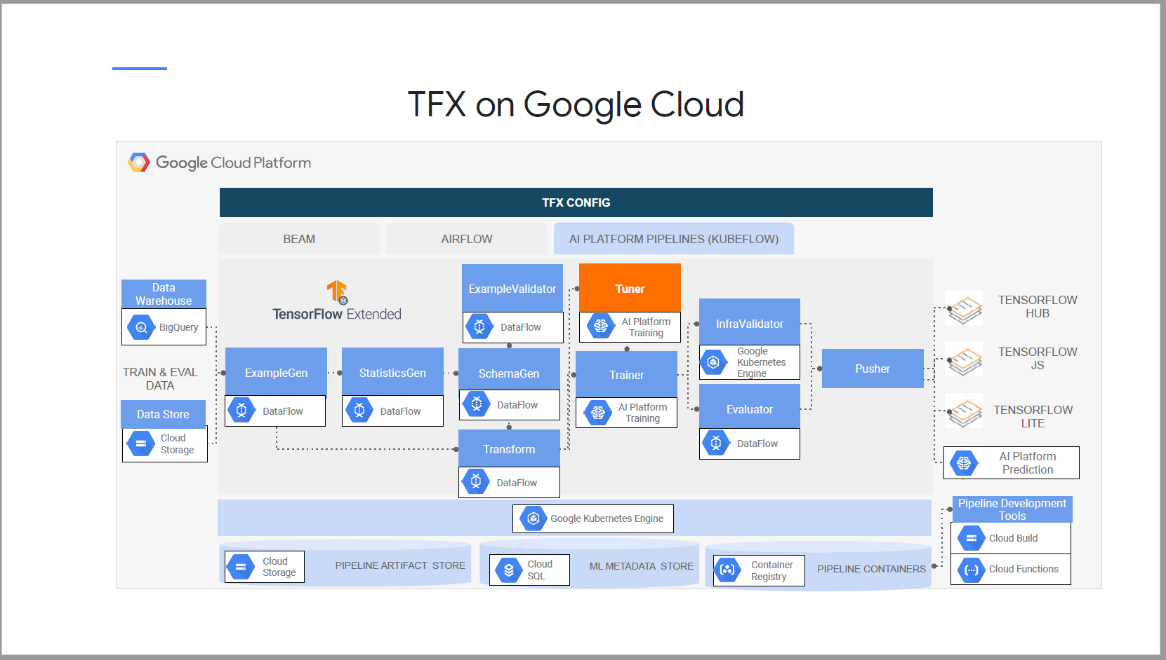

##### GKE and storage

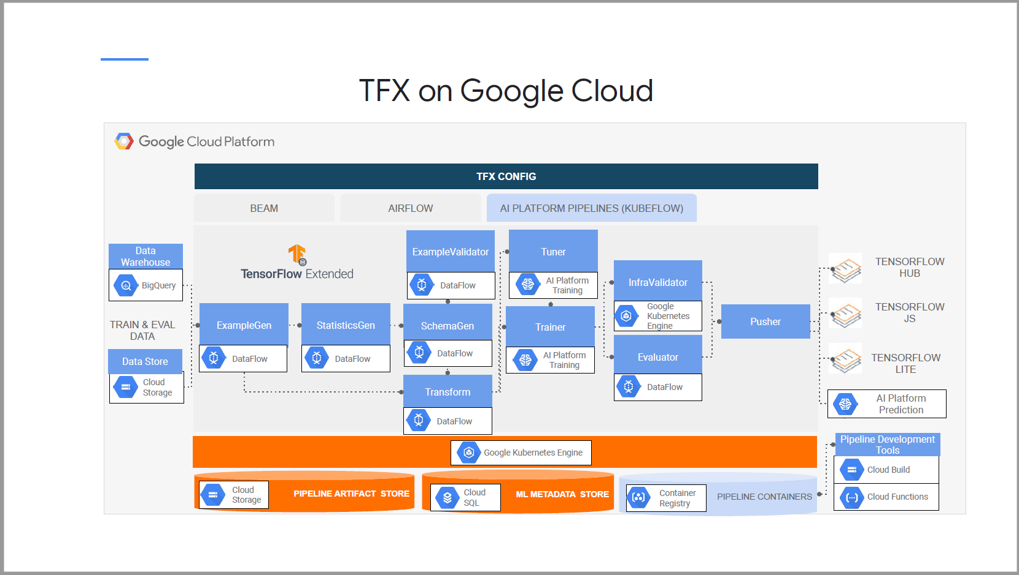

##### Google Cloud Development tools

* Cloud Functions, Container Registry and Cloud Build streamline TFX pipeline coaching, testing, deployment and CI / CD of ML pipelines.

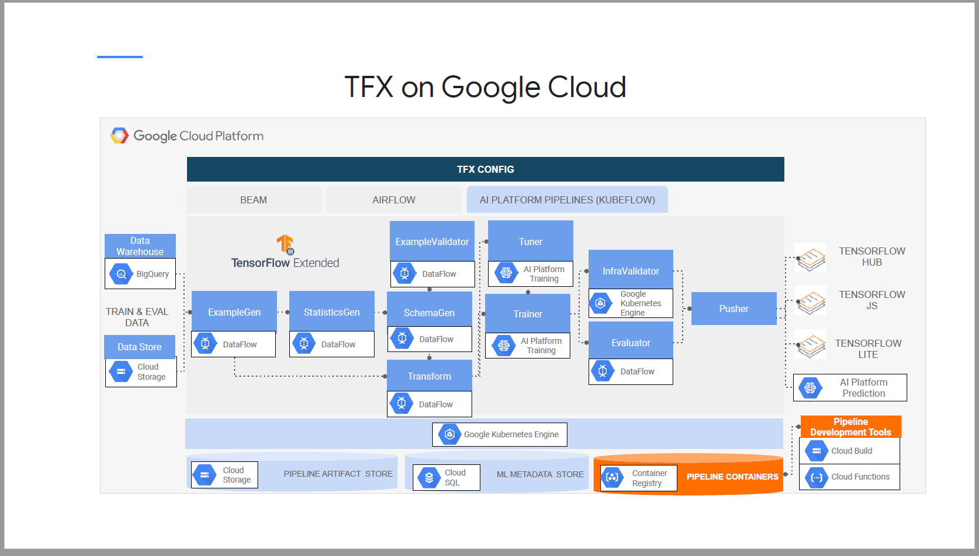

### Lab Intro: TFX on Cloud AI Platform

### Lab Summary:

In Section “Exercise: build your pipeline with the TFX CLI”

#TODO: Set your environment resource settings here for GCP_REGION, ARTIFACT_STORE_URI, ENDPOINT, and CUSTOM_SERVICE_ACCOUNT.

GCP_REGION = 'us-central1' # use us-central1 not us-central1-a

ARTIFACT_STORE_URI = 'gs://qwiklabs-gcp-04-3f6c4ea4531c-kubeflowpipelines-default'

ENDPOINT = '4c689f4c7798283a-dot-us-central1.pipelines.googleusercontent.com'

CUSTOM_SERVICE_ACCOUNT = 'tfx-tuner-caip-service-account@qwiklabs-gcp-04-3f6c4ea4531c.iam.gserviceaccount.com'

Then “Compile your pipeline code”, when you run the following command, you will get an error

!tfx pipeline compile --engine kubeflow --pipeline_path runner.py

Instead, Go to Exercise: deploy a pipeline version with tuning enabled

Run the compile command

!tfx pipeline compile --engine kubeflow --pipeline_path runner.py

Run the update command

!tfx pipeline update --pipeline_path runner.py --endpoint {ENDPOINT}

Come back to the first exercise, compile and create the pipeline.

PROJECT_ID = !(gcloud config get-value core/project)

PROJECT_ID = PROJECT_ID[0]

PROJECT_ID = !(gcloud config get-value core/project)

PROJECT_ID = PROJECT_ID[0]

!tfx pipeline create \

--pipeline_path=runner.py \

--endpoint=’ 3bcbf8cfb7e61485-dot-us-central1.pipelines.googleusercontent.com’ \

--build_target_image=’ gcr.io/qwiklabs-gcp-00-9a74164c63b4/tfx_covertype_continuous_training’

## Week 2 – Custom components and CI/CD for TFX pipelines

3 options to create custom components

* Python functions
* Containers
* Extending existing component classes

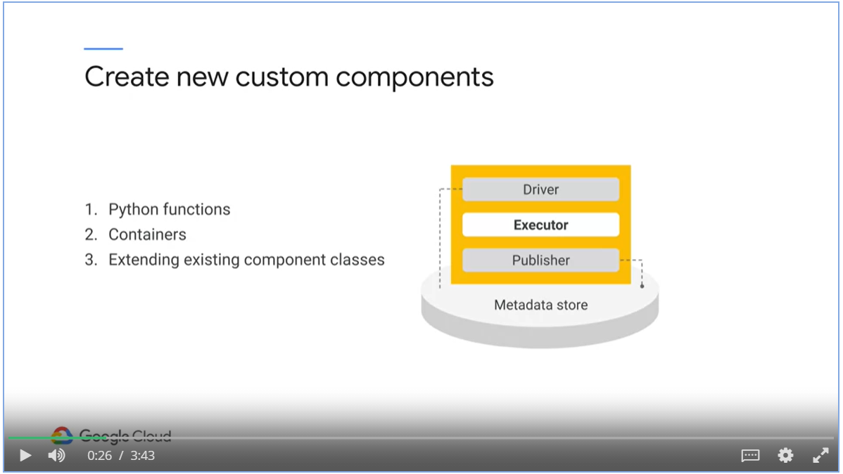

### TFX custom components – Python Functions

* Use python function-based component definition
* Write a function annotated with Python type hints which describes input and output artifacts.

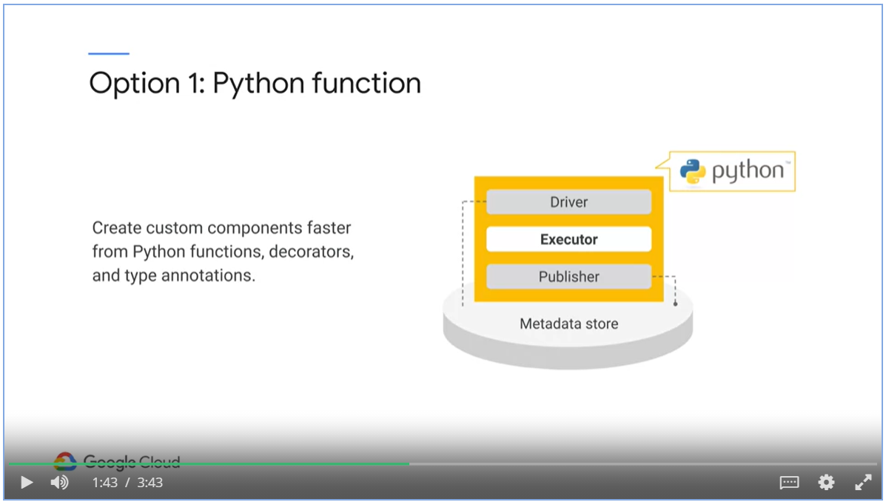

Steps to implement a custom component

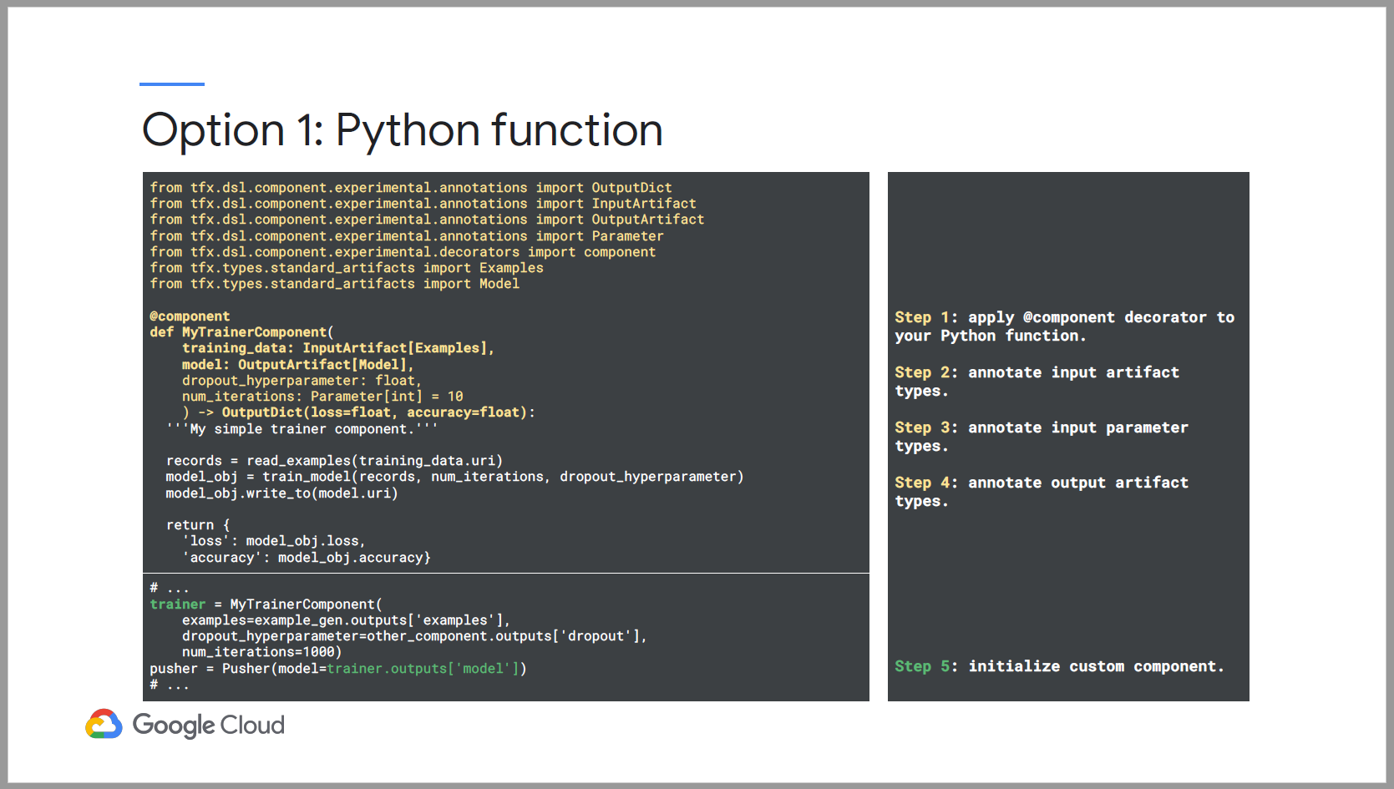

### TFX custom components – Container & Subclasses

* Container based components are backed by containerized command-line programs.
* You can integrate code written in any language into your pipeline as long as you can execute the code in the container.

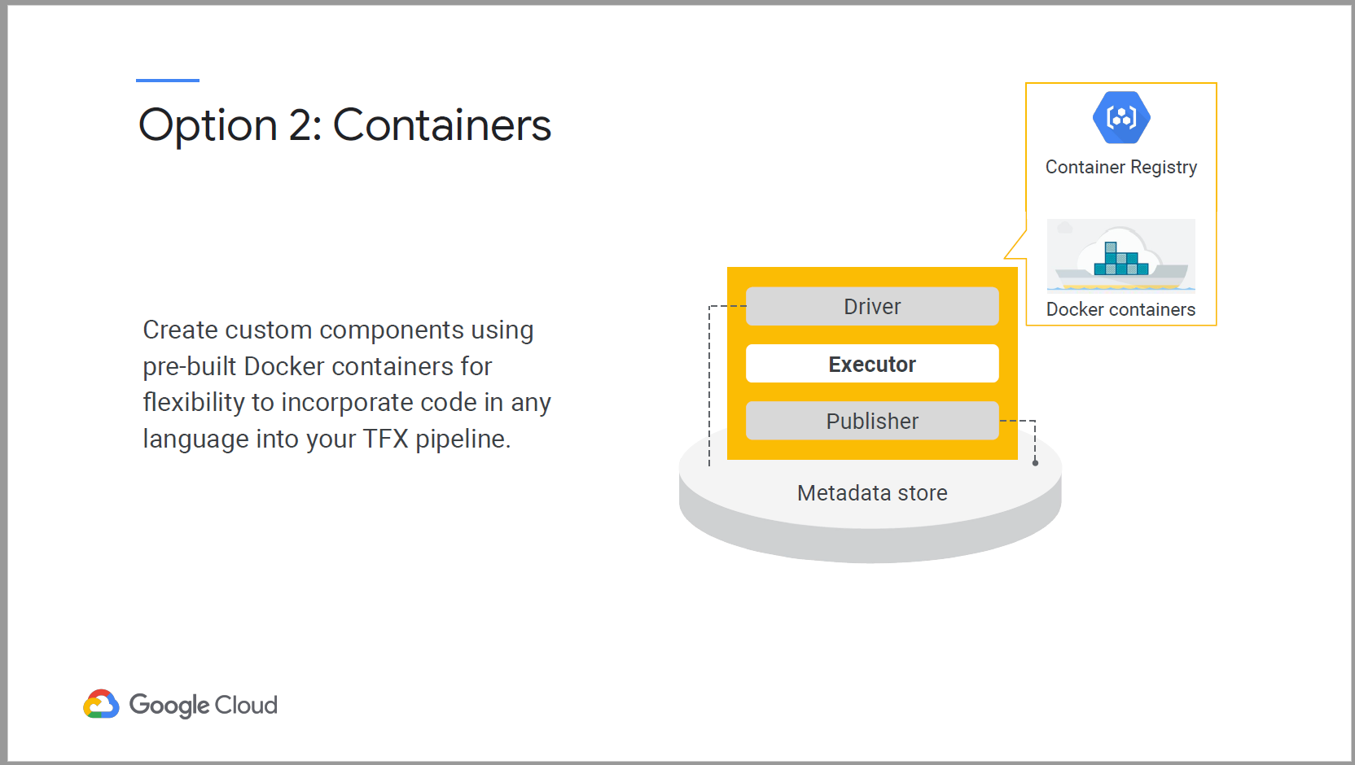

Steps to create container based component

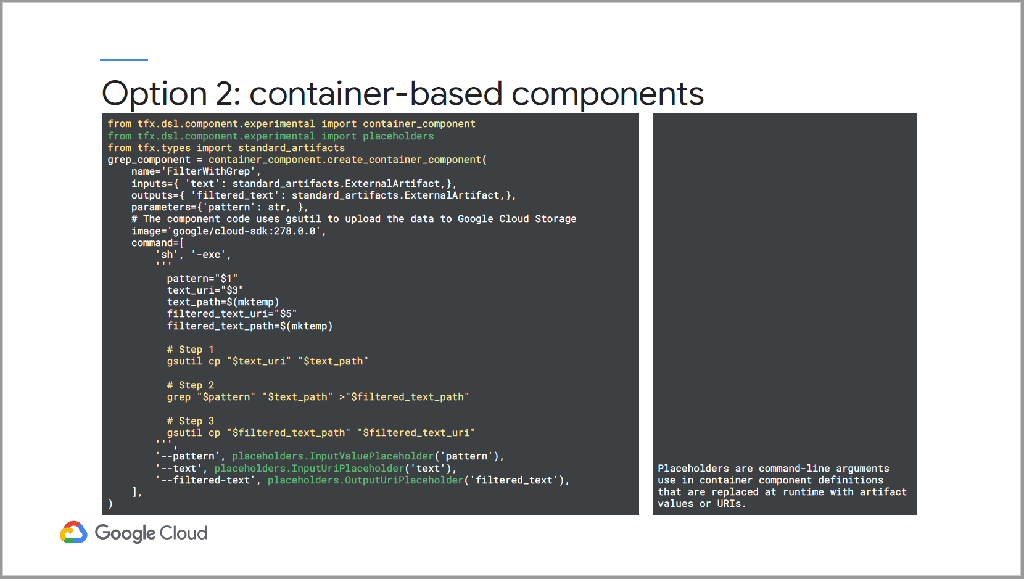

* A full custom component is needed when any of the input / output or execution properties are different from existing TFX components.

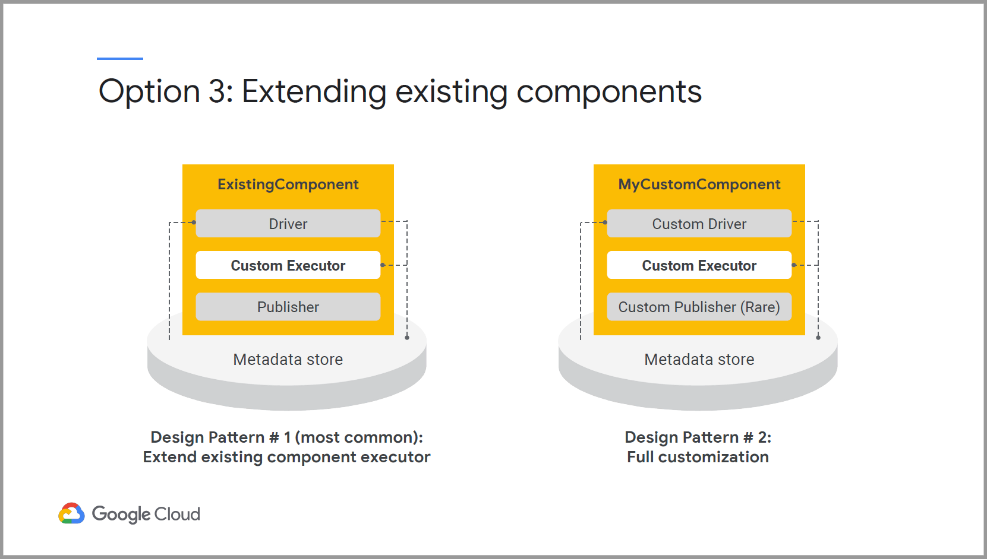

### CI / CD for TFX pipeline workflows

* GCP provides a complete enterprise created, easy setup, secure environment to build and deploy robust and reproducible TFX pipelines.
* At the heart, Cloud Build is managed service that executes your container build on Google Cloud Infrastructure.

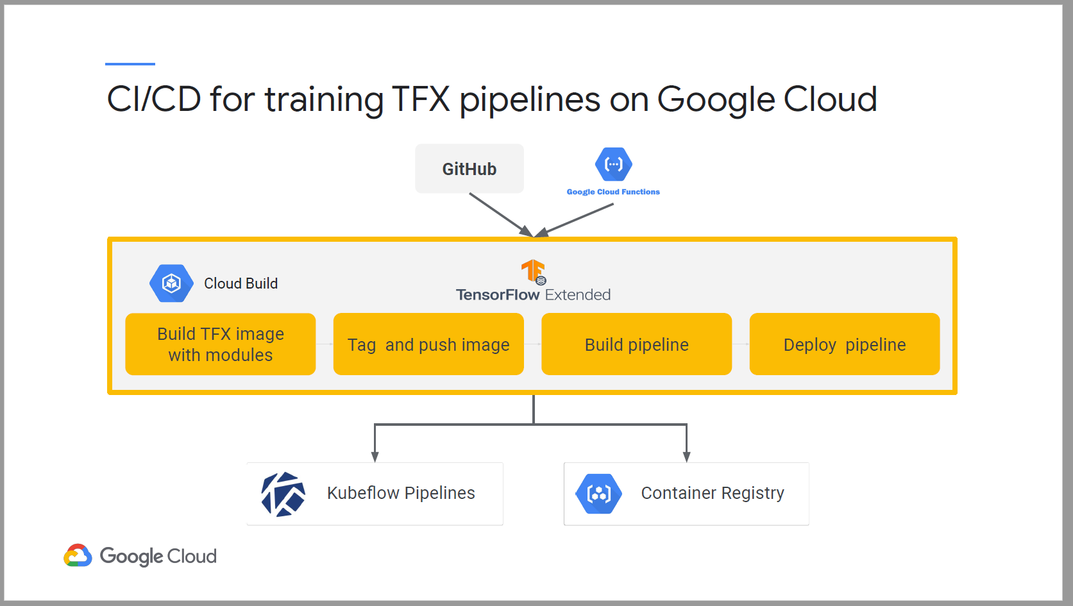

#### Fetch and Build

* Cloud Build fetches TFX pipeline code from repositories such as GitHub and GitLab.
* Execute a build to your specification and produce artifacts such as containers or Python tar files.
* Cloud build executes your build, in a series of steps defined in YAML configuration files. Each build step is run as a container.

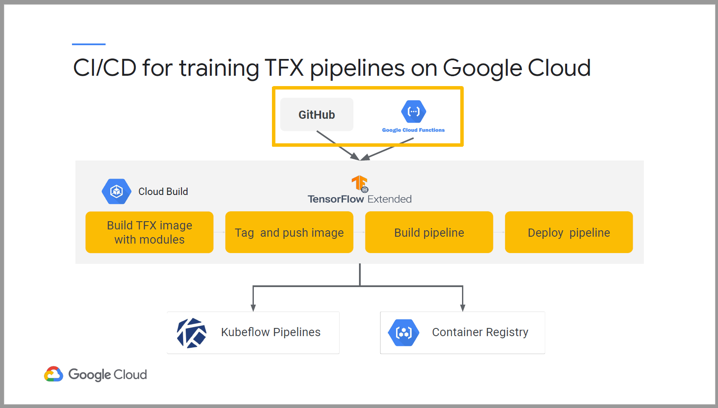

* Builds are triggered by GitHub actions or Cloud Functions



Example

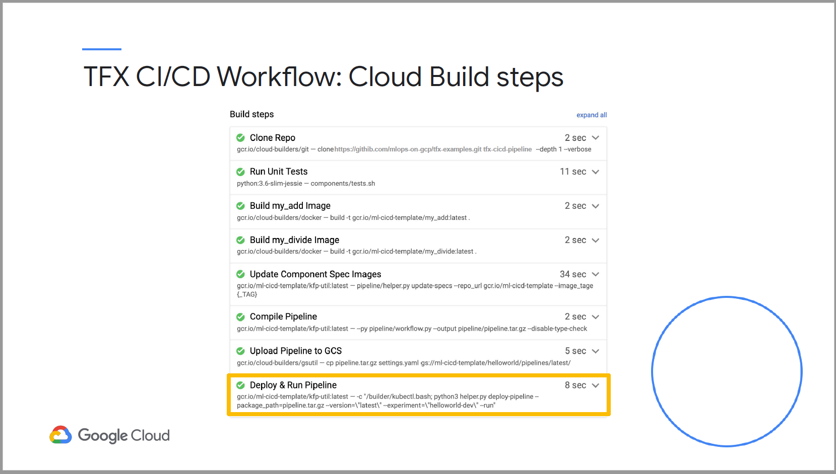

#### Level 0 ML process automation,Notebook

* Build pipelines interactively in Notebooks and export it to pipeline.

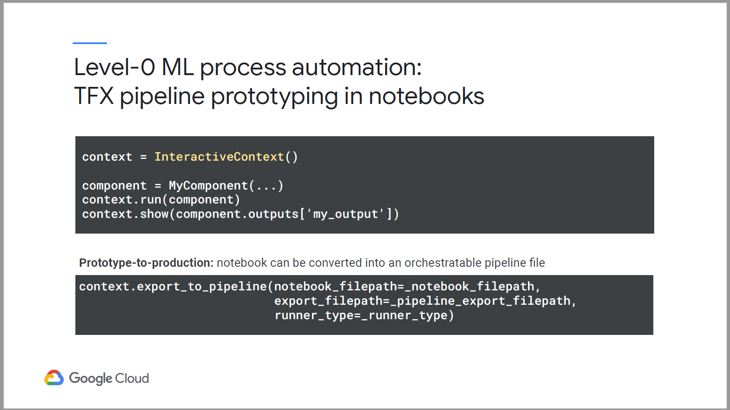

#### Level 1 Automation – Continuous Training

* For experimentation or testing, use TFX command-line utility or UI to manually trigger partial or full pipeline runs.
* For example, data ingestion hasn’t changed, but partially run the training step to test different hyperparameters.

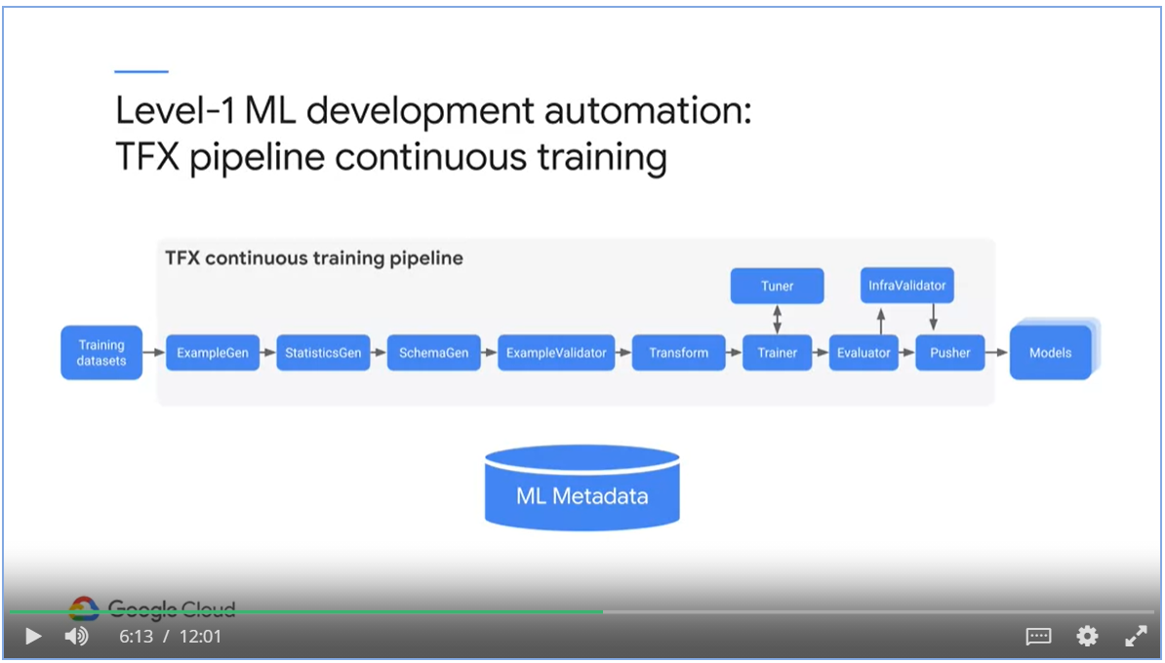

#### Level 2 Automation – Pipeline development automation

* CI / CD of the TFX pipeline codes.
* Build, Staging and Production environments.
* If given new code, the CI/CD process will deploy a new TFX continuous training pipeline.
* If given new data, the CI/CD process will deploy a new model prediction service.

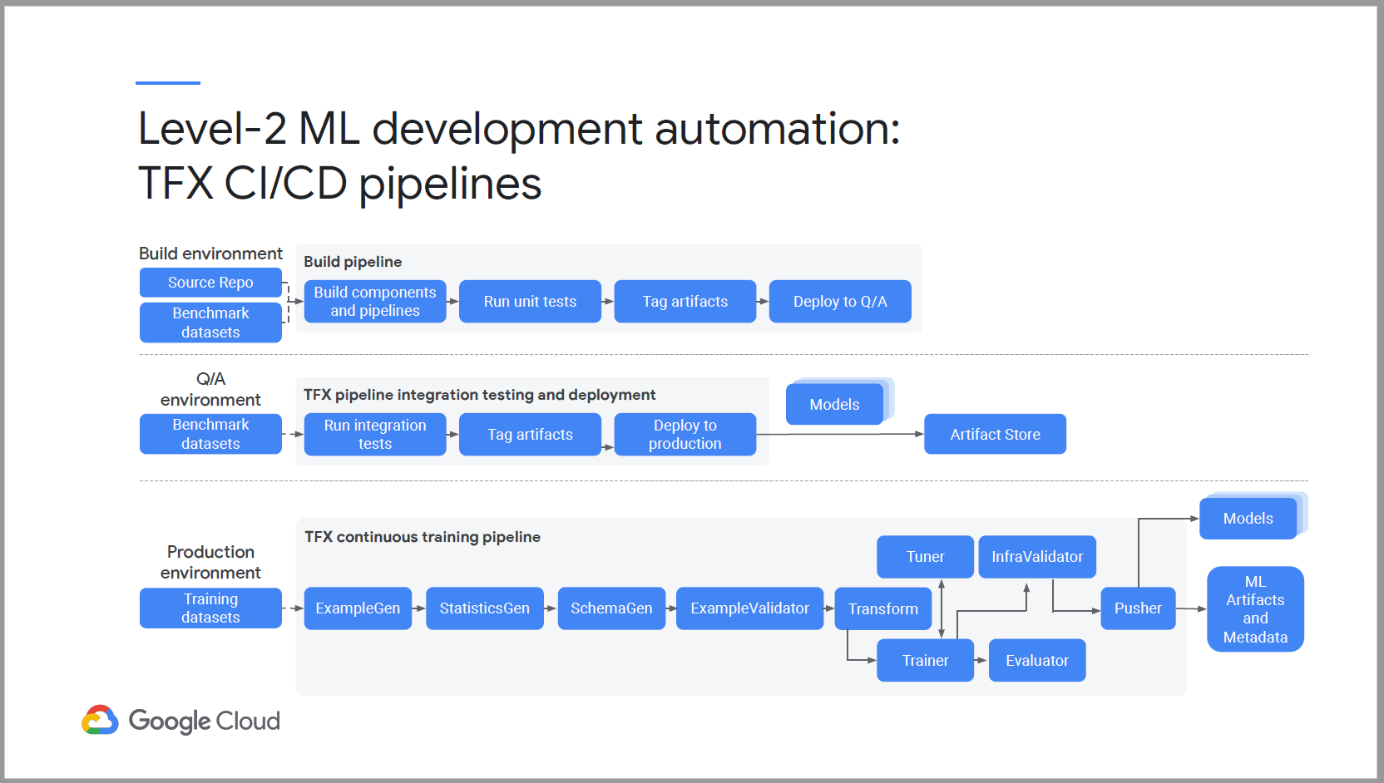

End to End TFX MLOps workflow

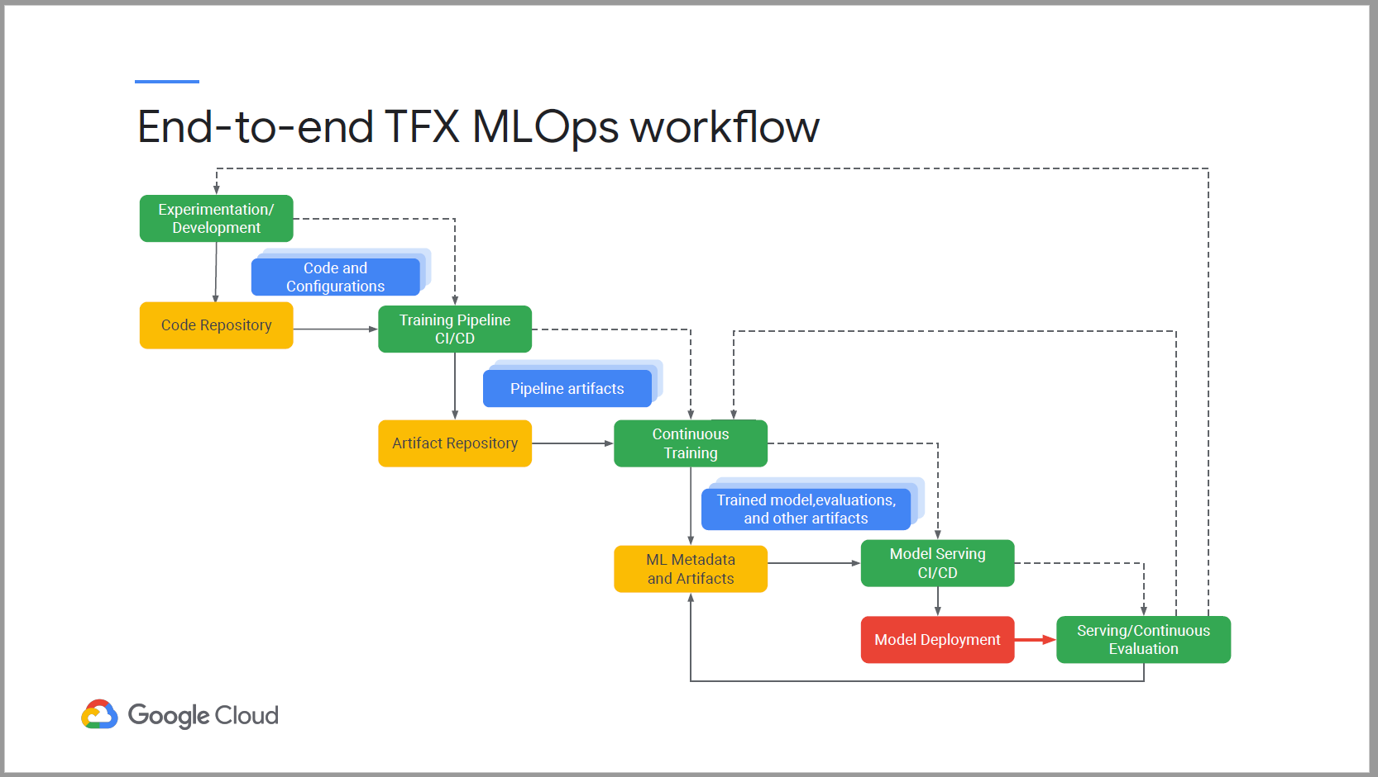

Future state of ML development

* Feature store to decouple feature engineering from model training
* Promote reusability of common features.

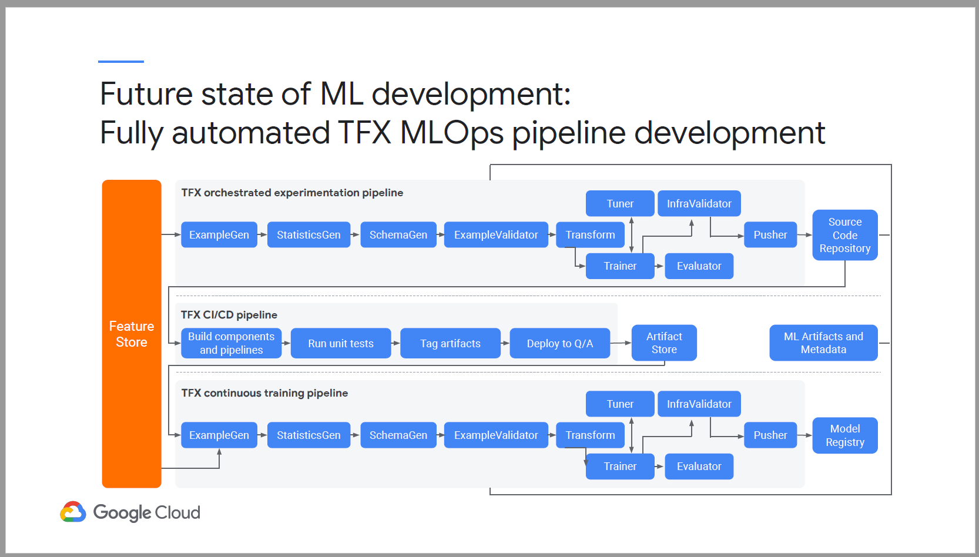

Orchestrated experimentation pipeline.

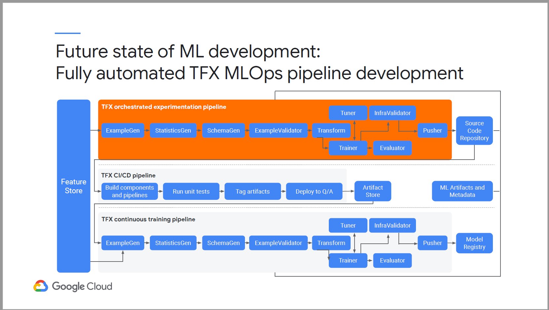

## Week 3 – ML Metadata with TFX

### TFX Pipeline Metadata

* ML metadata is the key foundation of TFXs task and data-aware pipeline orchestration.

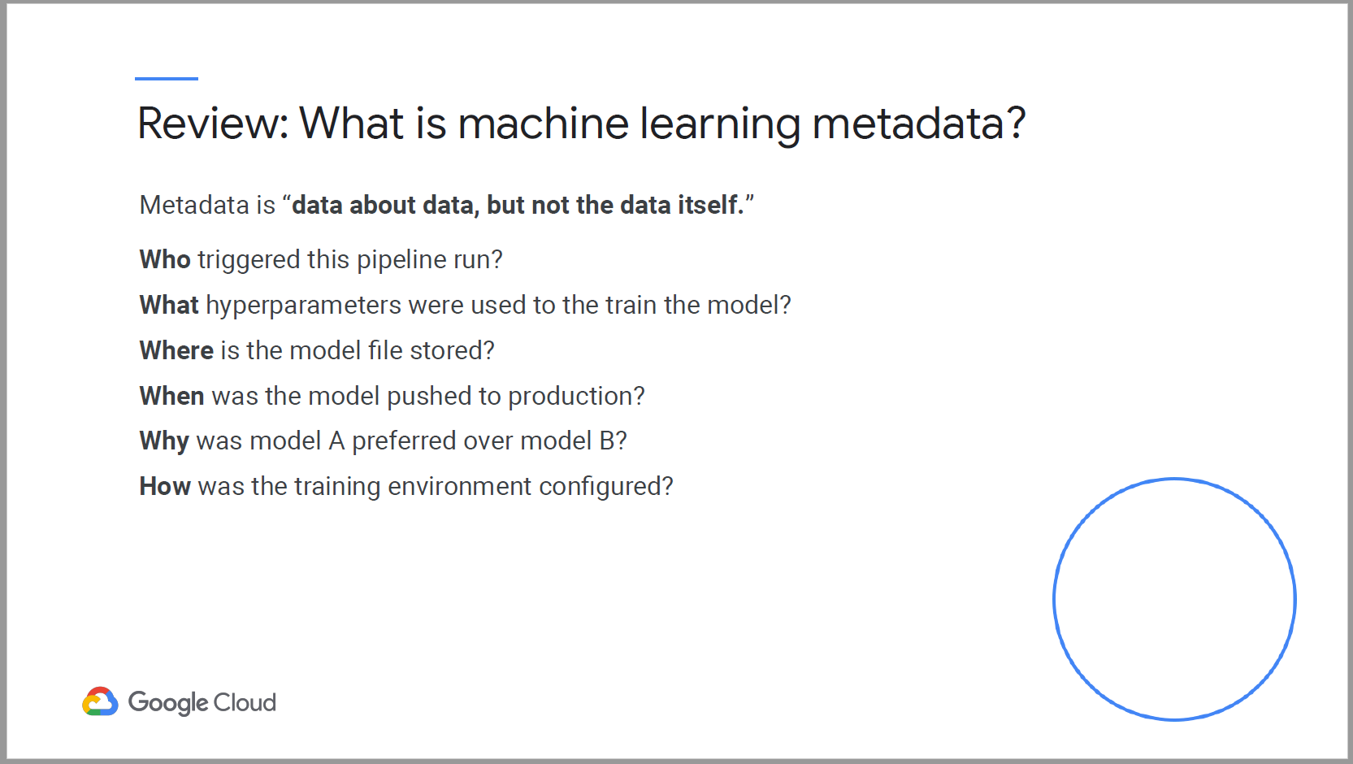

* Training data is stored along with other pipeline artifacts in Cloud Storage.
* TensorFlow SavedModel is stored is also stored in cloud storage, or a model repository such as AI hub.
* Metadata Store contains execution records and associated runtime configurations.
* TFX contains linkage records between artifacts, it enable full traceability to trace trained models back to their training runs, artifacts such as original training data.

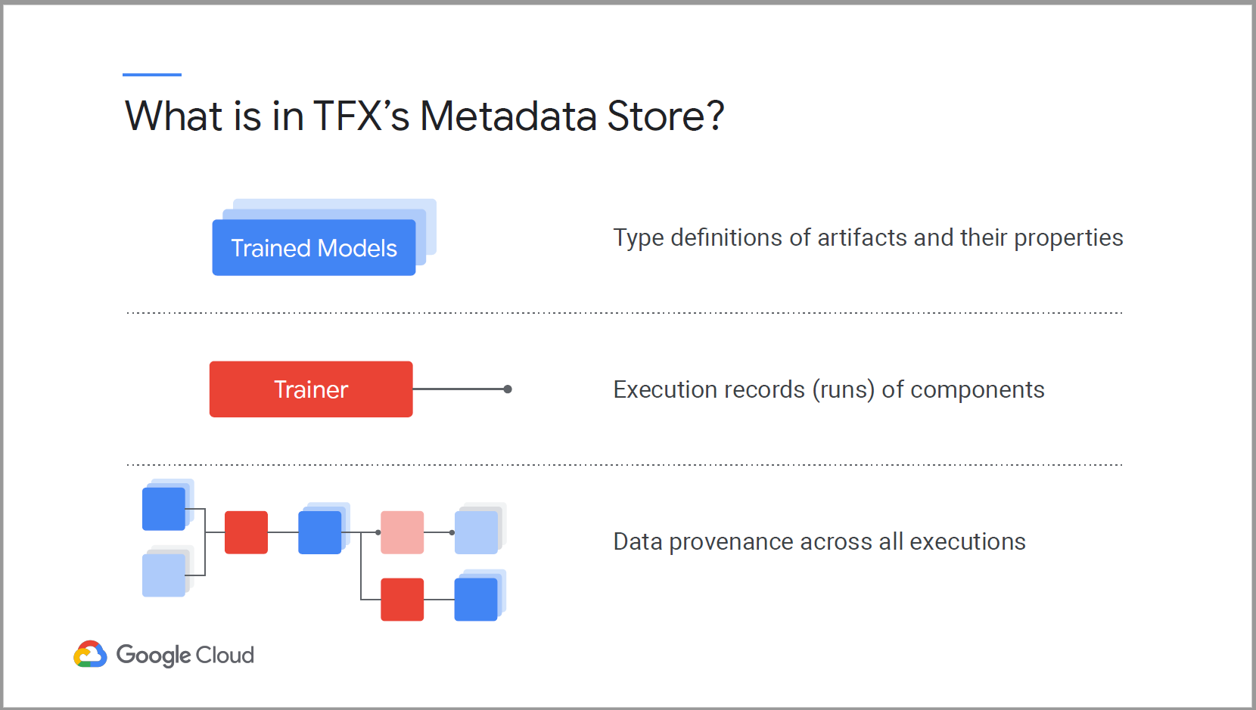

* TFX Metadata enables you to systematically trace the source of model improvements and degradations.

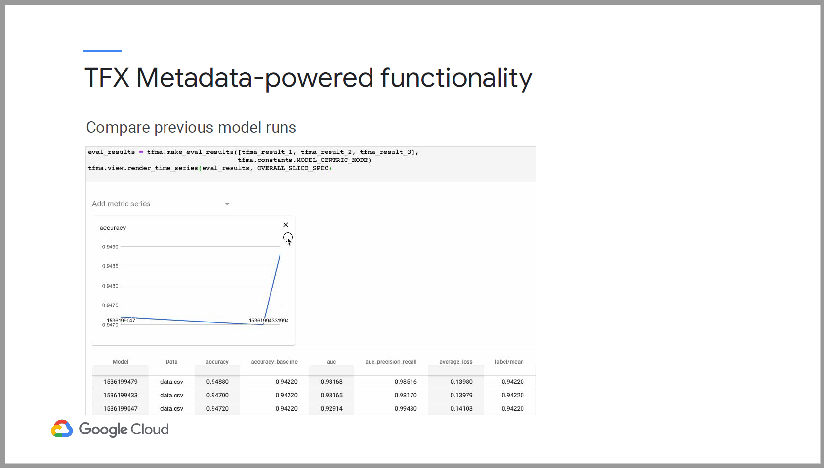

* TFX pipeline caching lets your pipeline skip over components that have been already executed with the same set of inputs in a previous pipeline run.

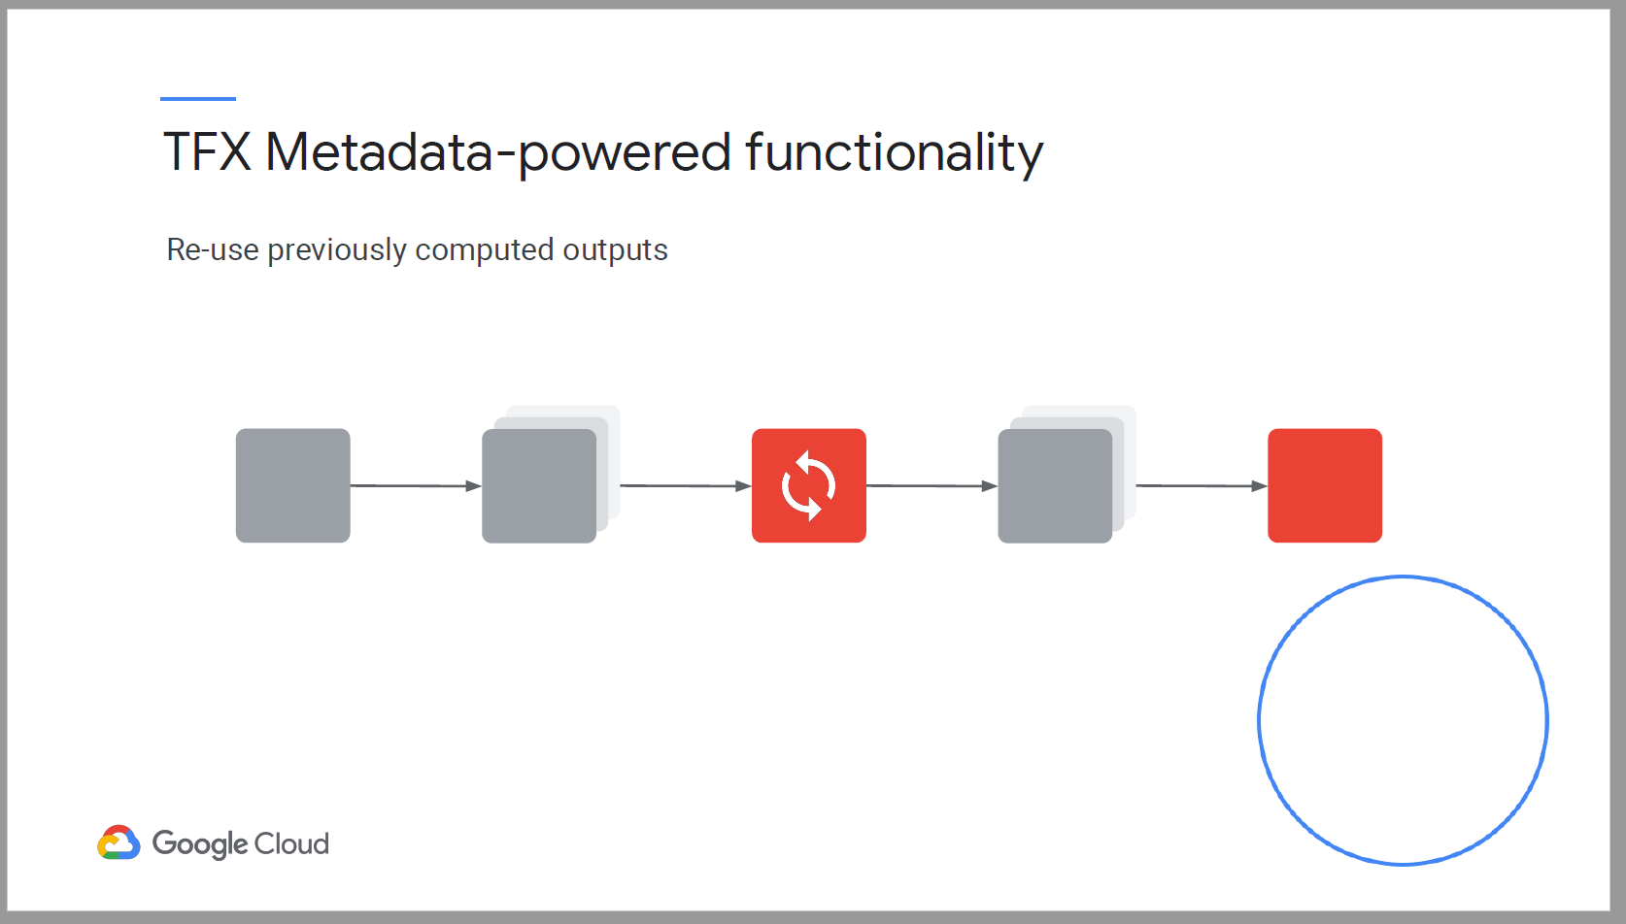

* TFX Metadata enables you to incorporate previously computed artifacts back into your pipeline.
  + Resume model training form checkpoints
  + Benchmarking model components in the evaluator component, this lets you import the last blessed model in order to determine whether to push the latest trained model to serve in production.

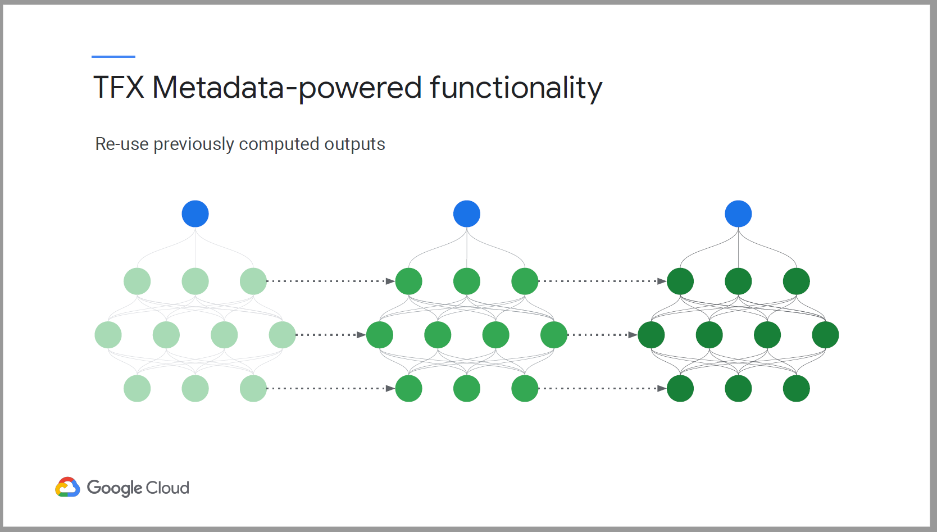

* Warm starting is a general alternative strategy where instead you initialize model weights by copying them from a previously trained model.
* Warm starting enables you to start from a better initial point on the low surface and achieve better performance.

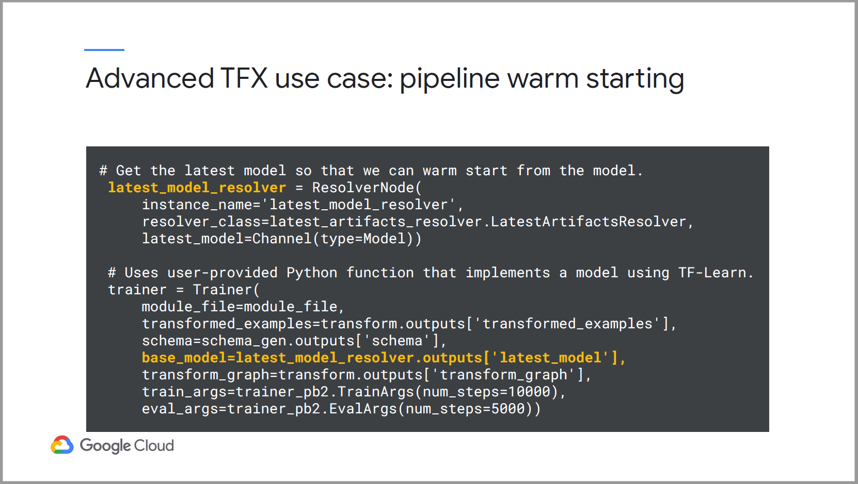

### TFX ML Metadata data model

* ML Metadata (MLMD) library is an integral part of TFX for recording and retrieving ML metadata.
* It is an horizontal layer and is designed to be used independently of TFX

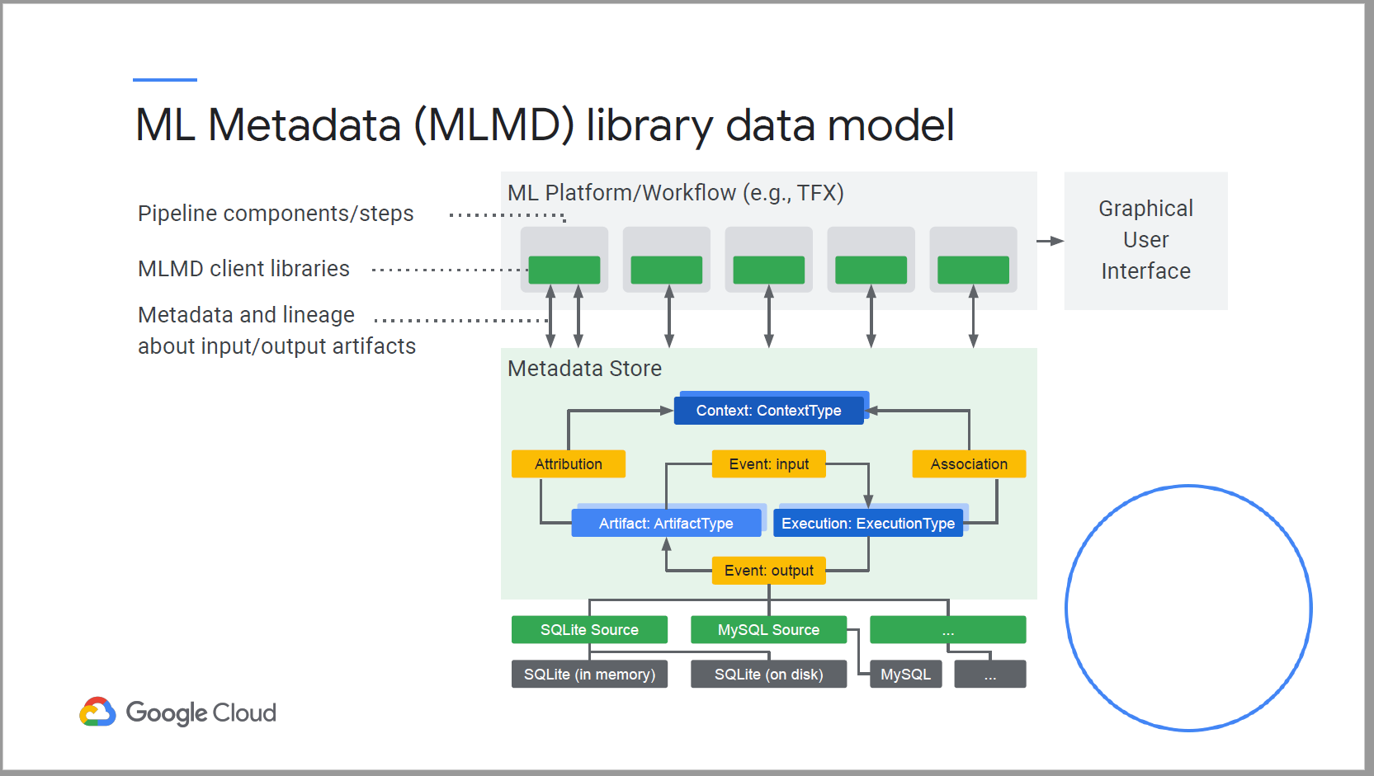

* The storage backend of MLMD is pluggable and can be extended.
* Google implemented using SQL Lite and MySQL.

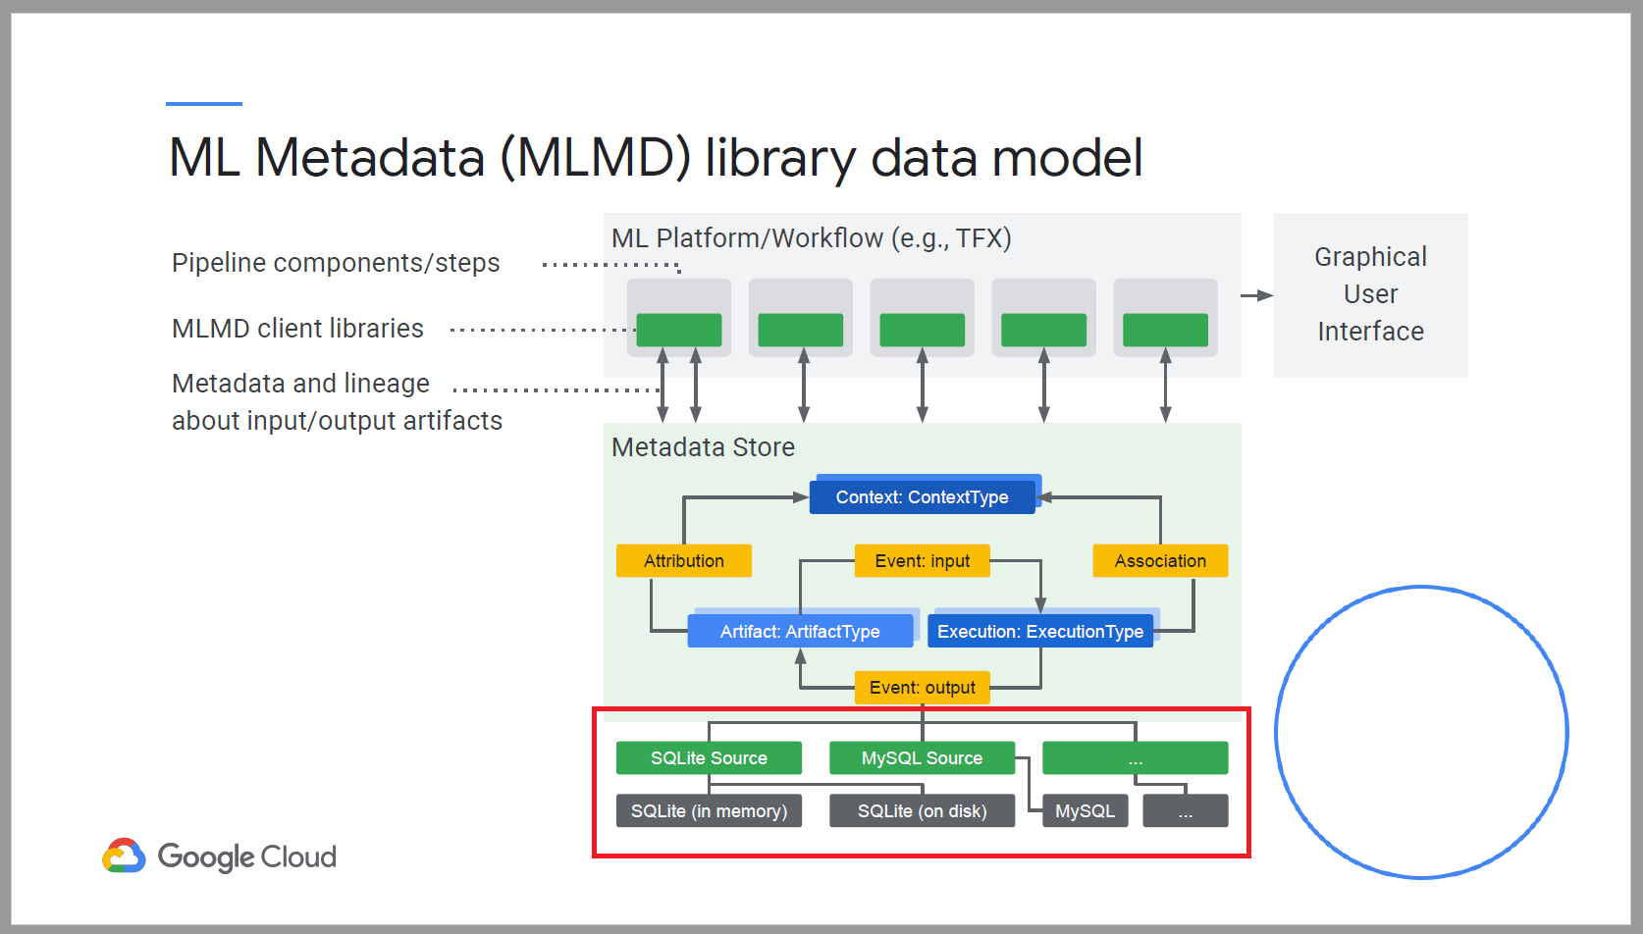

* Artifact type describe an artifact’s data type. Artifact is an instance of an artifact type.
* Execution type describes a type of component or a step in a workflow.
* Each execution is a specific execution type record of a component run.
* An event is a record of relationship between an Artifact and Execution.

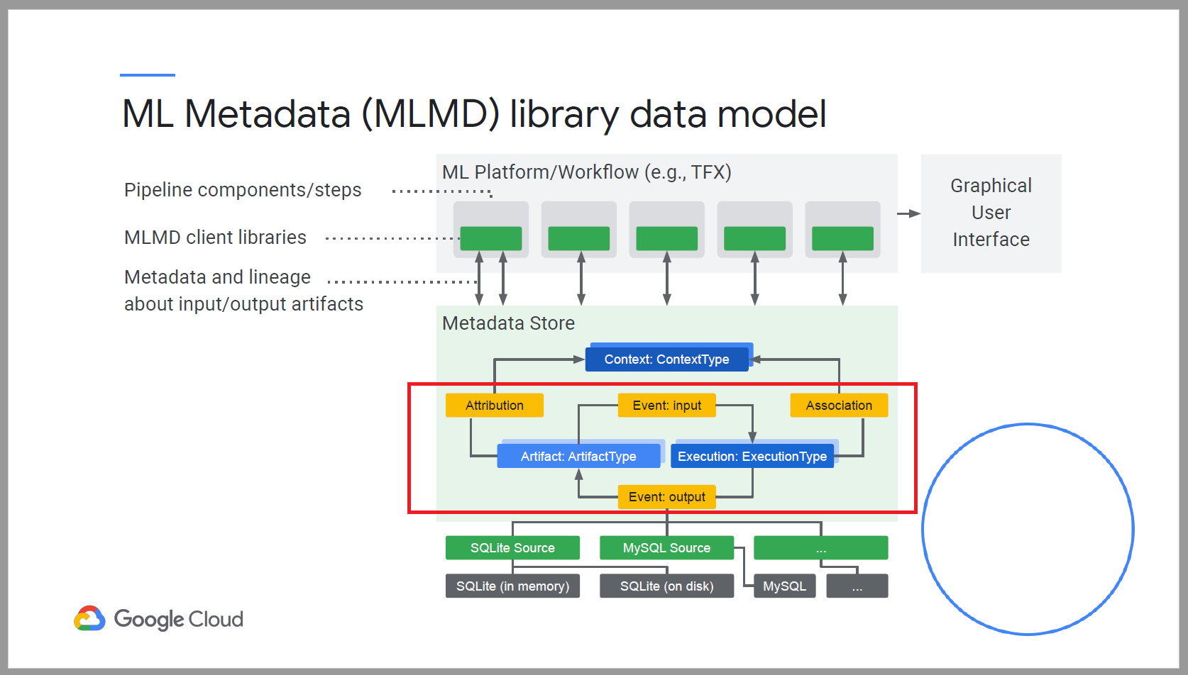

* Context describes the conceptual groups of artifacts and execution in a workflow.
* Attributions are record of relationship between artifacts and contexts.
* Associations are records of relationships between executions and contexts.

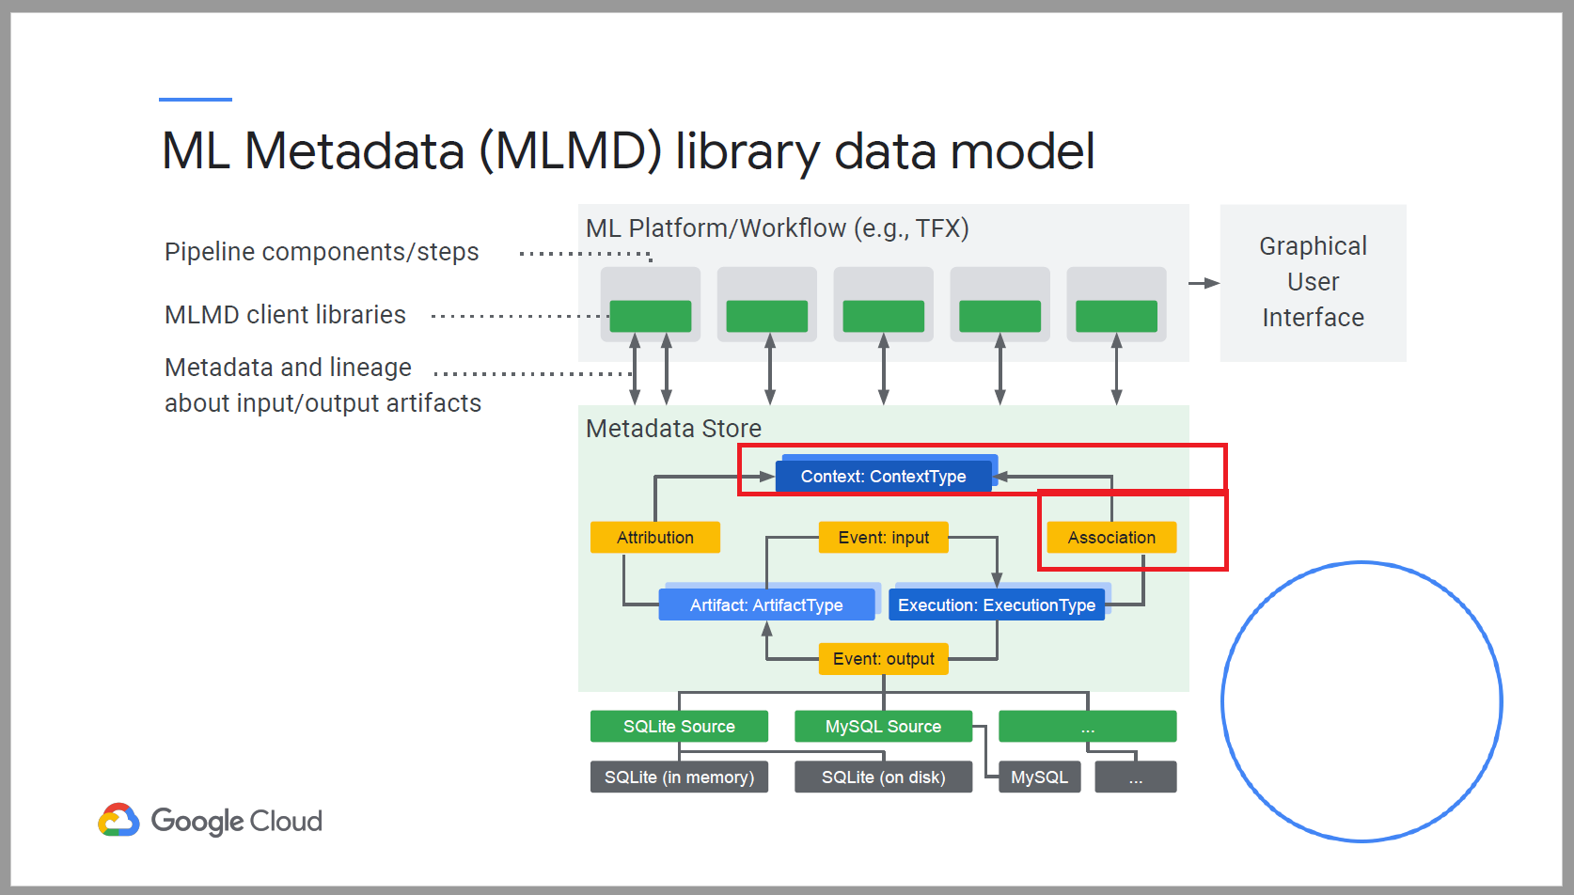

ML Metadata in action

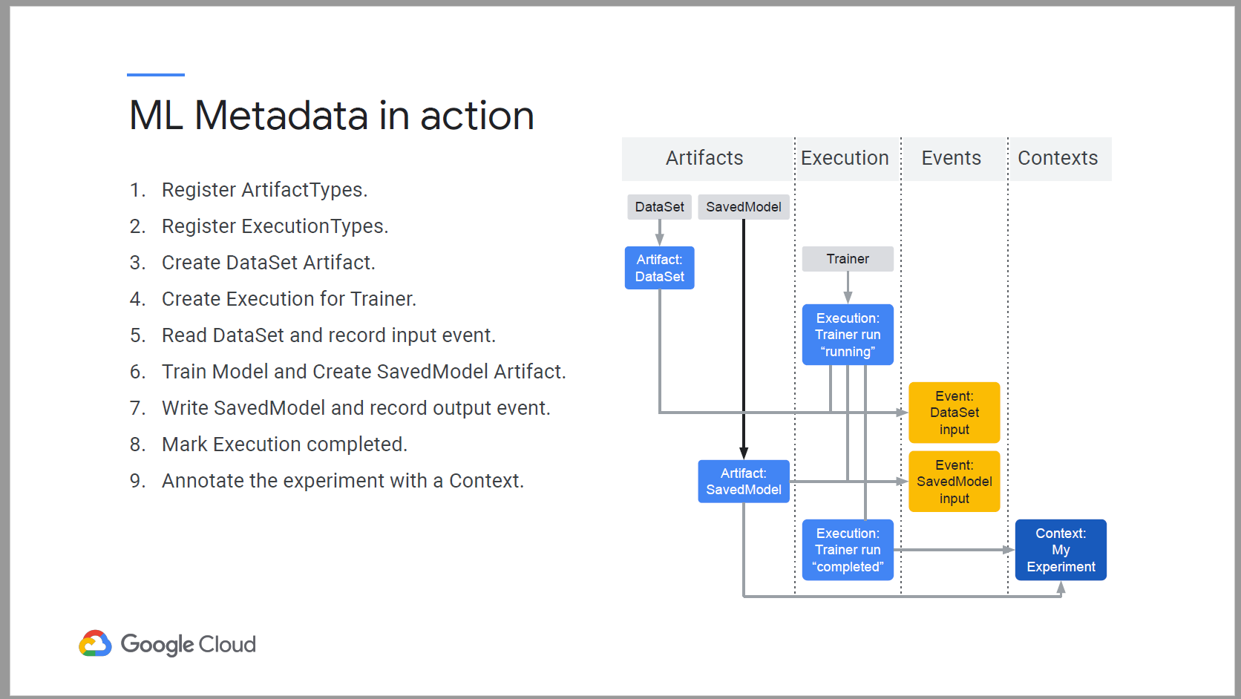

## Week 3 – Continuous Training with Multiple SDKs, KubeFlow & AI Platform Pipelines

### Containerized Training Applications

* Benefits of using containerized training applications.

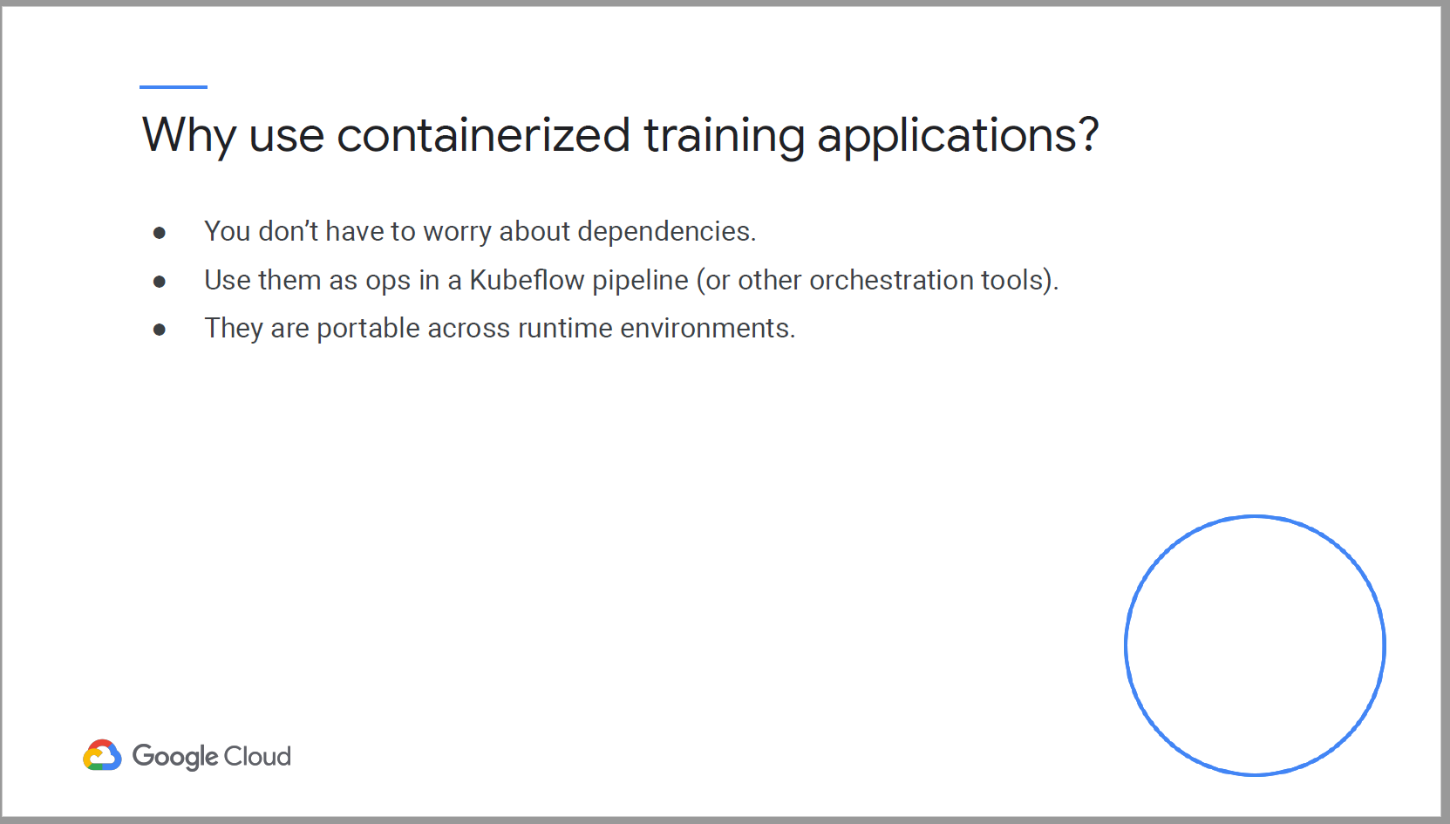

Submit a training job with custom containers using command line.

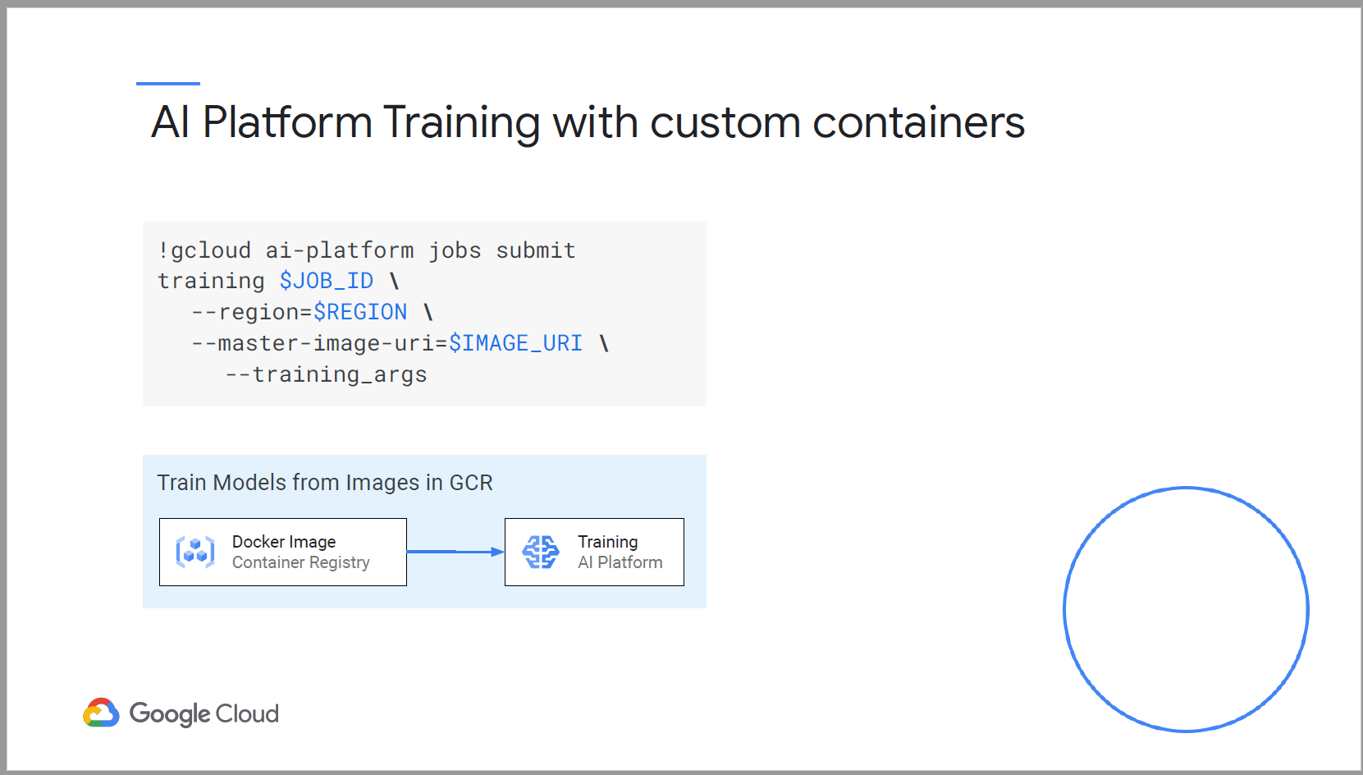

AI Platform Training job as an op in a Kubeflow pipeline

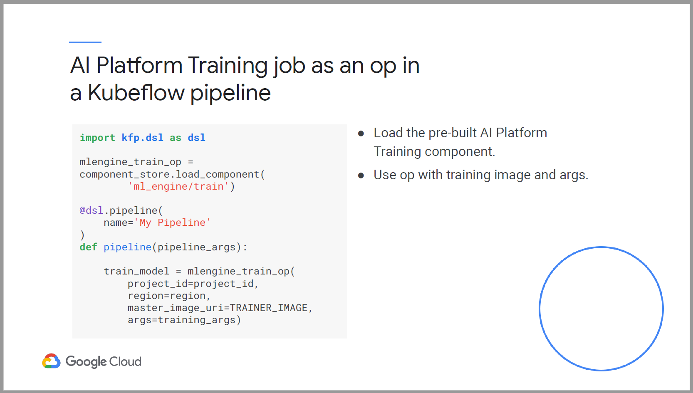

Step 1: Create a model training script

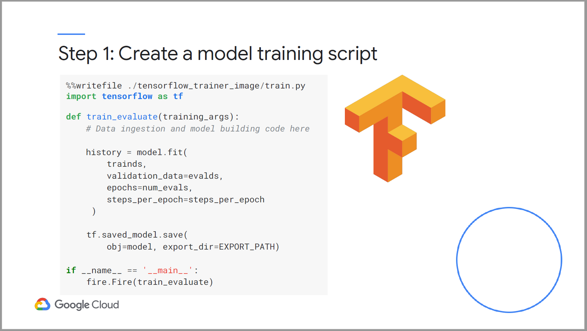

Step 2: Create a dockerfile

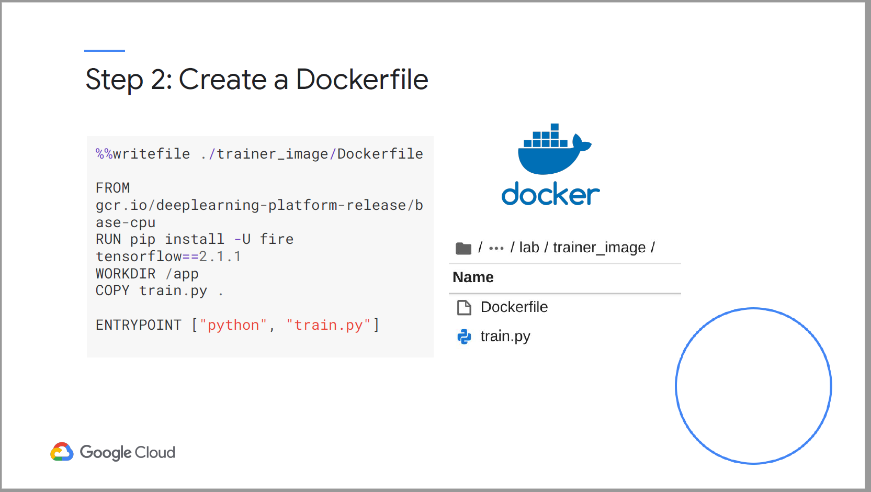

Step 3: Build the image and push to Container Registry

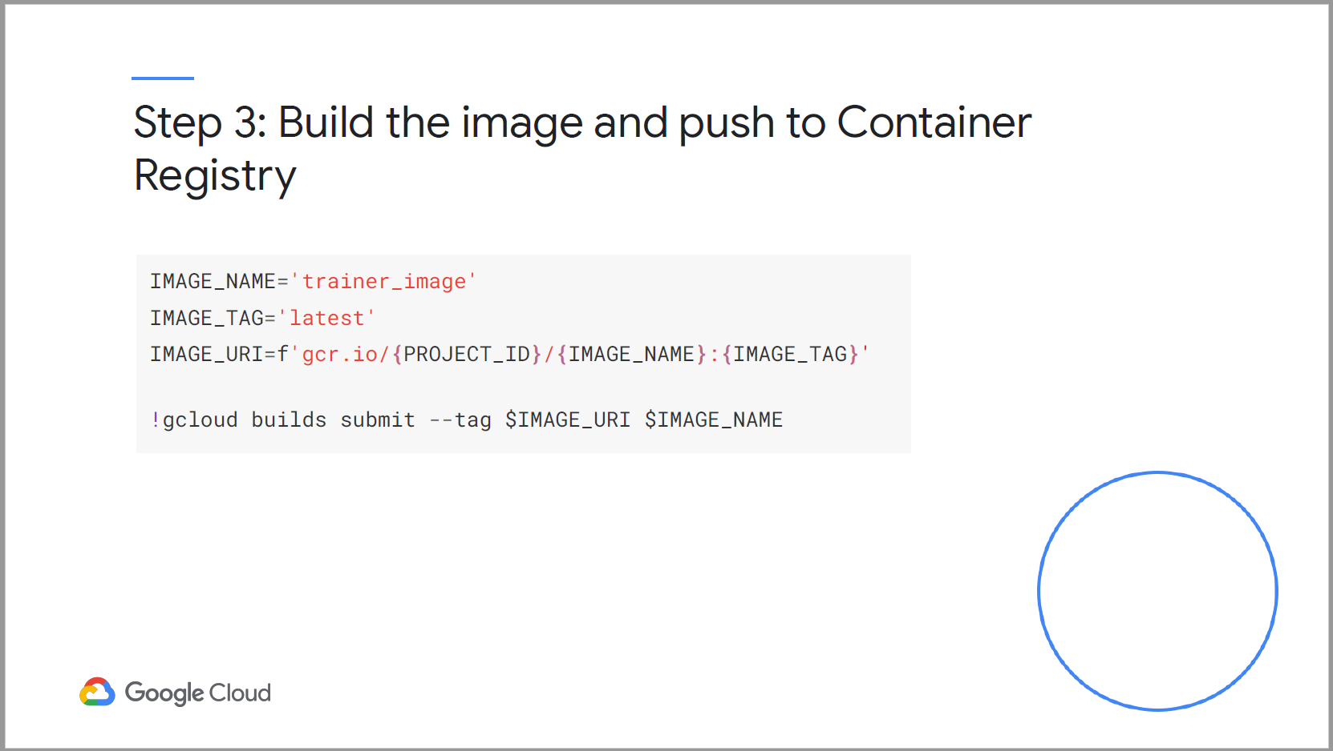

### Containerizing PyTorch, Scikit and XGBoost

The process is the same.

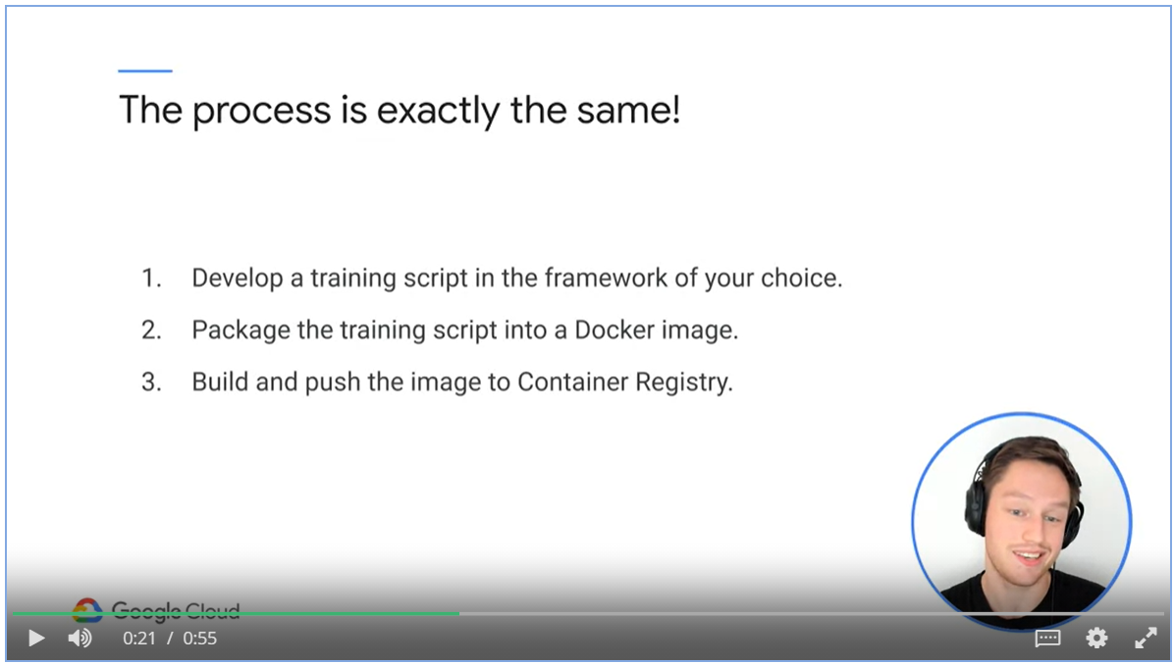

### KubeFlow and AI Platform Pipelines

To Train multiple models in a KubeFlow pipeline.

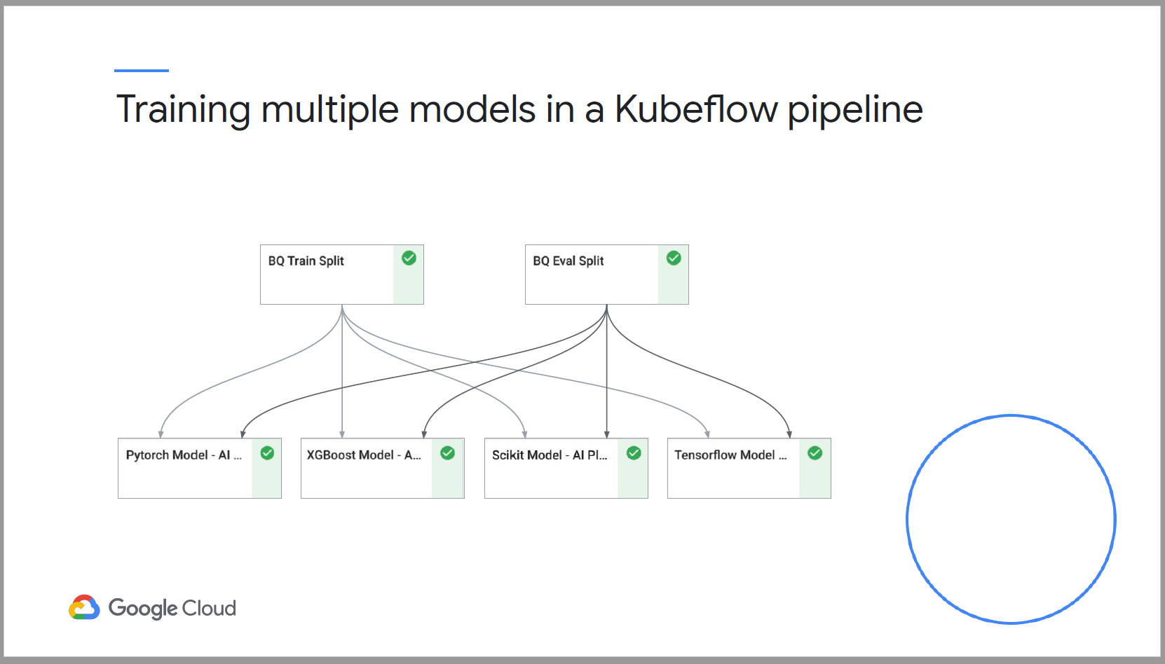

We create separate arg list for each container

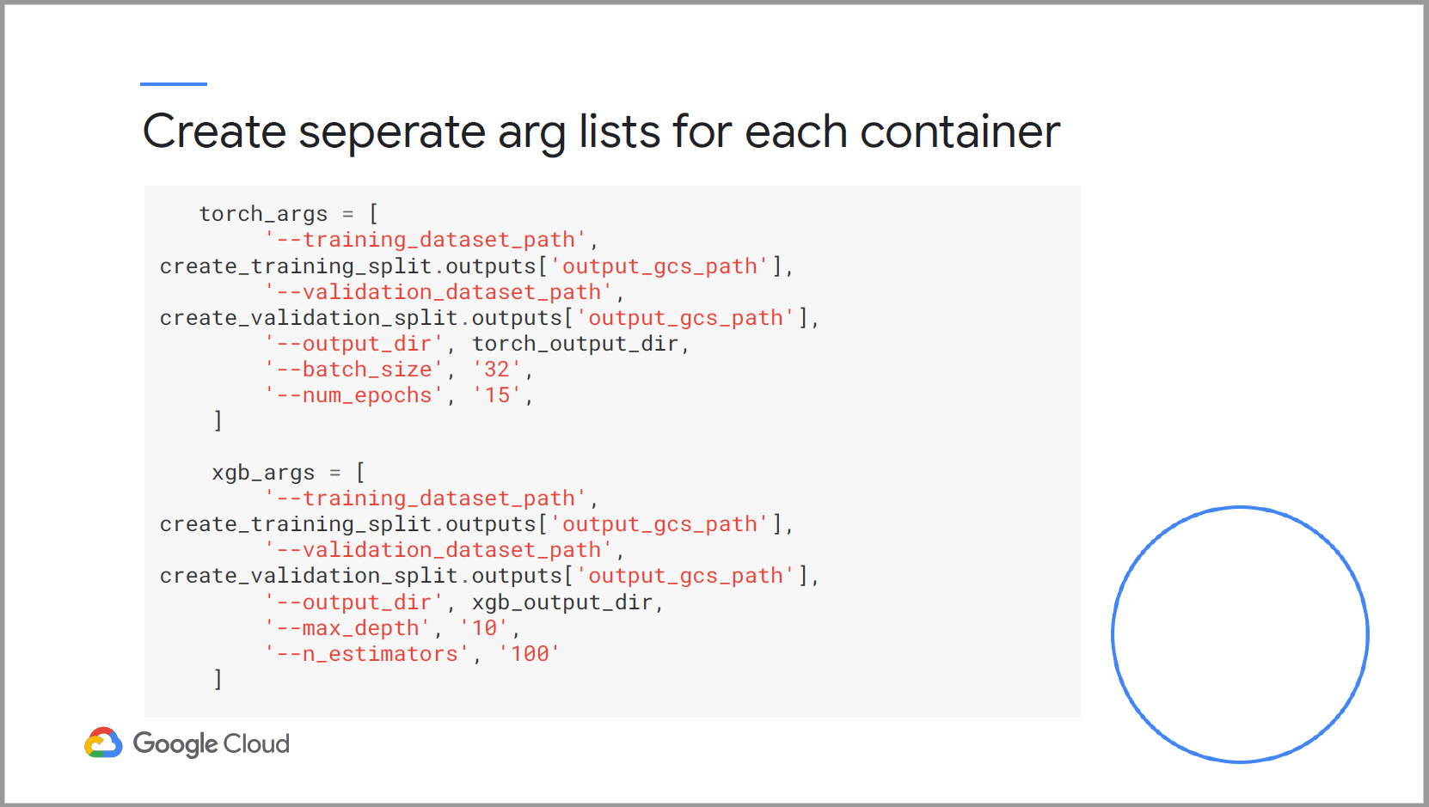

Use multiple mlengine_train ops in pipeline.

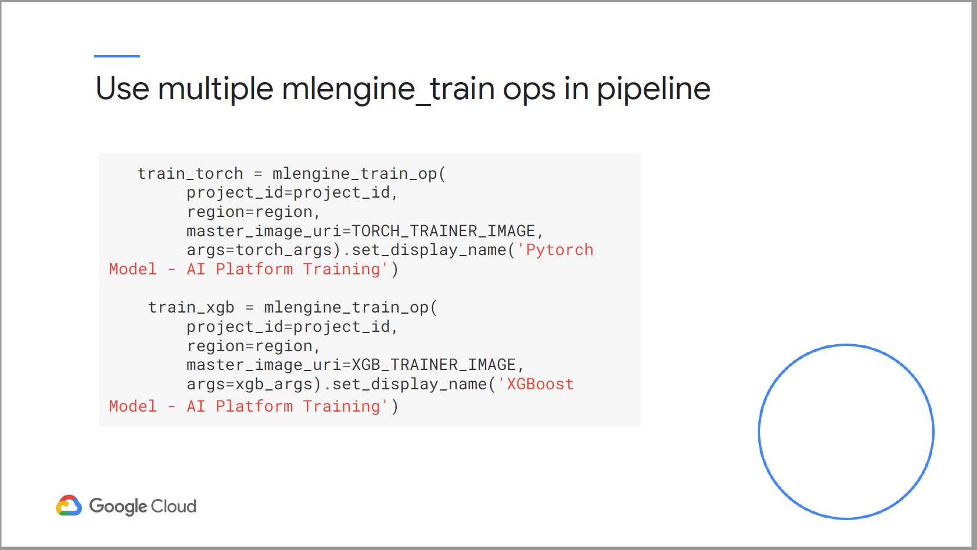

### Continuous Training

* Model performance deteriorate over time
* Changes in the data distribution causes deterioration.
* Consider the cost and time to retain model.

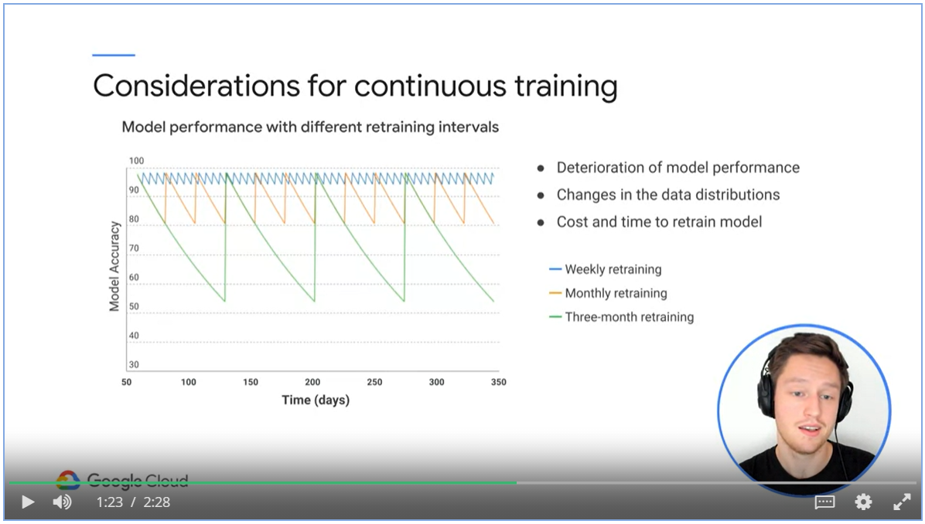

## Week 4 – Continuous Training with Cloud Composer

### What is Cloud Composer?

* Cloud Composer is based on Airflow.
* Apache Airflow is developed by Airbnb to author, schedule and monitor your workflows.
* Workflows are authored as directed acyclic graphs and are configured in Python.

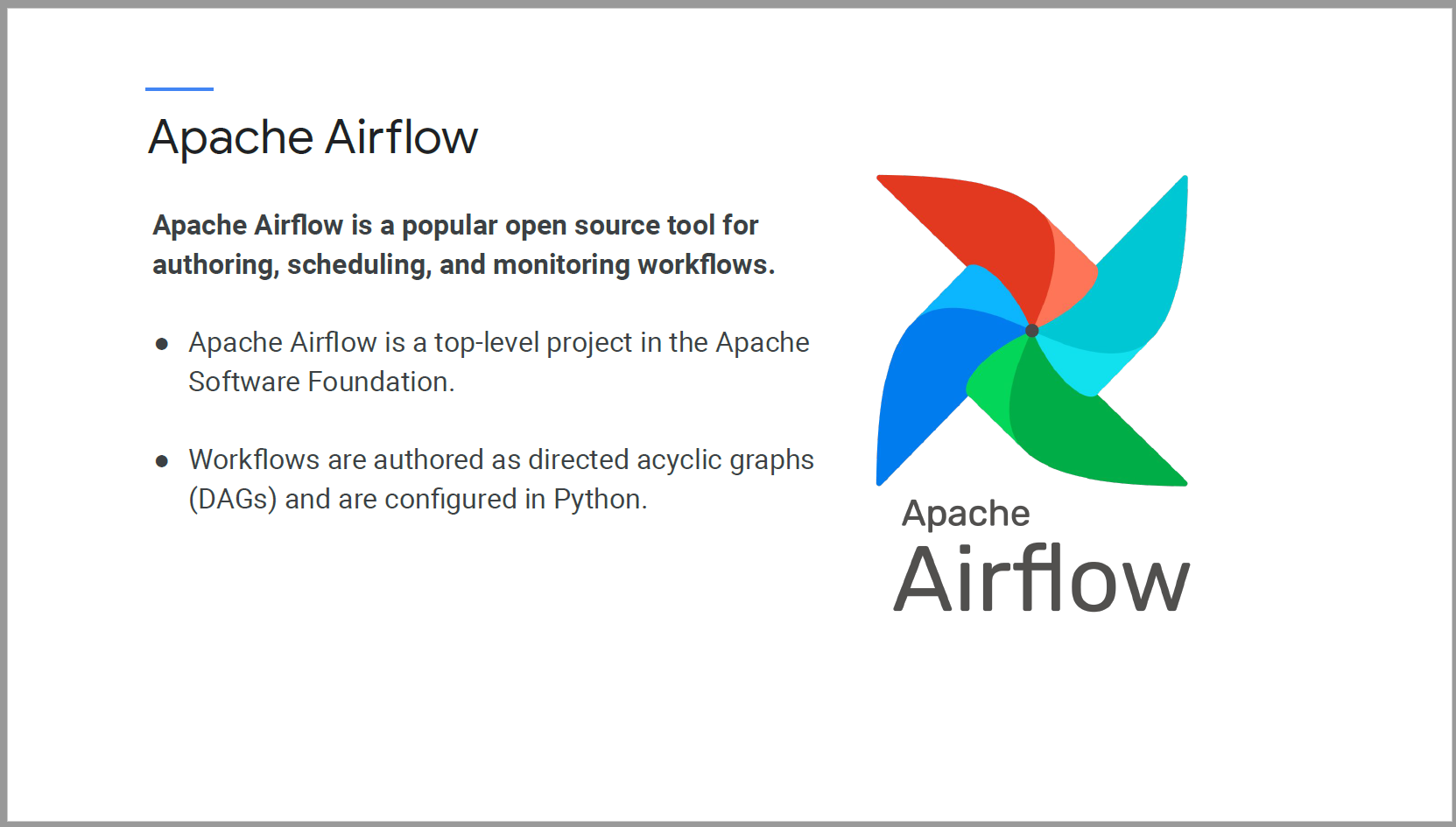

Pros and cons of Apache Airflow.

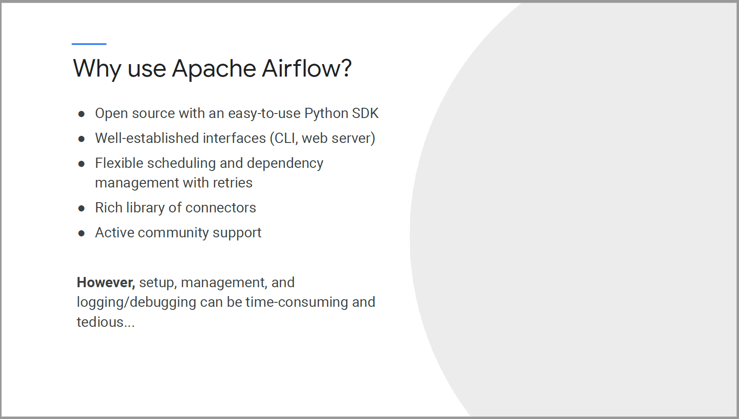

Cloud Composer is a managed Apache Airflow service that helps you to create, schedule, monitor and manage workflows.

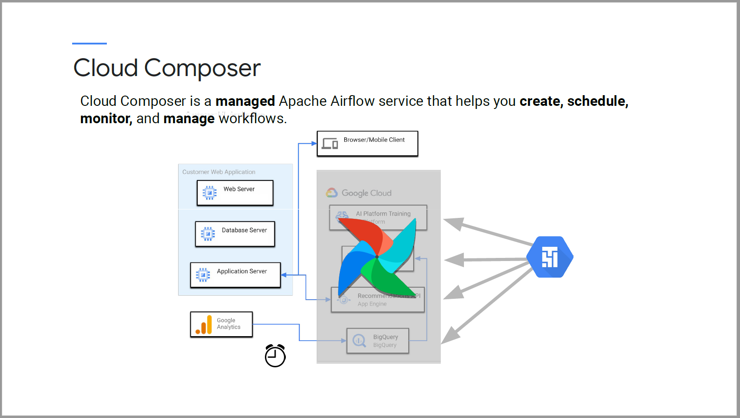

Why Cloud Composer?

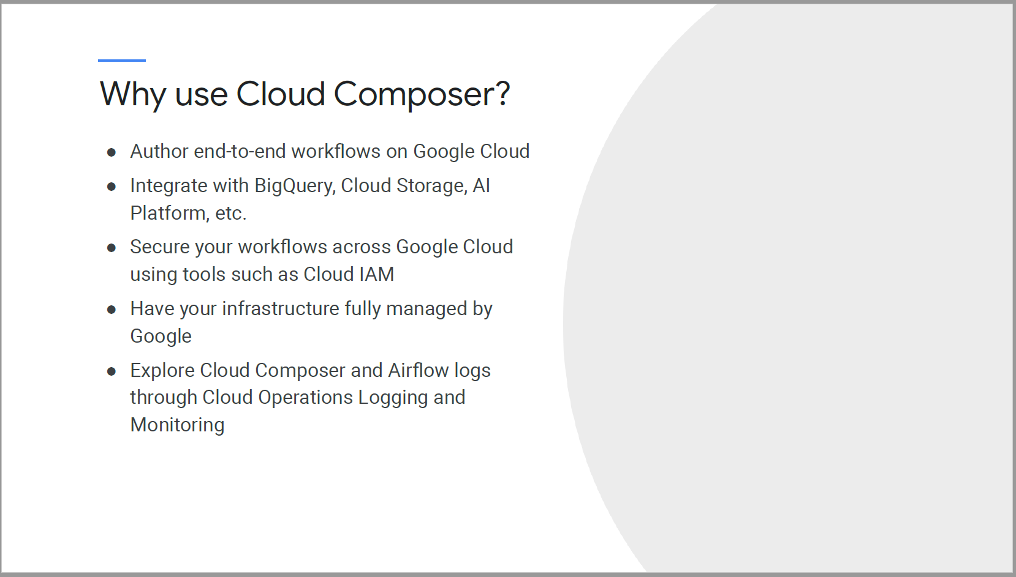

Connection to difference GCP services are already setup for Cloud Composer.

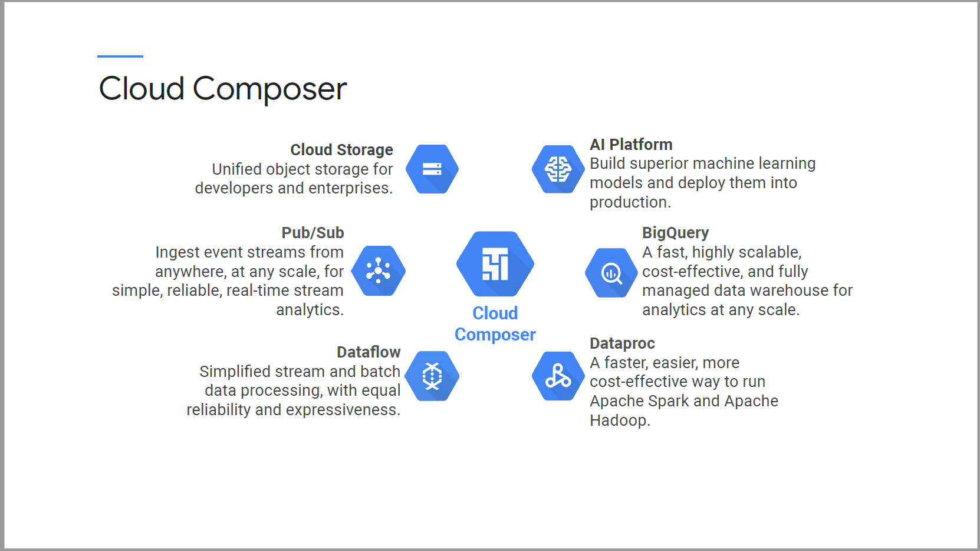

Apache AirFlow is open source and can run om-premises or in public cloud environment.

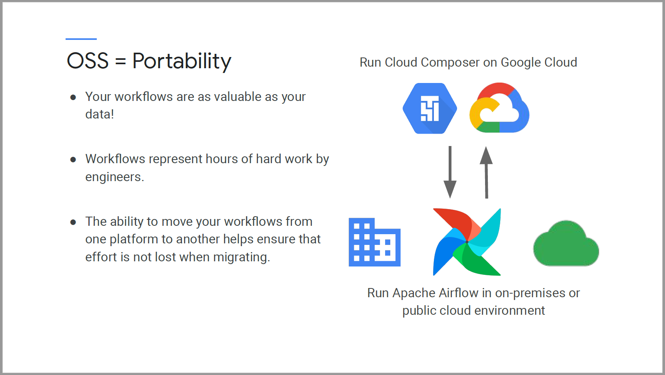

There is a rich library of connectors.

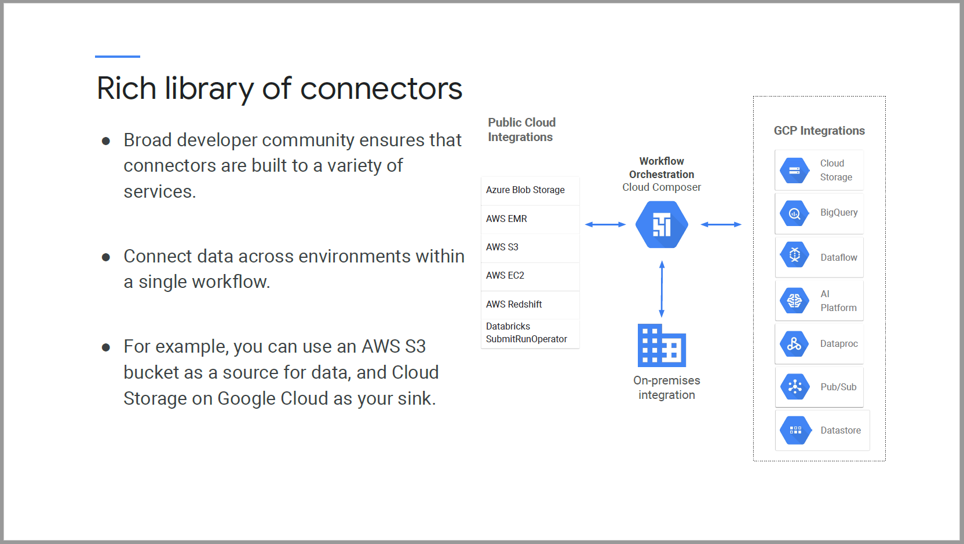

### Core Concepts of Apache Airflow

#### Directed Acyclic Graphs (DAGS)

* A DAG is a collection of all the tasks you want to run, organized in a way that reflects their relationships and dependencies.
* Every DAG has a definition, operators and definitions of the operator relationships.

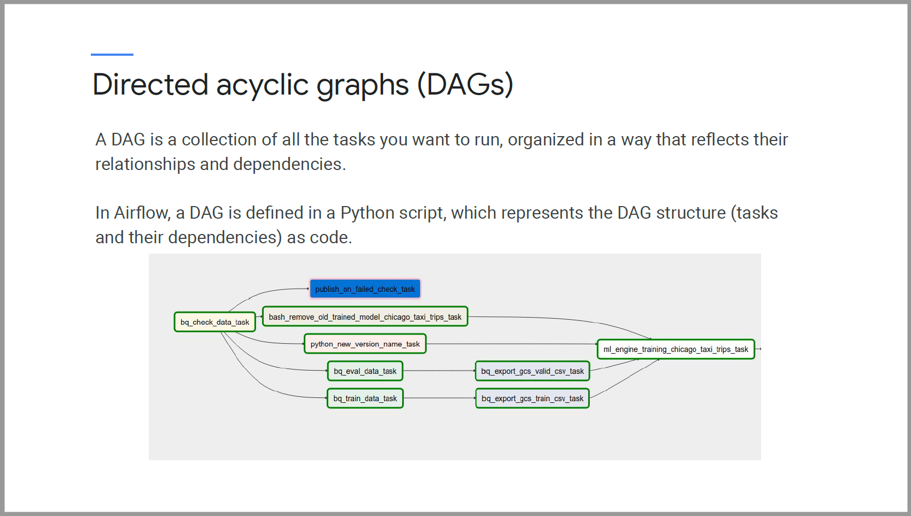

#### A Dag run

* A Dag run is a physical instance of a DAG, containing task instances that run for a specific execution_date.
* A Dag run is created by the Airflow schedule
* One DAG can have multiple DAG runs, each with a different execution_date.

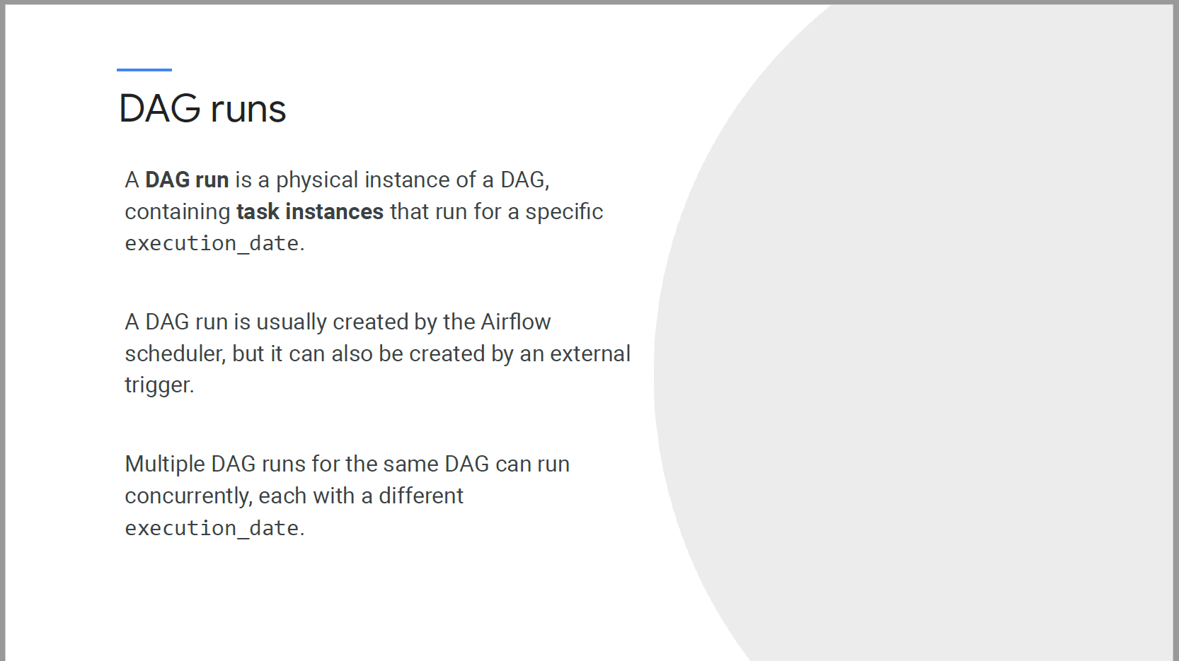

#### Task and Operators

* Task define a unit of work in your workflow. Task are parameterized implementations of operators.
* Operators are usually atomic
* In Airflow, you can leverage Xcoms to pass information between different operators.

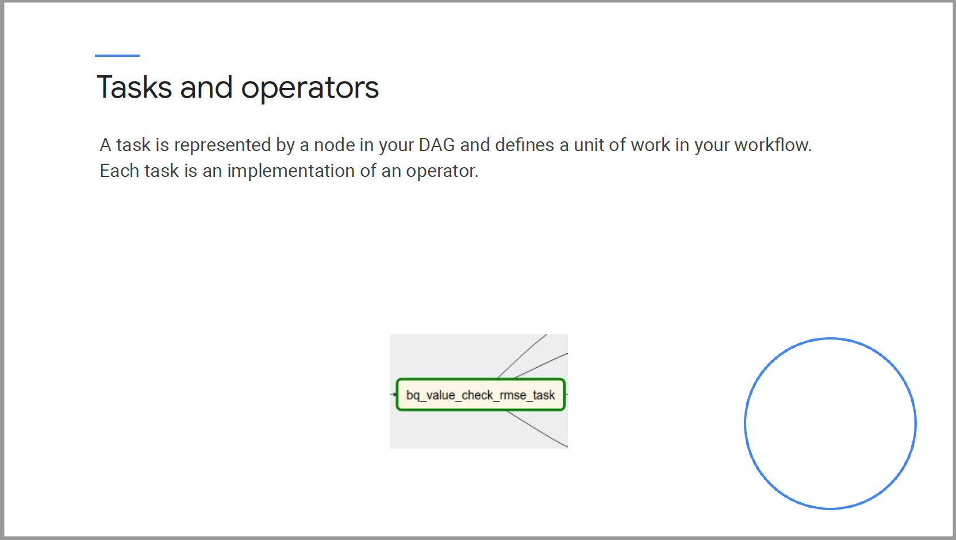

#### Operators

* Operators that perform an action or tell another system to perform an action
* Transfer operators that move data from one system to another
* Sensors that will keep running until a specific criterion is met.

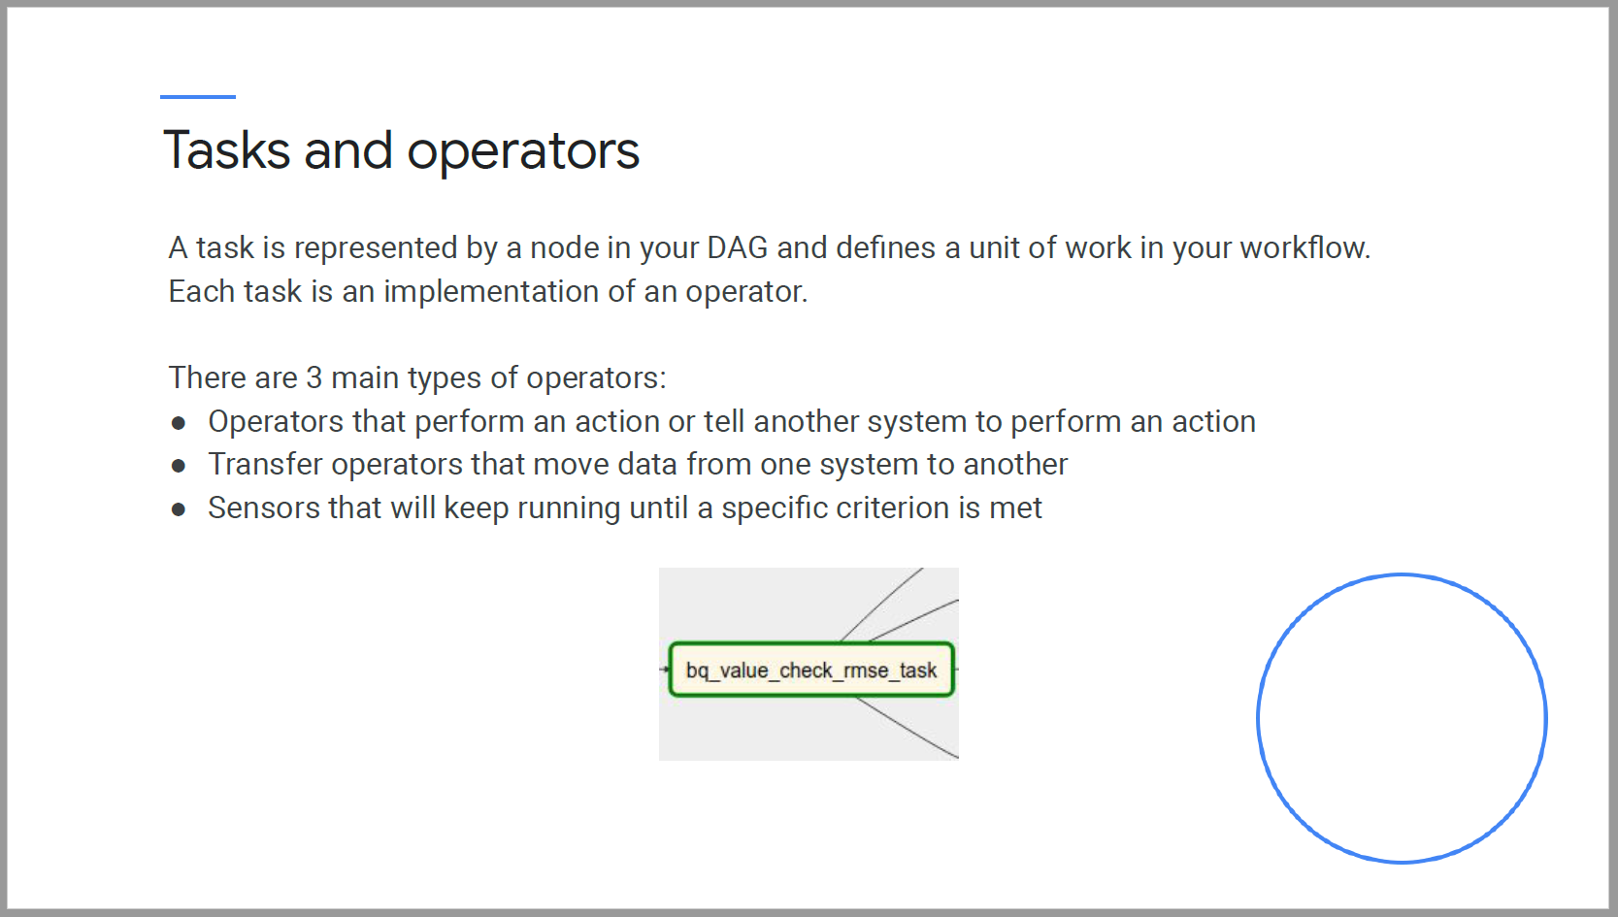

#### Airflow DAG in Python

* Airflow DAGs are python scripts with 5 main sections
* Other python code should not be in the script.

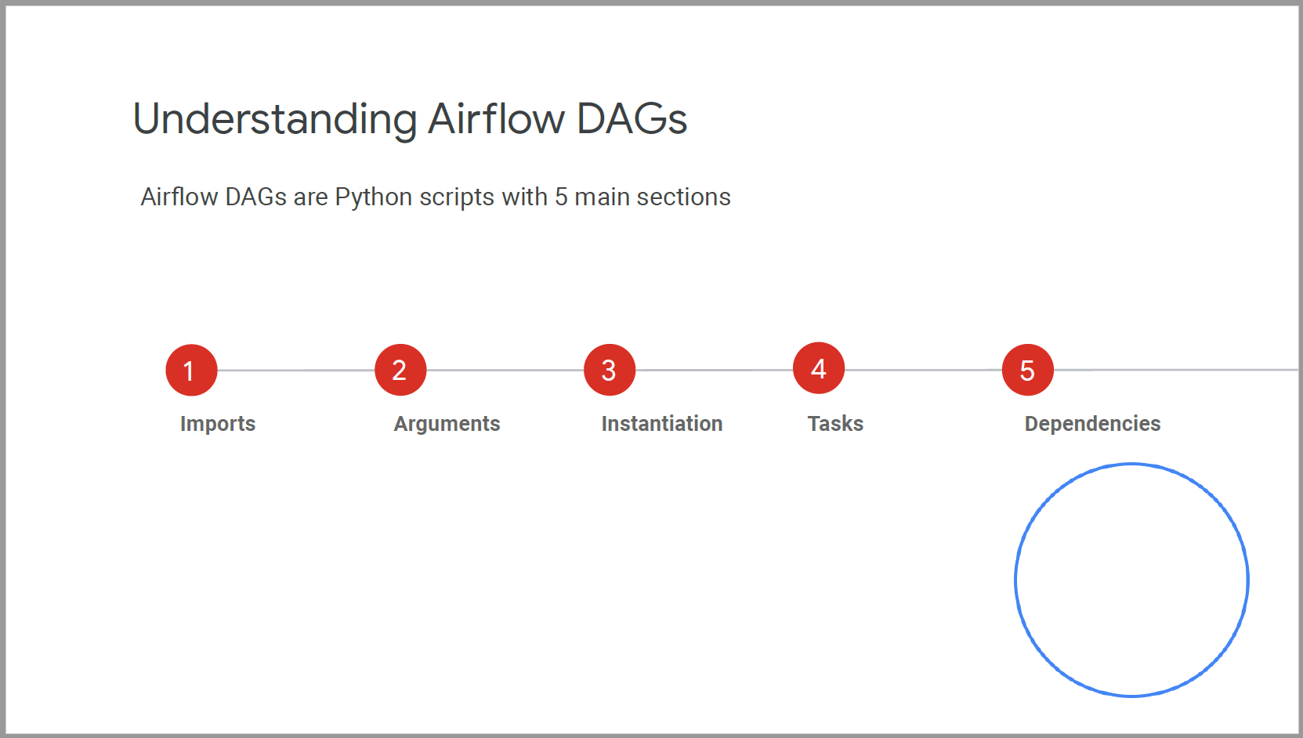

##### Imports

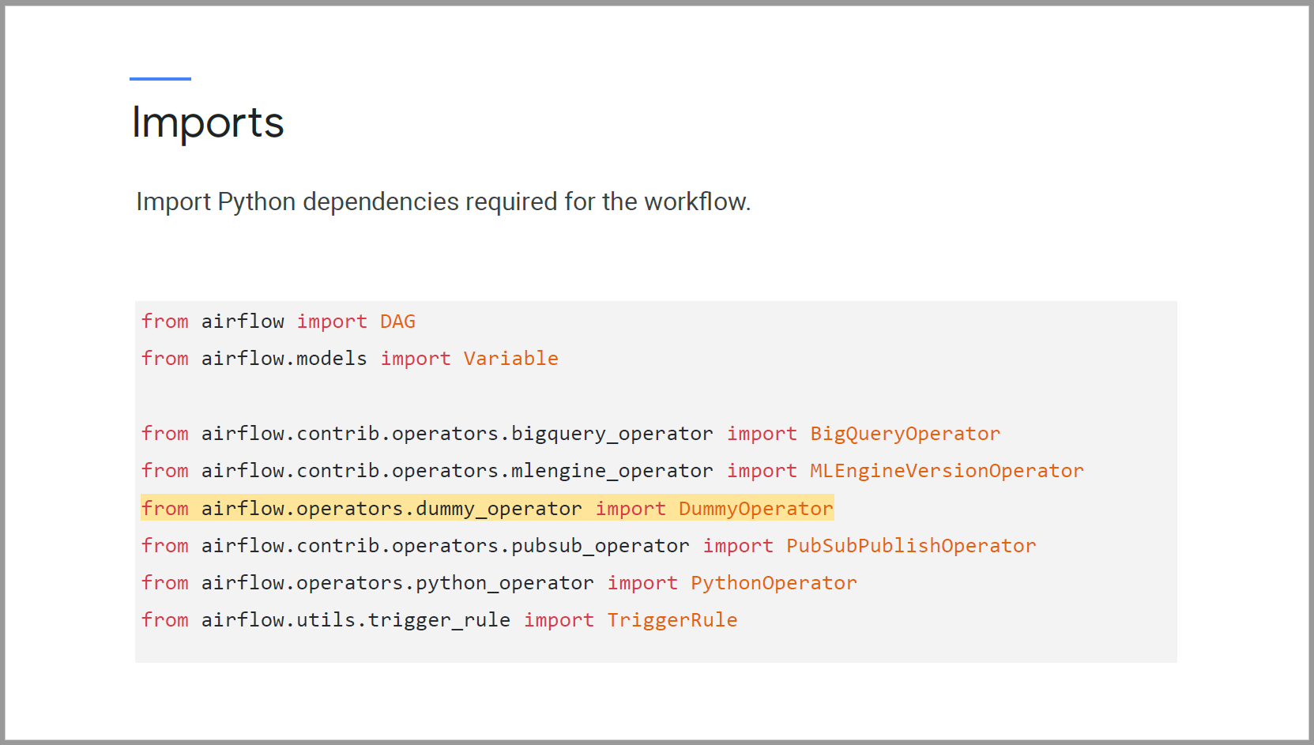

##### Arguments

* Arguments are defined in a dictionary
* When depends_on_past is set to True, the current task is only trigger when the previous task is successful.

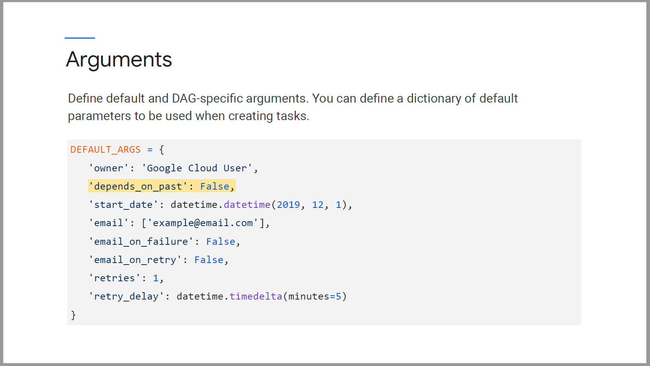

##### Instantiation

* Dag will be written within the context of a DAG object.
* We specify DAG ID which is a unique identifier in Airflow webserver.
* We pass in CROWN syntax to specify the schedule interval.
* If the task is scheduled one year ago and catchup is True, we will backfill the schedule and execute the task.

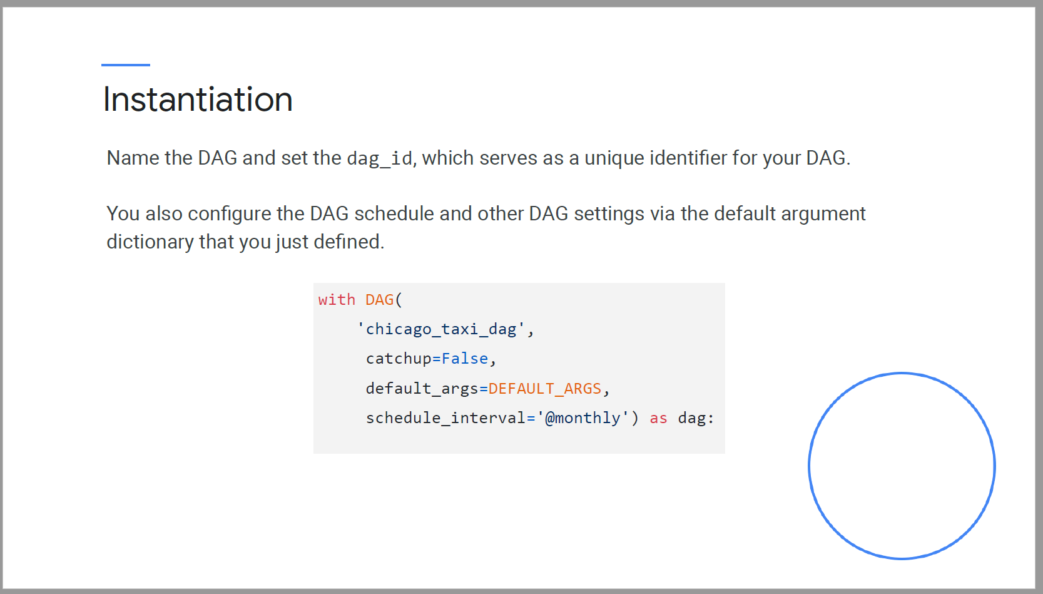

##### Tasks

* BashOperators and PythonOperators
* Operators to utilize GCP services.

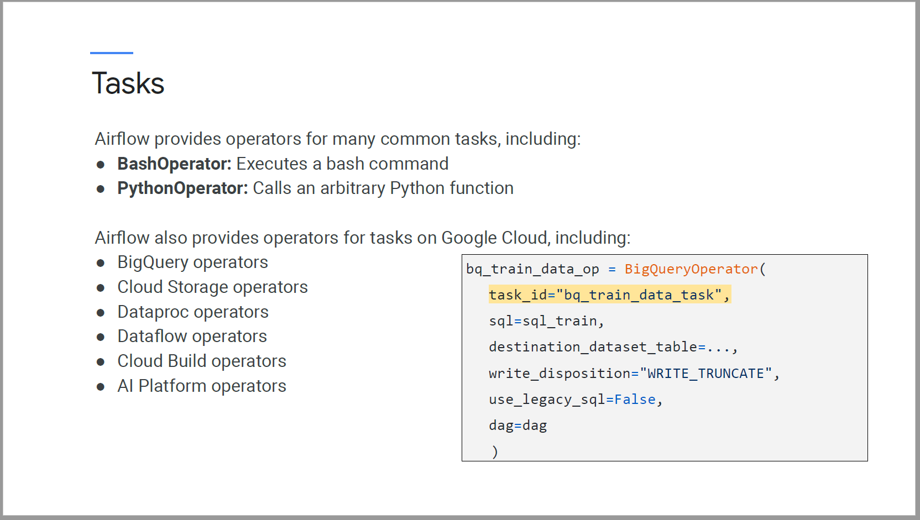

##### Dependencies

Operator relationships are set with set_upstream() and set_downstream() methods

In python, we can also use the bitshift operator >> and <<

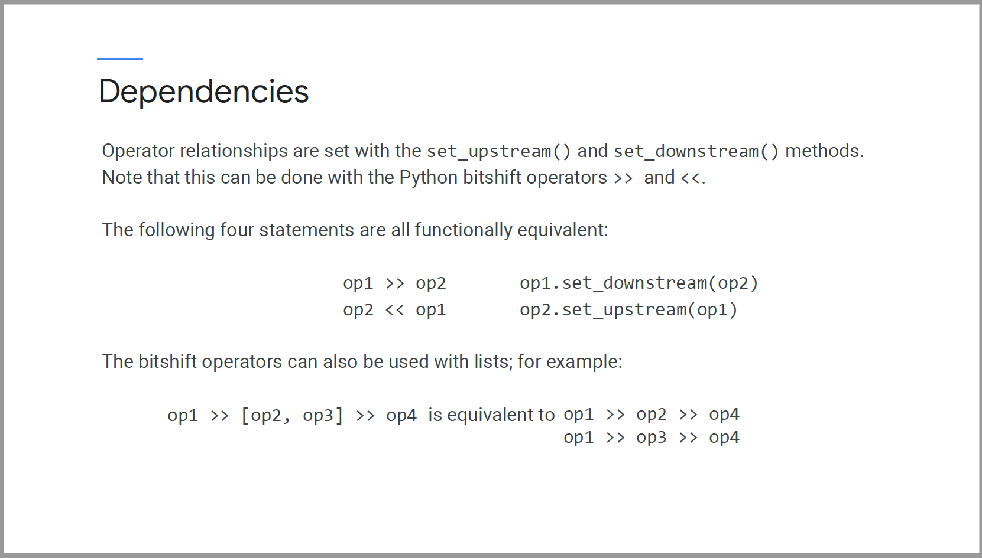

#### Creating and accessing environments

We can create and access environments in 3 different ways.

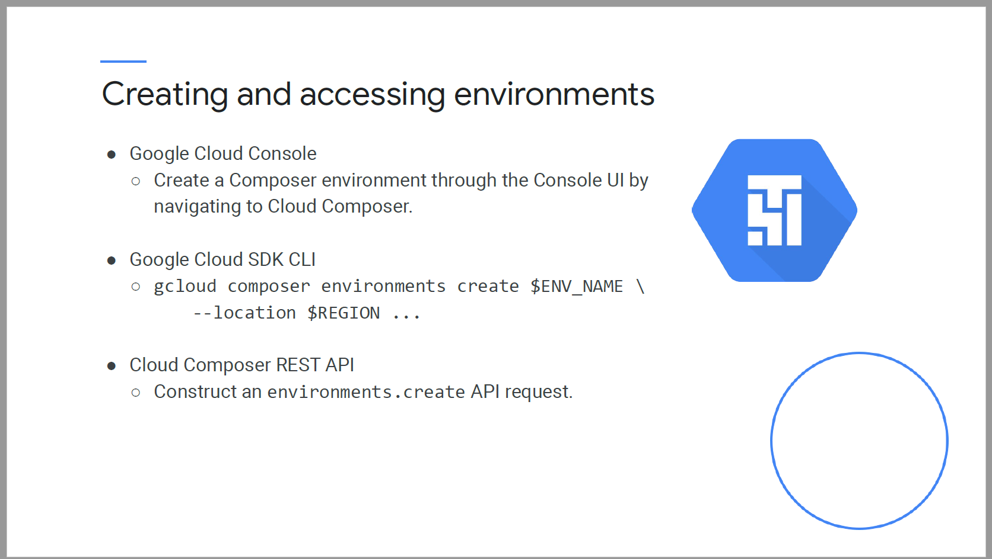

#### Sync with Airflow Webserver

* Folders in Cloud Storage are periodically synced to Airflow webserver.

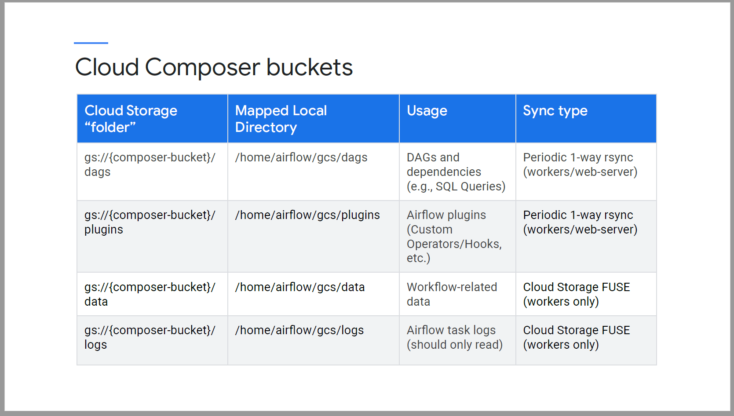

### Continuous Training Pipelines using Cloud Composer: Data

* 6 areas to consider in a continuous training pipeline.

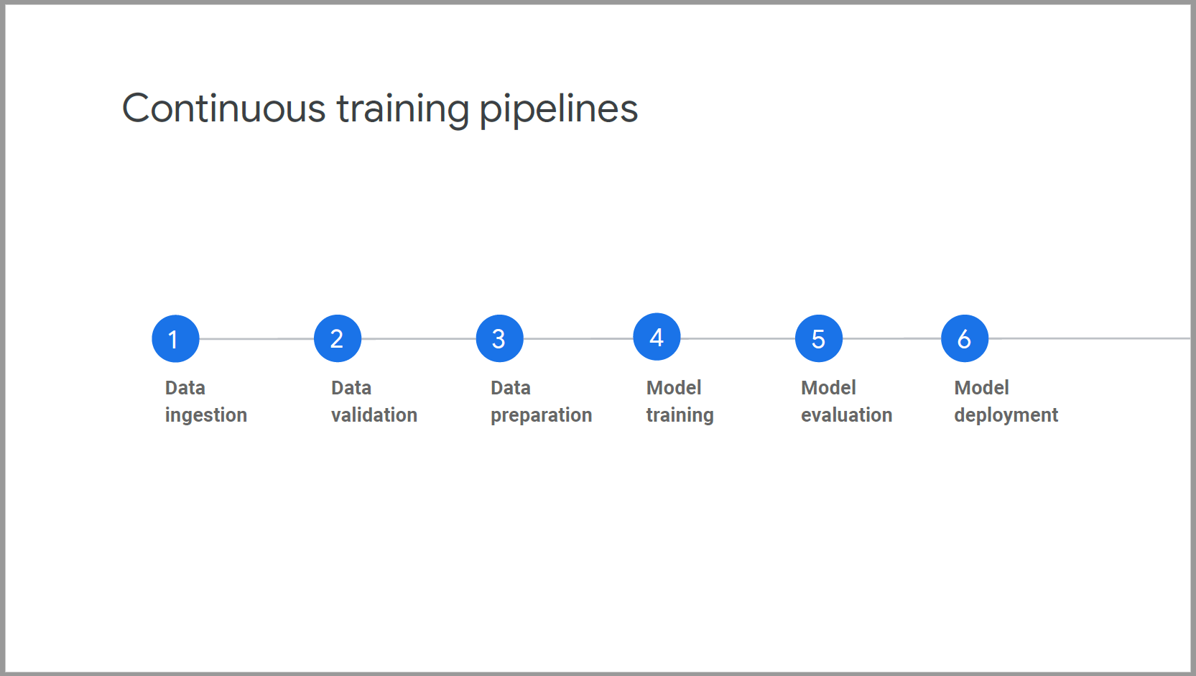

#### Data Ingestion

* Use BigQueryOperator and BigQueryToCloudStorageOperator to query and move data around
* Use CloudDataTransferServiceXXX operator to move data from Cloud to on-premises location.

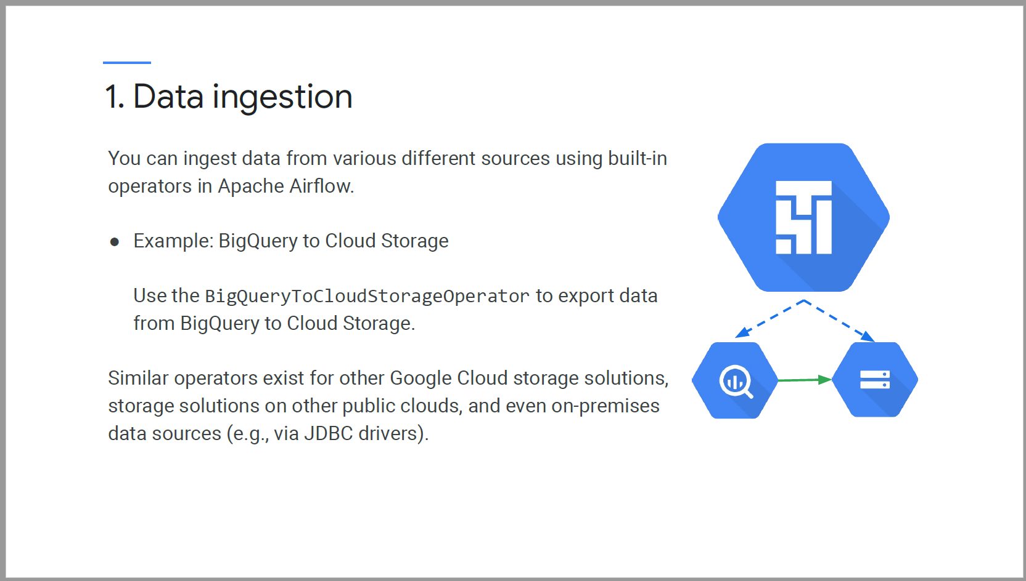

#### Data Validation

* Use BigQueryCheckOperator, BigQueryIntervalCheckOperator and BigQueryValueCheckOperator to ensure that the data meets the expectation.

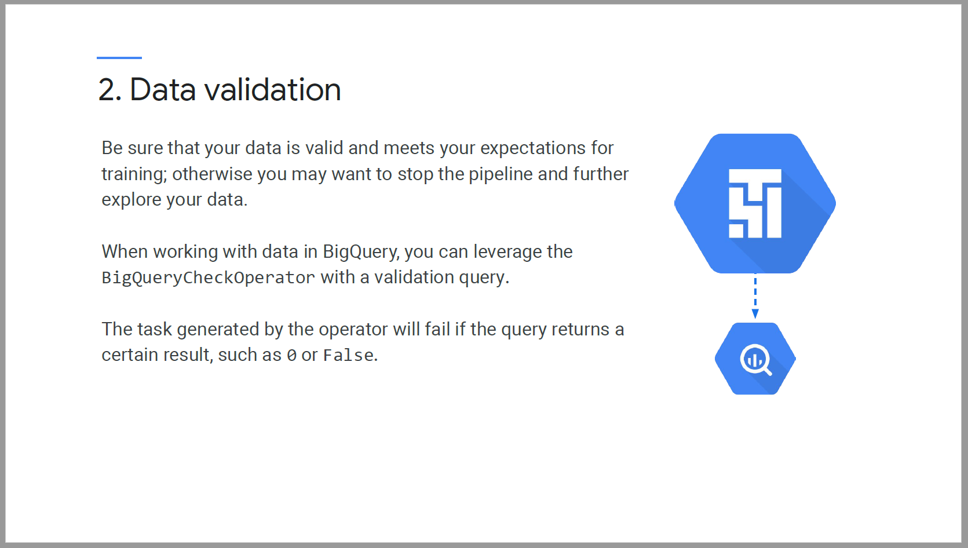

Example of data validation

* In Airflow, Variables, macros and filters can be used in **Jinja Templates**
* We are counting number of rows where trip_start_timestamp is no more than 30 days old, if you don’t have any fresh data within the last 30 days, we don’t want to re-run our pipeline.

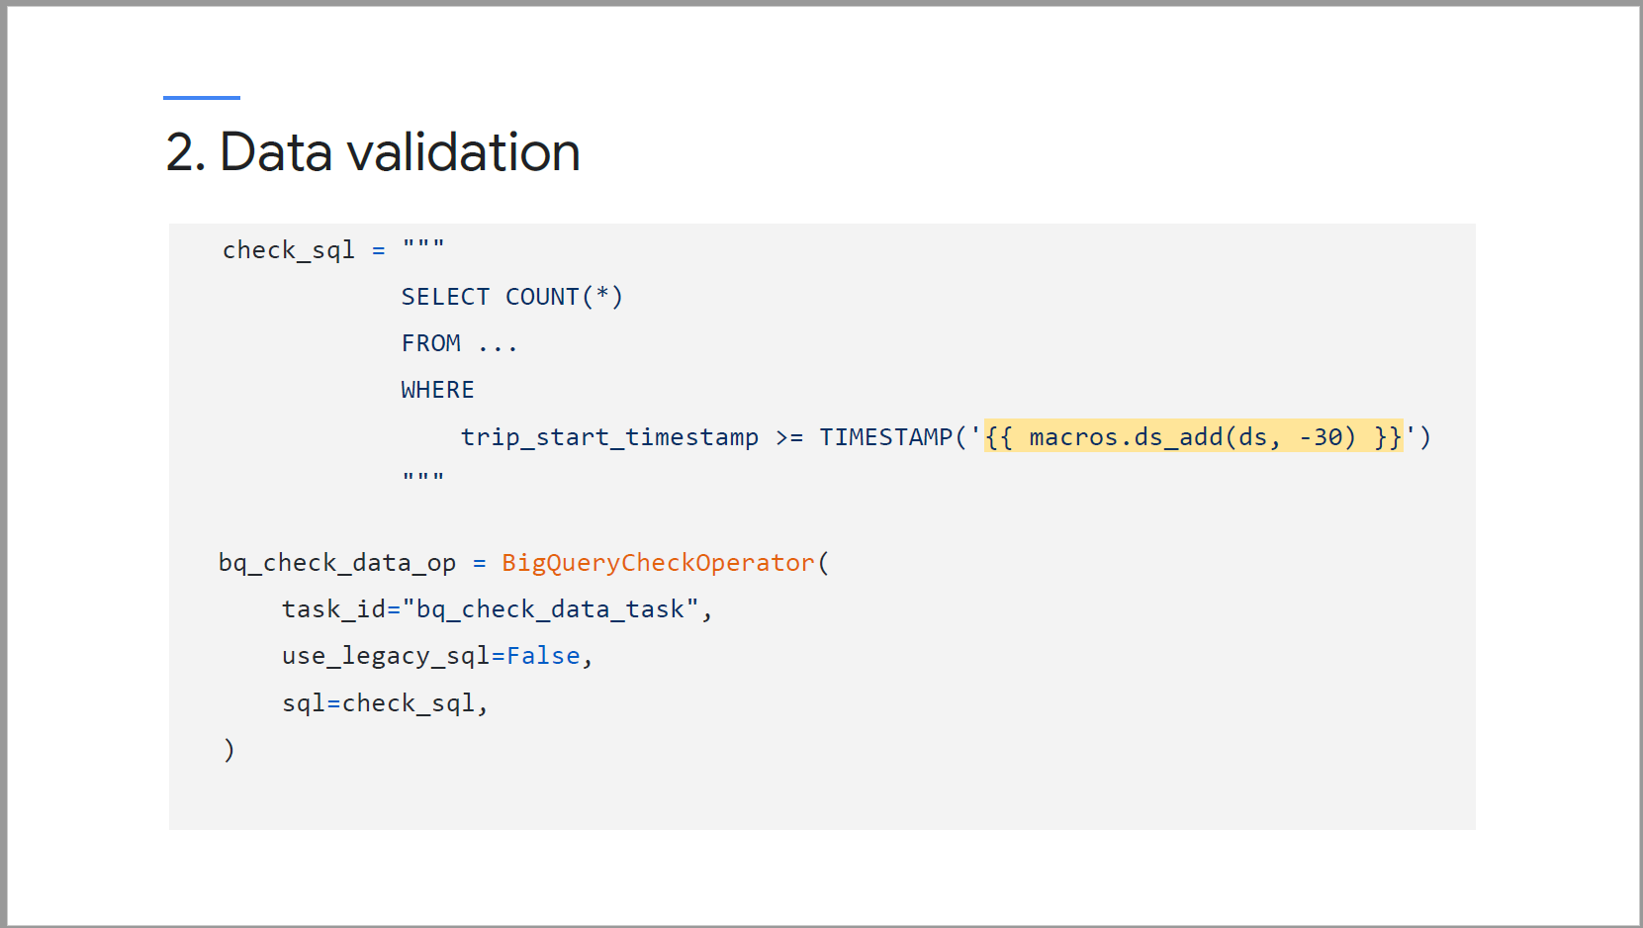

Other types of check operators

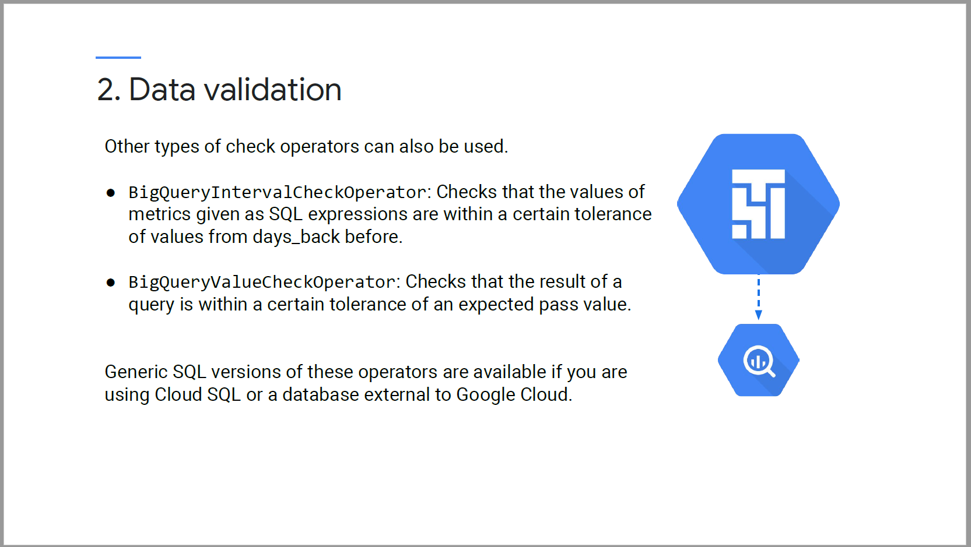

If check operator fails, youc an use the ALL_FAILED trigger rule to trigger a specific downstream task.

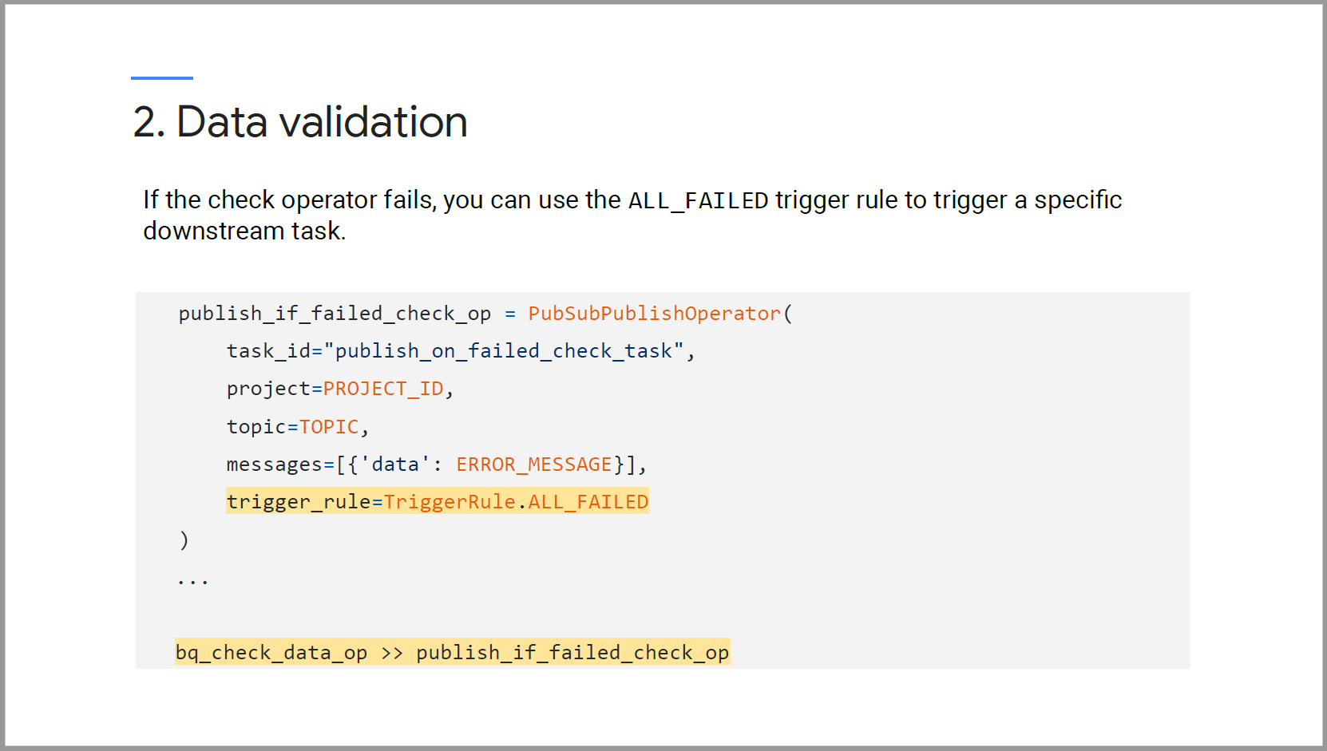

#### Data Preparation

* Use BigQuery operators for sql operations
* Use DataProc operators to run Apache Spark jobs
* Use DataFlowPython or DataFlowJavaOperator to run Apache Beam pipelines.

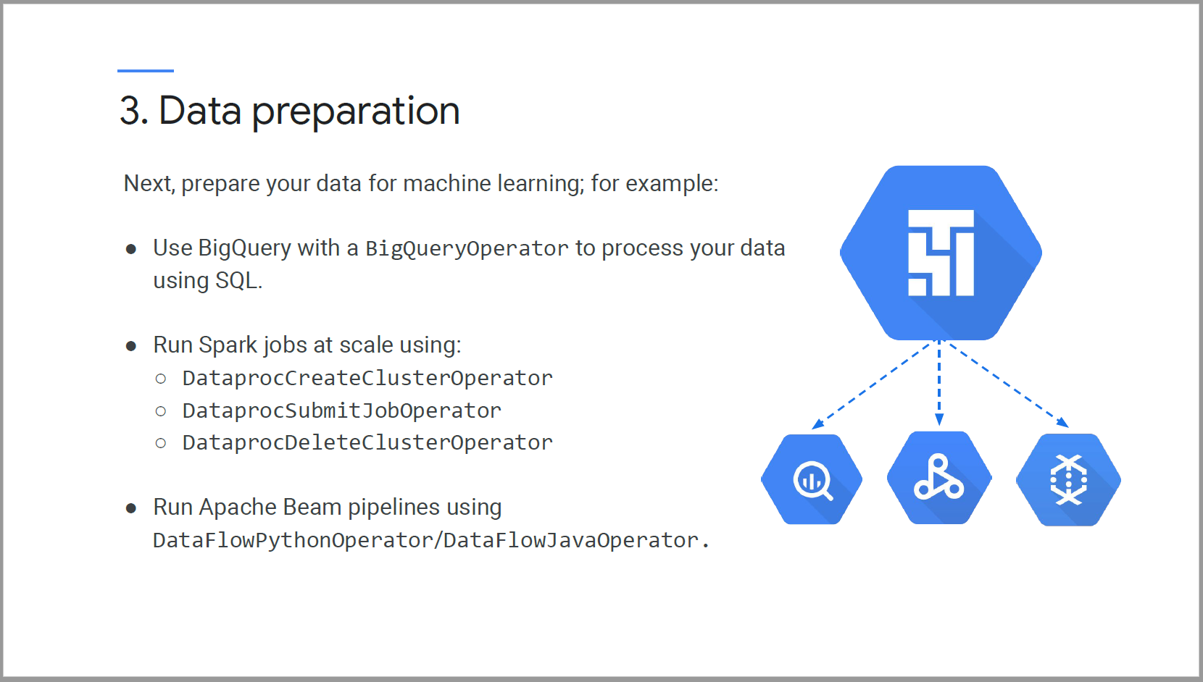

### Continuous Training Pipelines using Cloud Composer: Model

#### Model Training

* Submit your training jobs to AI Platform using the MLEngineTrainingOperator

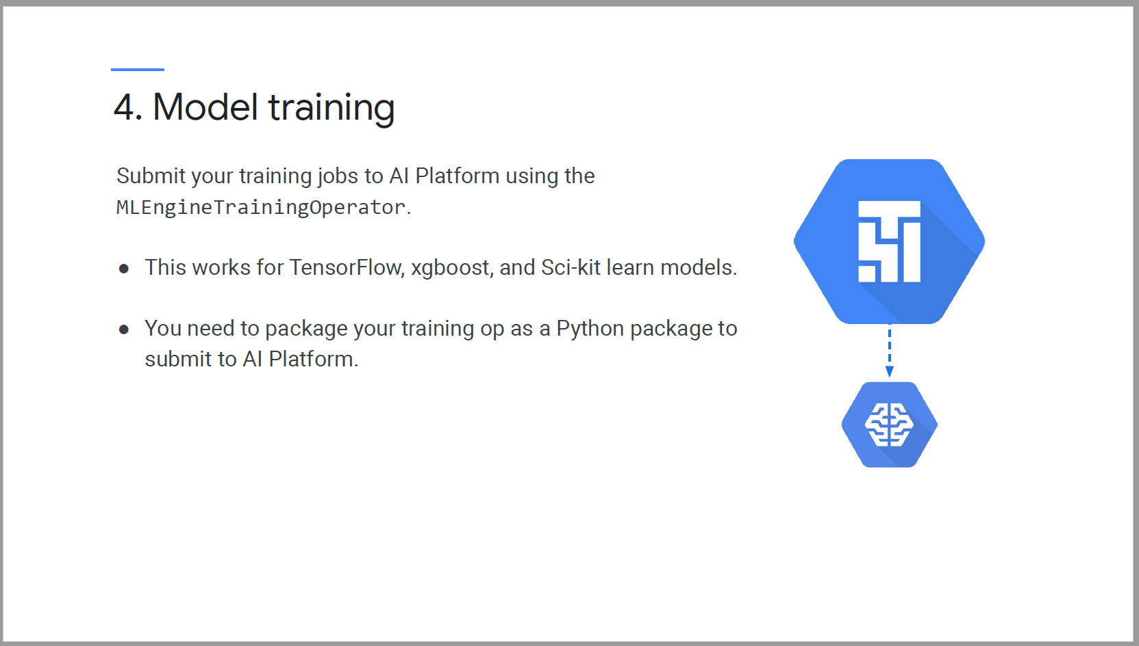

Pass in argument

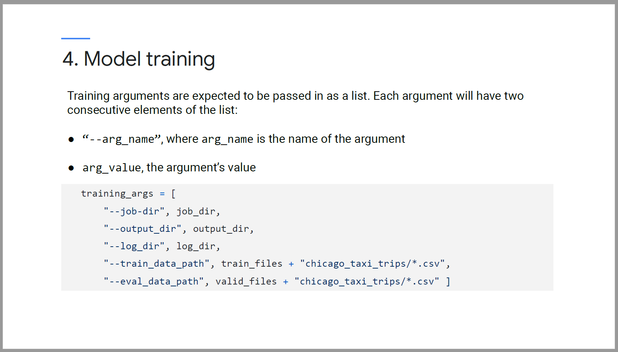

Wrap training task in the MLEngineTrainingOperator

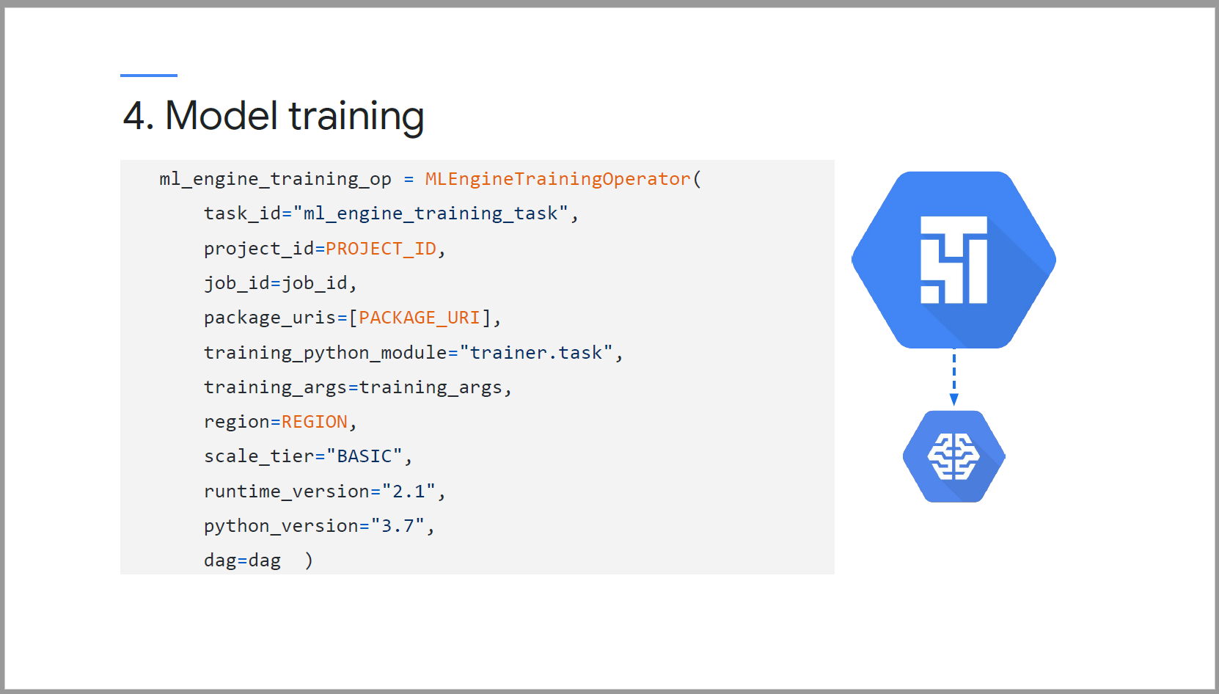

#### Model Evaluation

Extract evaluation metrics and store it in BigQuery table.

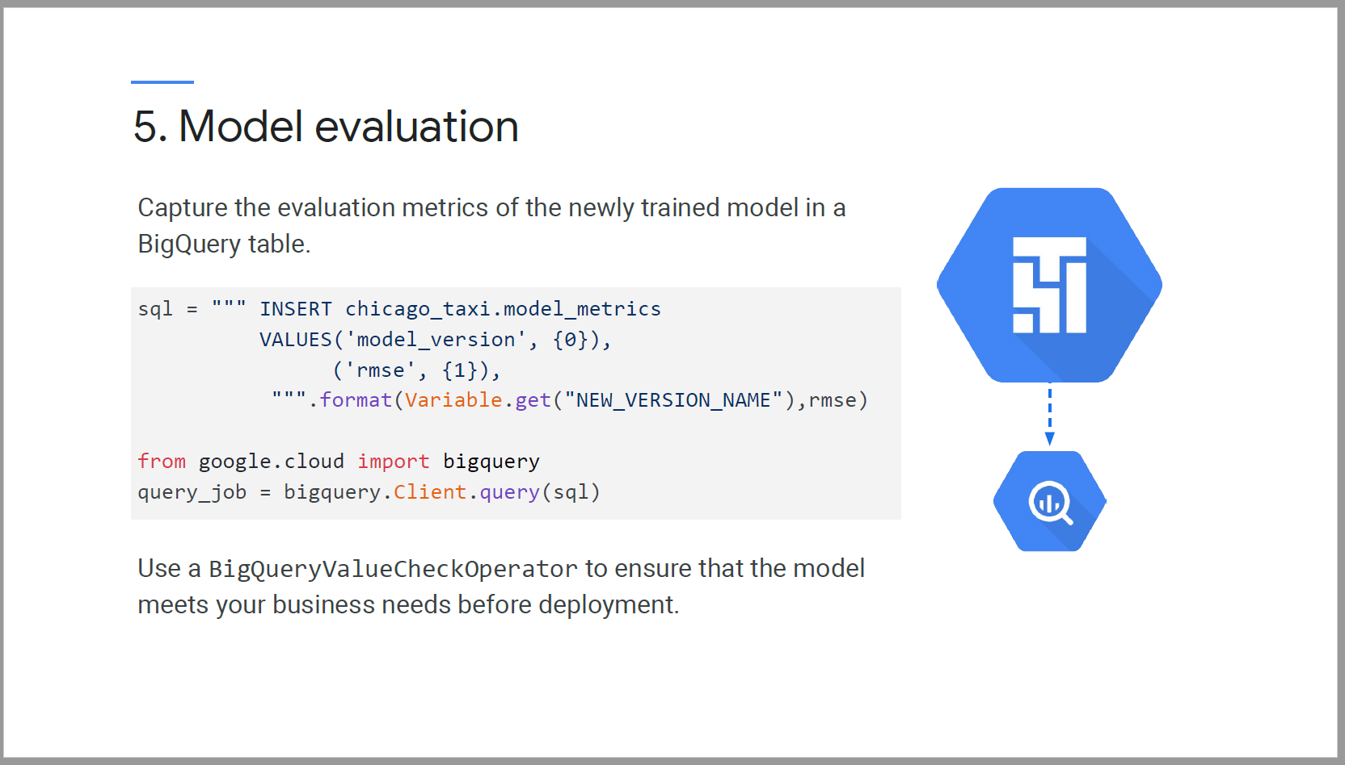

#### Model deployment

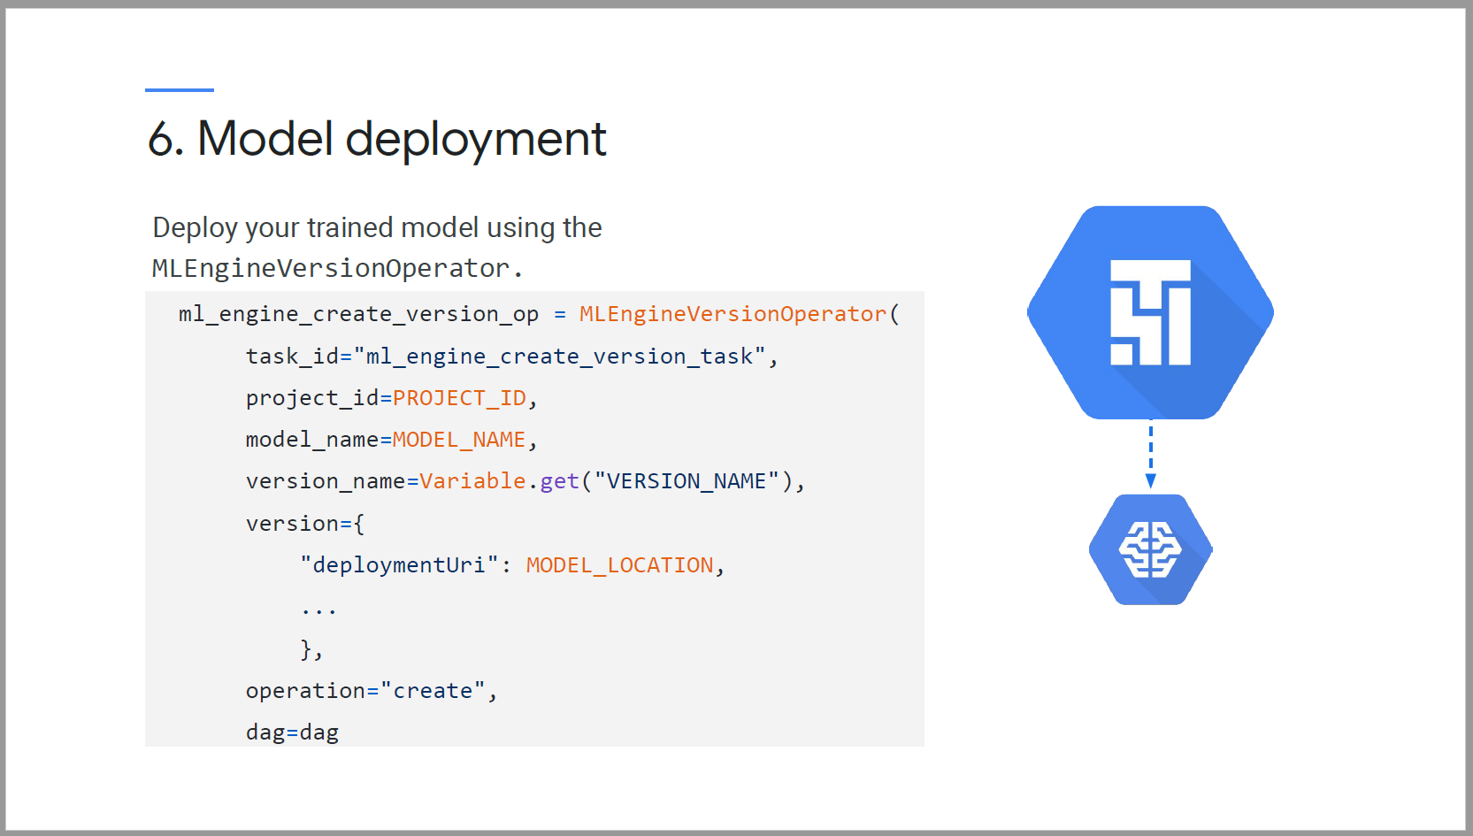

### Apache Airflow, Containers and TFX

## Week 4 – ML Pipelines with MLflow